SPRING 2018

The Sounding Board

The Publication of the National Federation of the Blind of New Jersey

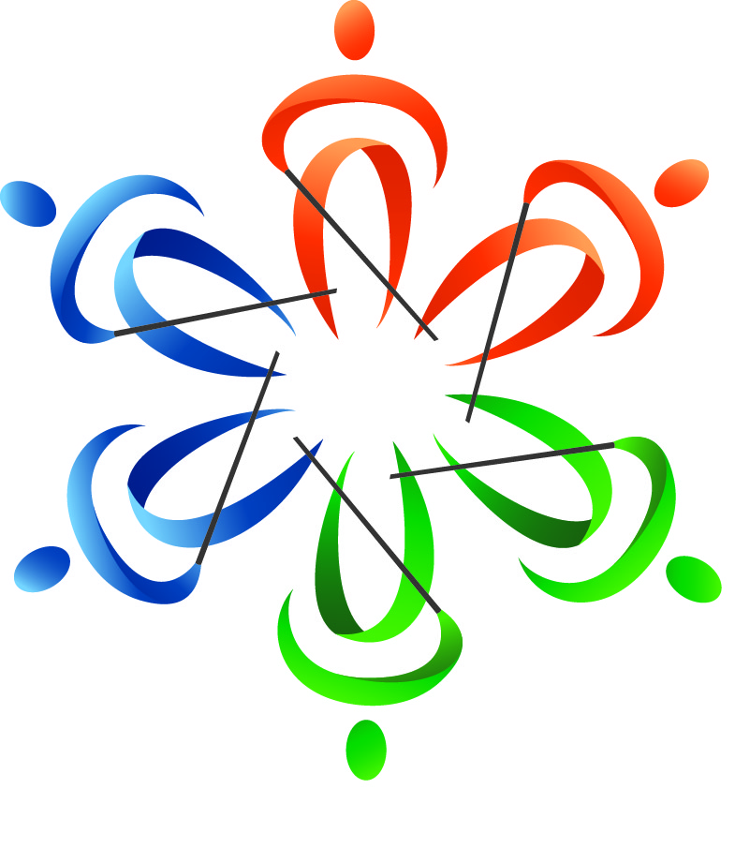
In This Issue

Andrew Rees
Tells how he won a First Timers Scholarship

Carol Castellano
Describes the advocacy efforts that saved NJ CBVI

Mary Fernandez
Announces the 2017 State Scholarship Winners

Annemarie Cooke
Reports on NFBNJ’s Future Planning Process

Rosa Santiago
Introduces the Spanish Committee

Linda Melendez
Introduces the Sports & Recreation Division

Live the Life You Want
THE SOUNDING BOARD
Spring 2018

Katherine Gabry, Editor
Annemarie Cooke, Mary Jo Partyka & Barbara Shalit, Co-editors
Barbara Shalit, Advertising Manager

Published by e-mail and on the Web through Newsline by
The National Federation of the Blind of New Jersey
www.nfbnj.org

Joseph Ruffalo, President
State Affiliate Office 254 Spruce Street Bloomfield, NJ 07003
E-mail: nfbnj1@verizon.net

All articles should be submitted to the State Affiliate Office at nfbnj1@verizon.net and specialk38@aol.com. Advertising rates are $25 for a half page and $40 for a full page. Ads should be sent to barbart@tullensound.com. The editorial staff reserves the right to edit all articles and advertising for space and/or clarity considerations.

Please Note: The deadline for the Fall issue is September 15, 2018.

Donations should be made payable to the
National Federation of the Blind of New Jersey
and sent to the State Affiliate office.

To subscribe via Newsline: Jane Degenshein 973-736-5785 or Jdegen16@comcast.net

DREAM MAKERS CIRCLE
Help build a future full of opportunity for the blind by becoming a member of the Dream Makers Circle. Your legacy gift to the National Federation of the Blind can be made in the form of a will or a living trust, an income-generating gift, or by naming the NFB as a beneficiary of a retirement plan or life insurance policy. You can also become a member of the Dream Makers Circle by making a legacy gift to your state affiliate. By committing to support an NFB affiliate, your gift will benefit both local and national programs, since all bequests made to affiliates are split evenly with the NFB national treasury. In addition to having the satisfaction of contributing to the future success of the NFB's mission, Dream Makers Circle members also receive a specially designed thank you gift and other benefits. For additional information, please contact Patti Chang at the NFB Jernigan Institute by e-mail at pchang@nfb.org, or by telephone at 410-659-9314, extension 2221.
Mission Statement
The National Federation of the Blind of New Jersey, Inc. is an organization of blind and interested sighted people who plan and carry out programs; work to improve the quality of life of the blind; provide a means of collective action for parents of blind children; promote the vocational, cultural and social advancement of the blind; achieve the integration of the blind into society on a basis of equality with the sighted; and take action that will improve the overall condition and standard of living of the blind.

The National Federation of the Blind knows that blindness is not the characteristic that defines you or your future. Every day we raise the expectations of blind people because low expectations create obstacles between blind people and our dreams. You can live the life you want; blindness is not what holds you back.

The National Federation of the Blind Pledge
I pledge to participate actively in the efforts of the National Federation of the Blind to achieve equality, opportunity and security for the blind; to support the programs and policies of the Federation; and to abide by its constitution.

The Sounding Board
The Sounding Board is the magazine of the National Federation of the Blind of New Jersey. It is published twice a year. Our hope is that through The Sounding Board, our members can keep current with local, state and national news, and issues of concern. We also aspire to provide a source of hope, inspiration, pride and camaraderie through the personal stories in our publication.
Hundreds of readers receive our publication via e-mail and Newsline. The Sounding Board is also available for download in its entirety from our website at www.nfbnj.org. We encourage our readers to share The Sounding Board with family members, teachers, professionals, neighbors, friends and any other interested parties. We estimate our circulation to be in the thousands, as readers from across the country regularly report that The Sounding Board influences their lives. We hope you enjoy this issue.
TABLE OF CONTENTS

Presidential Message, by Joe Ruffalo 1
From the Editor’s Desk: The Power of the People Has No Limits, by Katherine Gabry 3
The 2018 Washington Seminar Issues: Fighting For and Against, by Ryan Stevens 4
How to Apply for a First Timers Scholarship, by Andrew Rees 6
Advocacy in Action – Way to Go, Team! by Carol Castellano 7
Examine Yourself, by Ron Brown 8
Building the Federation Takes a Giant Step Forward in New Jersey, by Annemarie Cooke 9
Save the Dates for BELL 2018, by Mary Jo Partyka 10
NFBNJ Scholarship Winners Announced at 2017 State Convention, submitted by Mary Fernandez 11
The PAC Plan, by Brian Mackey 14
What is the DeafBlind TSA Experience? Come Along with Alice Eaddy and Find Out, as told to Barbara Shalit 15
Thanks from Jehovah’s Witnesses: Volunteers & Vendor at State Convention, by Janet DiNola Parmerter 17
Meet the NFBNJ’s Sports and Recreation Division, by Linda Melendez 18
Linda’s Personal Exercise Routine, by Linda Melendez 19
Back on the Air! by Ken Lawrence 20
A Spanish Committee Comes to New Jersey, by Rosa Santiago 21
Raising Awareness, Enhancing DeafBlind Services through Collaboration, by Carly Fredericks and Kathleen Spata 23
My First Official Released Album, by Bryan Woolbert 24
Get Your Free White Cane! 25
Information from Parents of Blind Children-NJ 26
From the Kitchen of the Sports & Recreation Division 27
NFBNJ Contact Info 28

PRESIDENTIAL MESSAGE

Dear Fellow Federationists,
As I write my thoughts on this last day of April, I am looking forward to the new growth that comes with spring. Spring is always a time for renewal, rebirth and growth, and these are my continued dreams for this affiliate as we strive to raise expectations. When we raise expectations, we begin to transform our dreams into reality. The new result is that we can live the life we want!
In this issue of The Sounding Board, you’ll find that many of the articles have a recurring, underlying theme of advocacy or self-advocacy. We have the right to live in the world with others. Through advocacy, we discover solutions to this quest. We learn about ourselves, and our drive and determination to educate the public about our rights. You’ll notice articles featuring the Washington Seminar and the successful phone, email and follow-up campaign to keep the New Jersey Commission for the Blind and Visually Impaired as a stand-alone state agency with its own executive director. Yes, these successes were as a result of the advocacy efforts of our members. We make change happen. GREAT JOB!
On March 24, NFBNJ board member Mary Fernandez conducted an intensive leadership building workshop at the Joseph Kohn Training Center. The 39 participants represented our seven chapters, nine divisions and one committee. Those in attendance were divided into six groups, and each group was charged with discussing and presenting solutions to resolve an issue important to the affiliate. We will be reviewing the results from the six groups and deciding on the next steps. In all, we are excited about taking this first formal step in grooming future leaders and continuing to build our membership. Annemarie Cooke’s article provides more details on this leadership workshop.
On April 18, Linda Melendez, myself and nearly three dozen Federationists attended the Senate Foreign Relations Committee hearing in Washington, DC to review and present the reasons to approve the Marrakesh treaty. In addition, Veronica Gaspa, president of the New Jersey Association of Blind Students, provided written testimony to adopt the treaty, which facilitates access to books and printed materials across the world. Here is the link to listen to the hearing of the Marrakesh Treaty with the Senate Foreign Relations Committee: https://www.foreign.senate.gov/hearings/treaties-041818
The NFBNJ website is managed by Brian Mackey. Brian and his family have moved to Pennsylvania; however, Brian has agreed to continue as webmaster for the affiliate and will also continue as treasurer until the fall election.
The 42nd State Convention of the National Federation of the Blind of New Jersey will be held Thursday, November 1 through Sunday, November 4, 2018. Our theme this year is Live The Life You Want: Blind With Vision. For those who may be arriving early, some rooms are reserved for Wednesday, October 31, but don’t hesitate! Make your room reservation as soon as possible because the rooms are quickly filling up. As of April 30, over half the rooms had been reserved. The location for this year’s State Convention is the Renaissance Woodbridge Hotel, 515 US Highway 1 South, Iselin, NJ, 08830. If you are traveling with Access Link, please inform the trip coordinator that the hotel is in Woodbridge; for some reason, Iselin does not show up as the location. To make your hotel reservation 24 hours a day, 7 days a week, call 732-634-3600 and use code: NFB. The best time to call is during regular business hours, 9 a.m. to 6 p.m. Room information is as follows:
- Standard Room $106, plus tax
- Junior Suite, $146, plus tax
- Please note that the hotel’s room rates are subject to applicable state and local taxes in effect at the time of check-out (currently 14.625%).
- Breakfast buffet is included in the rate for up to two guests.
Please find more information about the State Convention at www.nfbnj.org.
We are proud to announce the establishment of the Sports and Recreation Division and the Spanish Committee. Both of these new groups are highlighted in articles in this edition. Thanks to Linda Melendez and Rosa Santiago for their interest, effort and energy in leading these new groups.
Please take advantage of the state website at www.nfbnj.org as we are constantly posting and updating information. Soon, additional information pertaining to the bowling league, the Six Dot Dash, the Affiliate Challenge and the 3rd Annual Surfing Experience will fill the next few months with interest, action and involvement.
The BELL Academy staff, volunteers, students and parents are looking forward to the 5th NFBNJ 2-week program in July. In this edition, you’ll find additional information highlighting the program.
I hope that you will consider attending the National Convention in Orlando this July. Pre-registration is open until May 31. Please visit www.nfb.org for updated information.
Enjoy the growth of spring, the growth in yourself and the growth in the affiliate!

Sincerely,
Joe Ruffalo, President
National Federation of the Blind of New Jersey

FROM THE EDITOR’S DESK:
THE POWER OF PEOPLE HAS NO LIMITS
By Katherine Gabry

I’m just back from the Network of the Americas Conference in Hyannis, MA, hosted by Deafblind International and the Perkins School for the Blind. The last conference hosted by Perkins was in 1997 – a very long 21 years ago – and this is the first such conference ever held in the U.S. The theme of this year’s conference was “Partnerships for Lifelong Learning,” and a pervasive awareness throughout was that we are all stronger when we work together. More than 100 workshops were offered, plus discussion groups and poster sessions. Even better, those who organized the conference built in plenty of time for networking, as we all know that the learning we derive from each other is at least as valuable as that which we glean from the classroom.
Once home, my good luck continued, as I had the fortunate distinction of organizing a group of Jersey volunteers to work with Scott Stoffel and his Tactile Carnival at a Take Your Children to Work Day sponsored by Merck in Rahway. Organizations represented were the NFBNJ’s DeafBlind Division, Helen Keller National Center, the American Association of the DeafBlind, DeafBlind Community Access Network of New Jersey, American Sign Language Interpreter Referral Service, DeafCAN! and the Tactile Carnival. Once again, an amazing opportunity to network amongst friends, peers and other professionals interested in DeafBlindness and to interest 650 young minds in the tactile world.
I relish these opportunities to meet people who are traveling the road with me. Personal conversations, compelling stories, shared research and ideas – they all offer the chance to grow beyond where I am at this moment, to affect and change me, and possibly others, too. I suppose this could be called advocacy or self-advocacy. I call it The Power of People, and there are no limits to the good that can come of it.
Today, unfortunately, folks are missing out on these personal connection opportunities. Across the state and the country, organizations cannot get attendees at their functions, much less get them to join as members or run for board offices. Our own Parents of Blind Children-NJ, once a model national program, has been struggling to find the next generation of leaders. It seems the world of tweets, Facebook and other social media has replaced the personal get-togethers that form the basis of these organizations. This saddens me because I am 100 percent certain that your 129 Facebook posts are not nearly as personal or insightful as spending a couple hours at a club meeting or a workshop with one good friend. My advice? Let the laundry, vacuuming, cooking, gym, sports, et al wait. Take time for you and make a personal connection: Call a friend, meet for lunch, set a play date, go to a conference or workshop or club meeting. I guarantee you will feel The Power of People: Inspiration, rejuvenation, self-growth and no limits.
THE 2018 WASHINGTON SEMINAR ISSUES: FIGHTING FOR AND AGAINST
By Ryan Stevens, NFBNJ Legislative Director

Greetings once more, my fellow New Jersey Federationists. Between January 29 and February 1, the National Federation of the Blind held another successful Washington Seminar in our nation’s capital. Members from around the country, including 13 from our own affiliate, went to Capitol Hill to talk with our Congressional representatives about the most pressing legislation concerning the blind. This time, we addressed four issues. Three of them are ones for which we have previously advocated. The fourth is one which we strongly oppose. Here is a brief rundown of each topic.
The first issue concerns the Accessible Instructional Material in Higher Education, or AIM-HE, Act. Much of the material used by university and college faculty to teach their courses is available to students only electronically or online, and a good portion of these tools are not accessible to blind and print disabled students. While the Americans with Disabilities Act and other laws mandate full accessibility in the classroom, there are no guidelines for institutions of higher education and manufacturers of these materials to follow to ensure compliance. AIM-HE would establish these guidelines for users and creators of such software. It would also give legal protections to those who follow the guidelines. The current bill in the House of Representatives is HR1772, sponsored by Congressman Phil Roe of Tennessee. The companion bill in the Senate is S2138, sponsored by Elizabeth Warren of Massachusetts.
The second legislative issue we discussed is the Access Technology Affordability Act. Access technology enables blind people to participate in today’s connected world and to perform tasks that they were once unable to accomplish themselves. Today, the blind most often acquire this technology through their state blindness agency or through their employer as a reasonable accommodation. The problem with going through the state agency is the length of time it takes to receive the equipment. The drawback of receiving it from an employer is that such requests can make the company wary of hiring blind people because of the expense. Unfortunately, the cost of access technology also prevents most blind people from purchasing it themselves. The Access Technology Affordability Act helps to alleviate this burden by providing a tax credit to the blind person when he or she purchases equipment. In the current bill, the person buying the equipment can deduct $2,500 over a three-year period. For example, if a blind person were to purchase JAWS for $1,000 this year, he or she could claim that as a tax credit. The person would then still have $1,500 over the next two years to buy other adaptive equipment or software. The current House bill is HR1734 and is sponsored by David Young of Iowa, and the Senate bill is S732, sponsored by John Boozman of Arkansas.
Our third topic was the Marrakesh Treaty. This treaty, if ratified by a two-thirds vote in the Senate, would greatly expand access to books and other printed material to blind and print disabled people throughout the world. It would allow a person from one country to get a book in non-visual format from another country, rather than having to wait for his or her home country to create its own non-visual version. It also makes it easier to acquire material in multiple languages. At the Great Gathering In Meeting, which was held the evening before we went up on the Hill, NFB leadership told us that they expect ratification of the treaty and accompanying implementation legislation sometime this spring.
Our final item in 2018 was a bill we strongly oppose. It is the ADA Education and Reform Act (HR620). This bill would essentially gut the Americans with Disabilities Act by forcing a person with a disability who is denied access to a public accommodation to first notify the offending business of the violation within two months. The business would then have two months after notification not to fix the problem, but to make “substantial progress” toward addressing it before legal action could be taken. This means that a barrier to equal accommodation could remain in place for an additional 120 days with no guarantee that it would be fully remedied. For the blind, this would include such things as continued inaccessibility of online shopping and banking sites, loss of privacy regarding medical information, and the inability to order from a restaurant menu independently. Unfortunately, HR620 passed the House of Representatives on February 15. We are now focusing our efforts on stopping the bill in the Senate.
For more details and the full fact sheets for each of these issues, go to https://nfb.org/washington-seminar
As I have pointed out in the past, while going to Washington, DC and addressing these important issues directly with our elected officials is certainly important, it is only the beginning of our legislative agenda. Also, there will be other concerns that will arise during the year. We cannot ignore any of these until next January. All of us need to make an effort to help all blind Americans live the lives we want.
To contact your member in the House of Representatives or the US Senators from New Jersey, call the Capitol Switchboard at 202-224-3121. To find your House member, you can either contact your local public library or go to www.house.gov and enter your zip code.

HOW TO APPLY FOR A FIRST TIMERS SCHOLARSHIP
By Andrew Rees

Editor’s Note: Andrew attended the National Convention in 2017 for the first time as a scholarship award winner from New Jersey. He is vice president of the Central Jersey Chapter and the DeafBlind Division, and treasurer of the Senior Division. In this article, he discusses how to apply for the Jernigan’s First Timers Scholarship award.

The beginning of this application process is to think about why the NFB’s national office should invest this money in you. The NFB needs to know that your goal is to continue as a strong, active and productive member of the organization.
One of the most important decisions of this process is your selection of a mentor. The selection of your mentor should be a leader in your state affiliate. I chose Alice Eaddy as my mentor because of our close NFB DeafBlind Division connection.
The next step in this process is formulating a letter for the First Timers Scholarship Committee. This is where you detail all of the duties and responsibilities you perform for the NFB, as well as future duties and responsibilities you want to take on. The scholarship committee needs to know how you will continue to be an active and productive part of our organization.
Formulating this letter was a time-consuming process for me and helped me to think deeply about where I fit into this organization. It also helped me identify why I became a member over 12 years ago. Over these years, I have wanted to become a stronger member and give more to the NFB.
Once the draft of your letter is complete, you forward it to your mentor for their review. Your mentor will suggest changes, additions and corrections to strengthen it. Once you send the final version to your mentor, they will send your application with their thoughts to our state president, Joseph Ruffalo.
The next step of this application process is for Joe to give his opinion of whether or not to grant you this scholarship. He then forwards the completed application to the Jernigan’s First Timers Scholarship Award Committee. This committee is responsible for determining all of the scholarship recipients from all 52 affiliates. The goal of this committee is to choose the most deserving members of the NFB. They have only a limited allowance of funds available. This is why they invest in the NFB members who have the potential to strengthen our movement. This award can only be given to members who are attending the National Convention for the first time.
I would like to end by saying everyone should attend a National Convention. You cannot help but feel inspired and invigorated after attending a National Convention. I left my first National Convention feeling the power of our movement in helping us break down barriers and obstacles so we can live the lives we want.
Advocacy in Action—Way to Go, Team!
By Carol Castellano
Founder, POBC-NJ

My first inkling of concern came in December, after the election of our new governor, when I saw the makeup of his Transition Committee on Human and Children Services. I recognized several names from the past when there had been movements to dismantle the Commission for the Blind and combine it with other state agencies. I wondered if there might be any such push this time. It appeared that there were no blind people on the committee. The only person on the committee who we thought would be looking out for the interests of the blind and blindness services was Mildred Crump, the Newark Municipal Council president who for many years was a teacher of the visually impaired at the Commission.
At that point, Joe Ruffalo, president of the NFBNJ, and I wrote letters to the governor and the Transition Committee expressing the strong support of the blindness community for Dan Frye to continue as Executive Director. We didn’t say anything about concern over dismantling the Commission because we didn’t want to give them the idea if they hadn’t already thought of it! We knew that Dan, along with other heads of departments and divisions, had been asked by the new administration to submit a letter of resignation. These positions are all appointed ones—appointed by a former governor.
We weren’t too worried because never in anyone’s memory had the Executive Director of the Commission been removed by a new governor. The Commission position had never been political and was always occupied by someone with blindness knowledge and expertise.
And then the first bombshell dropped: Dan’s letter, along with those of others appointed by the previous governor, was accepted, and he was asked to leave.
We immediately mobilized—spreading the word to the blind of New Jersey and to parents of blind children to write, email and call the governor’s office asking for the reinstatement of Dan Frye. Our aim was to have 100 calls in two days. I am quite sure we exceeded that number!
But then just a short time later, the report of the Transition Committee came out. There they were—phrases like “fragmentation” and “multiple, overlapping departments” and “duplication of services” and “better alignment of programs,” that we knew were code for dismantling the Commission and folding the pieces into other agencies.
Again we went into action, creating a Fact Sheet and sample messages to educate consumers and families and ultimately state legislators, the Acting Commissioner of the Department of Human Services, and the governor about why we need the Commission to be preserved as a stand-alone, blindness-specific agency. Several of our students and young people were able to get meetings with state legislators—congratulations to Amy Albin, Vee Gaspa, Michael Halm and Kristin Panaro for their excellent work on this. We inundated the commissioner’s and governor’s offices with phone calls—and they heard us. Thanks to each and every one who sent a message or made a call.
In February we got word that Mildred Crump was able to secure a meeting in Trenton with Acting Commissioner Carole Johnson. Two minutes before I was leaving the house for the meeting, an email came in from the commissioner’s office saying “the Murphy Administration is committed to CBVI's important work ... and has no intention of dismantling or eliminating CBVI.” We had won the day—the Commission would be preserved. At the meeting we did ask for Dan to be reinstated, but unfortunately, this was not to be. Apparently, if they reversed one decision, they would be pressed to reverse others, and that simply was not going to happen. We did request that the search for a new Executive Director be made nationwide and that the search team consult with leaders in the blindness community.
The commissioner seemed impressed with the level of our mobilization. She was very gracious and expressed her desire to work with us in the future. We will certainly be inviting her to our next convention and we hope you can all meet her there.
We plan to nurture our relationship with the new commissioner, continue our cordial and productive working relationship with the Commission for the Blind, and remain vigilant to any signs of threat to blindness services. We can accomplish great things when we work together. Congratulations, team!

EXAMINE YOURSELF
By Ron Brown

Editor’s Note: This article ran in the NFB of Indiana Newsletter, Spring 2007.

There was a blind girl who hated herself just because she was blind. She hated everyone, except her loving boyfriend, who was always there for her. She said that if she could only see the world, she would marry her boyfriend.
One day, someone donated a pair of eyes to her and then she could see everything, including her boyfriend.
Her boyfriend asked her, “Now that you can see the world, will you marry me?”
The girl was shocked when she saw that her boyfriend was blind too, and refused to marry him. Her boyfriend walked away in tears, and later wrote a letter to her saying, “Just take care of my eyes, dear.”
This is how the human brain changes when our status changes. Only few remember what life was like before, and who has always been there even in the most painful situations.
BUILDING THE FEDERATION TAKES A GIANT STEP FORWARD IN NJ
By Annemarie Cooke
Editor’s Note: Annemarie is an active long-time member of the NJ Affiliate, serving as vice president of the Sports and Recreation Division, board member of the Garden State Chapter and the Technology Division, and a member of the At-Large Chapter and the Scholarship and Sounding Board committees. She also enjoys her role as a mentor and cooking coach with students in the EDGE program. Her hobbies include international and domestic travel.

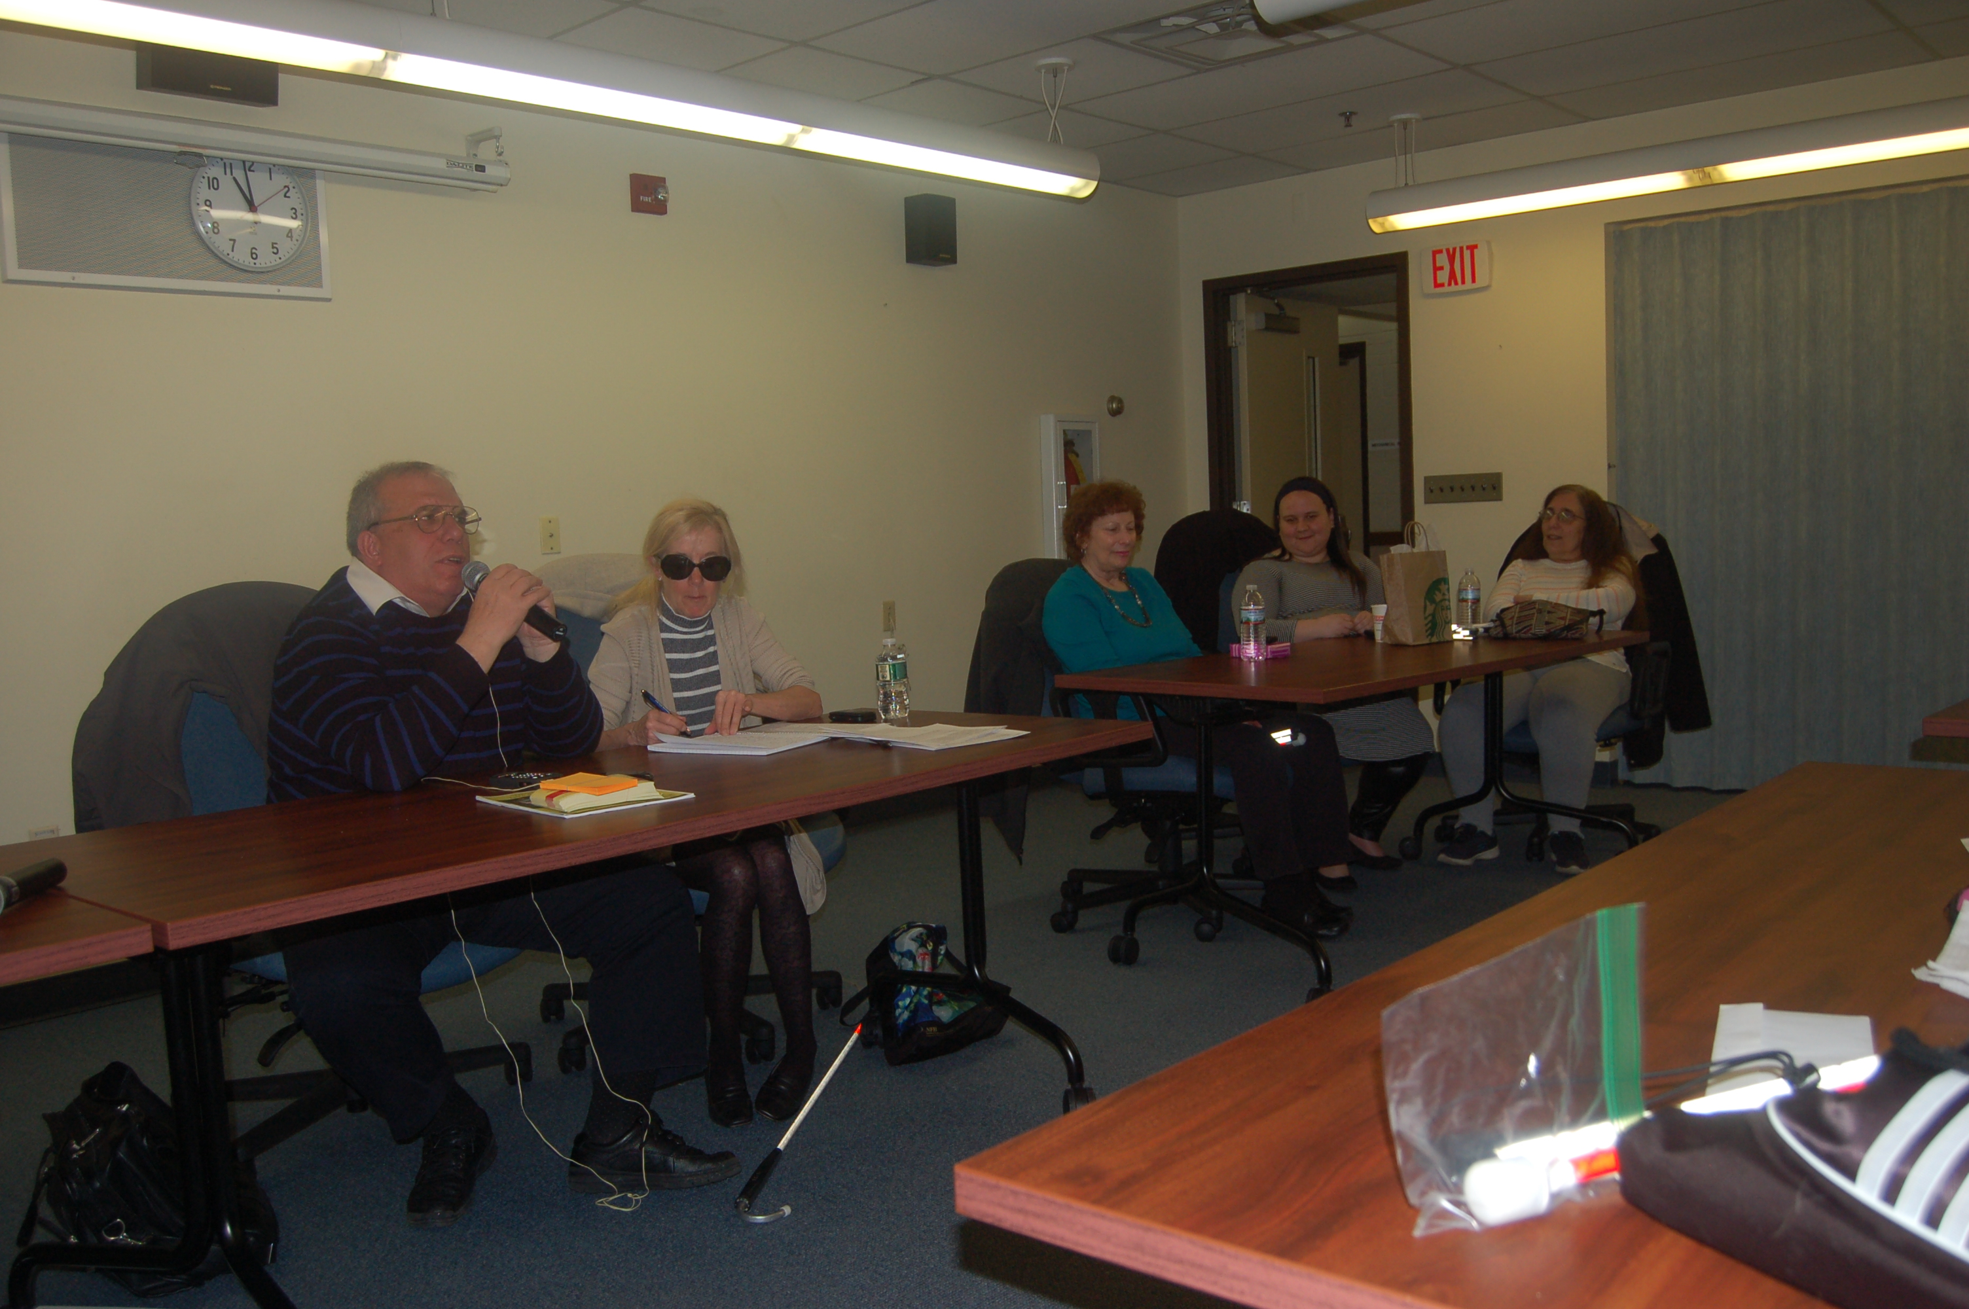
Our New Jersey affiliate took a giant step forward in helping to build the National Federation of the Blind with an intensive leadership workshop March 24 at the Joseph Kohn Training Center in New Brunswick. The 39 participants represented our seven chapters, nine divisions and one committee. The leadership training followed a morning-long regular meeting of the NFBNJ Board of Directors. Two board members participated by phone because of health or family obligations.
Joe Ruffalo, NFBNJ state president, pictured at left in photo above, along with other New Jersey leaders, noted that the event was designed to expand and share leadership roles among affiliate members who already have demonstrated active participation and incentive on the local level.
“Strengthening our leaders makes for a stronger affiliate and a stronger Federation overall,” Joe said. “We want to give our members tools and techniques they can use in active leadership roles. This training and planning doesn’t end on March 24; it will continue throughout the immediate future.”
Facilitating the leadership workshop was Mary Fernandez, NFBNJ Board member who is on a 6-month contract in the NFB’s Membership Development Office in Baltimore. She will enter the MBA program at Duke University in the fall.
Participants were randomly divided into teams of six, and each team then started a fun exercise in teamwork. With each person wearing sleep shades, teams worked to inflate balloons and then use masking tape to create a free-standing structure. The exercise also served as an ice-breaker to acquaint all team members
Each of the six teams was then assigned a specific topic area including fund-raising, expanding membership and use of social media in promoting our state affiliate. The teams discussed priorities, resources needed for success and other factors within the context of their topic areas. Finally, each team designated a spokesperson who summarized the group’s discussion of each of the assigned questions.
All participants subsequently received a follow-up packet from Mary which included minutes of the workshop and a summary of the NFB’s brand identification specifics – all the factors that make the NFB a consistently identified “brand.”
Each group has been asked to complete an action plan based on their topic discussions, including a time line and estimates of resources needed, as well as elements that will define the project’s or action’s success. It is expected that additional meetings by phone or in person will take us to the next step in making the NFB more familiar to the disability community and the public in general.

SAVE THE DATES FOR BELL 2018
By Mary Jo Partyka

The bells will be ringing again as the NFBNJ sponsors its fifth Braille Enrichment through Literacy and Learning (BELL) Academy on weekdays from 9 a.m. to 3 p.m. July 16 to 27, 2018 at the Puerto Rican Association for Human Development (PRAHD) located at 101 First Street in Perth Amboy, NJ. Parents will be required to transport their children to and from the facility each day and to provide them with lunch, unless otherwise specified. There is no cost or registration fee for children to attend this program.
The purpose of the BELL Academy is to provide instruction in Braille and Activities of Daily Living (ADL) to children ages 4 through 12 who previously lacked the opportunity or had minimal exposure to these key skills that are so critical in their educational and future development. Highlights of last year’s program include: Working with model trains, building toolboxes, enjoying hands-on activities at the Turtleback Zoo, building motorized cars and helicopters with Legos, playing goalball, and participating in scientific experiments pertaining to chemistry and magnetism.
Besides learning their lessons, the children will have a chance to form friendships with the students in their classroom and will have the opportunity to interact with sighted children who attend the PRAHD’s own summer program. Blind mentors and volunteers will work with the children and provide excellent role models, keeping expectations high and proving that blindness is not the characteristic that defines their future. The goal of the BELL Academy is to enable the children to live the lives they want through upbeat and positive attitudes, skills and experiences provided by BELL staff.
To complete or review the BELL Academy application for 2018, please visit https://nfb.org/BELL-student-application-form. You can also read the Affiliate-Specific Frequently Asked Questions brochure for New Jersey at https://nfb.org/BELL-Academy/FAQS-affiliates-New Jersey. For more information, please contact Mary Jo Partyka, our State Coordinator, at choirnfb@gmail.com or by phone at 609-888-5459.

NFBNJ SCHOLARSHIP WINNERS ANNOUNCED AT 2017 STATE CONVENTION

Mary Fernandez, chair of the State Scholarship Committee, has announced the winners of the 2017 NFBNJ state scholarships. Congratulations to each of the following:

Sena Pottackal: Tom & Gail Ferry Memorial Scholarship
As a scholarship winner, I was connected with a wonderful mentor. I hope to continue cultivating this valuable relationship. Additionally, this event gave me the opportunity to network with other blind individuals, familiarize myself with innovative adaptive technology, and learn about proposed legislation affecting the blind community. I am glad I attended this convention and look forward to participating again next year.
Losing my vision as a teenager presented many challenges. However, I developed strategies to overcome these obstacles and recognized I could not forge my dreams into reality without completing a college education. After graduating summa cum laude from Rowan University, I continued my pursuit of higher education at New York University, which has one of the best public relations master’s programs in the country. Ultimately, I aspire to use PR to make a positive social impact by changing the public perception of what it means to be disabled in this country.
While pursuing my goals, I am diligently working to create opportunities for my disabled peers to accomplish their own aspirations. As a member of student government, I am collaborating with others to improve NYU’s disability services. Specifically, my goal is to create an academic environment in which disabled students can truly persevere and excel.
My educational pursuits would not be possible without generous support from scholarship sponsors like your family. Thank you for enabling this opportunity.

Claress Knight: Louise & Pete Facchini Scholarship
I am honored to be one of your scholarship recipients. I can't tell you how thrilled I was to have received the news of this wonderful opportunity! As a first-time attendee at the State Convention, I enjoyed meeting new people and catching up with those I have not seen in quite some time. Also, it was a great opportunity for me to attend meetings. Each one has inspired me in many ways.
I loved how each speaker took their time out for us by sharing their stories as blind individuals and strategies on how to overcome a situation. For example, I have learned that as a blind person, it is OK to fight for the rights I need, as well as any other human being. All of the meetings taught me something new. I learned so much about technology and how accessible it is for the blind.
Now that I have attended my very first State Convention, I am more educated on what the National Federation of the Blind is all about, and I am very happy to be involved in the activities that will help me live the life I want as a blind individual. Last but not least, it was my pleasure meeting you. I am glad that we had the chance to get to know each other and share our life experiences. Once again, I thank you for your generous donation and giving me the opportunity to spend some time with my Federation family.

Andrew Chin: Klaus & Michelle Zechner STEM Scholarship Award
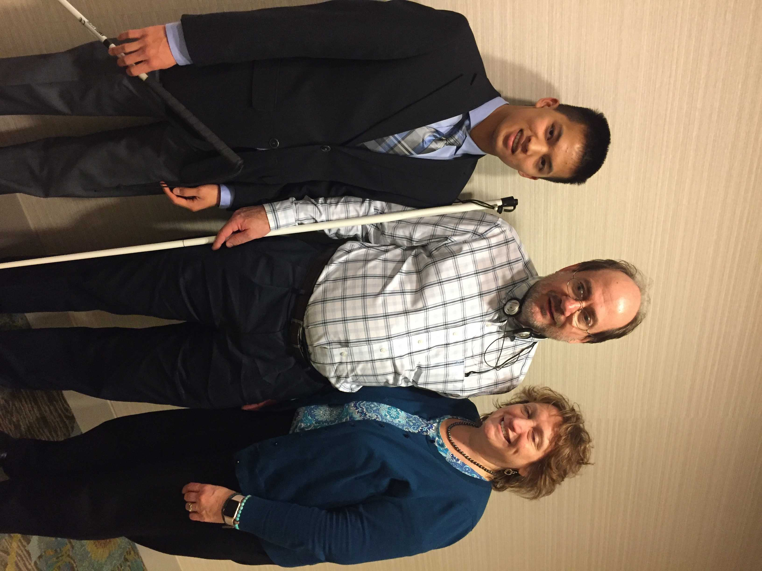
I am honored to receive a scholarship from the NFBNJ. This will help me in my expenses of attending college, especially since I am in a 6-year doctorate program. I am enjoying my classes and the experiences of college life.
I have learned so many things since attending the NFBNJ State Convention. This was my first time attending, and it was wonderful meeting so many successful blind professionals. It was also great meeting people who are successful in the STEM fields, since there are such a small percentage of blind people in these fields. It makes me even more determined to complete my degree and be able to help others be successful as well.
Meeting so many people who are successful and who are blind and living so close to me is one of the highlights of the State Convention. It is hard sometimes being blind and not having anyone that you can talk to about problems and how you are feeling. To be able to meet other people my age and who are living a successful life means so much to me. It gives me hope and encouragement that I can also do well and live a fulfilling life.
I want to embrace the NFB’s ideals that blindness does not define who I am or my future, but that my high expectations will make my dreams become a reality in the future.

Alyssa Shock: Tara Carty Memorial Scholarship
Thank you for awarding me the Tara Carty Memorial Scholarship. I feel extremely honored to be the recipient of this scholarship. I am currently a senior at Fairleigh Dickinson University. After graduation, I plan to obtain a graduate degree in clinical mental health counseling or school counseling. The scholarship will be used to assist me in achieving this goal.
I also wish to thank you for the wonderful opportunity to attend the State Convention. As a National Scholarship winner in 2017, I attended the National Convention, and as I was preparing to attend the State Convention, I found myself wondering whether it would be just as memorable as the national one. As I expected, there were differences and similarities between the two conventions. The State Convention was smaller, and the focus was on issues and items of interest specific to New Jersey. However, the State and National conventions were also alike in many ways. Speakers and mentors at both conventions affirmed my belief that I can live the life that I want. At both conventions, I learned about barriers faced by those who are blind, and ways the NFB is attempting to overcome these barriers. With this in mind, the biggest thing I discovered while attending the State Convention was that the NFB is truly alive and well in New Jersey. To put it another way, the New Jersey State Convention was just as memorable as the national one.

Ilire Goca: Dr. Ed Lewinson Scholarship Award
This scholarship has landed me one step closer to the next chapter in my life: College. I will be attending Kutztown University in Pennsylvania, majoring in special education and becoming a teacher of the visually impaired. My ultimate goal is to not only be a teacher, but also a mentor and role model. I aim to teach the importance of braille in everyday life and independence, and to encourage students who are blind to strive for the best and become successful in their lives. I am so grateful to the Scholarship Committee for giving me the opportunity to receive an NFBNJ State Scholarship.
I was honored to join the NFBNJ community at the 2017 State Convention, as I have been wanting to attend a State Convention for a long time. I met so many people from many walks of life, and I made plenty of new friends. I was especially glad to become an active member of the New Jersey Association of Blind Students. The student meeting was very informative and engaging. As we discussed accommodations, everyone in the group related to each other in some way or another, being that we are either preparing for college or in college already. I am proud to be part of this division because the focus is on making a difference in the lives of college students who are blind and visually impaired. I was impressed by the dedication and engagement of the speakers, and I was honored to have the opportunity to introduce Daniel Frye. He is an inspiration to me, and his words are always very personal and relatable. In conclusion, I want to thank the NFBNJ and the Scholarship Committee. Overall, I had an amazing time at the State Convention this year, and I would definitely consider attending again next year.

THE PAC PLAN
By Brian Mackey

Greetings to my fellow Federationists throughout the New Jersey Affiliate! This is your friendly neighborhood PAC Plan chairman, and this is my update on how we are doing with our contributions to this very important program.
As most of you know, “PAC” stands for “Pre-Authorized Contribution,” and the plan is the easiest way for NFB members to make regular donations to our organization. It’s easy because it’s a one-time process to sign up, and it’s easy on the wallet because you can contribute as little as $5 a month ($0.17 a day). It’s important because it helps fund the programs and activities that are so vital to the success of blind people. It helps with providing free literature, free white canes, free slates and styluses, educational and outreach programs, assistance with fighting legal battles, free web hosting to state affiliates through nfbnet.org and much more.
In terms of our ranking among the states, as of February 2018, we are in 23rd place, with a monthly contribution of $589.50. This amount comes from the generosity of 41 individuals, chapters and divisions. I wish to thank those who help the Garden State make such a fine showing; however, we can definitely do more to climb the ladder. We are only $40.50 behind Illinois, and we trail Washington by a mere $88.50. If we pass Washington, it would put us over $680 a month and solidly in the Top 21.
Thanks to modern technology, signing up on PAC is significantly easier than it has ever been. Since 2015, you can create or increase your PAC contributions by using an online contribution form. Donations can be taken from either a checking account or a credit/debit card. To get to the online form, go to https://nfb.org/make-gift and then click on the “Pre-Authorized Contribution (PAC)” link. You can choose to start a monthly contribution or increase an existing one, select your payment method, and fill in the corresponding information right there. You can then print out the form, sign it and send it to NFB’s National Center and to the attention of their accounting department.
Making these regular tax-deductible contributions, and encouraging your friends, family, fellow Federationists, neighbors, etc. to join as well, would show how important the National Federation of the Blind is to you, and would demonstrate how proud an affiliate New Jersey is, so as the song says, please … get on the PAC Plan. Sign up today!
Can we raise our expectations on our PAC contributions by going at least over $650 a month? We will find out after the national convention.
What Is the DeafBlind TSA Experience?
Come Along with Alice Eaddy and Find Out

As told to Barbara Shalit

What does it take to immerse the Transportation Security Administration (TSA) into my world of travel fear and the DeafBlind communication experience? When is it appropriate to separate a consumer from communication access devices in the name of a security check?
Come along with me and discover my world as a person who has limited sight and hearing. This story started when I lodged a complaint of poor handling of a DeafBlind consumer – me – on a July 16th flight after the 2017 NFB National Convention. Not only did I miss my flight home, but my ride, as well. I ended up routed home by way of St. Louis to Philadelphia. Coincidentally, at the National Convention, the DeafBlind Division had hosted a panel on travel, and one of the speakers was from TSA. I notified this individual about my difficulties, and was referred to Susan Buckland, Senior Policy Advisor, TSA Disability Branch. Susan and I discussed my experience, and she then invited me to an upcoming disability and medical conference – the TSA Annual Coalition Conference – in Arlington, Virginia. I was thrilled to attend, but knew that my journey would take research and preparedness.
I began by checking out the hotel and its location, and adding that information to my White Pages app. Using another app, Trip Planner, I input key information for route and best transportation modes. I packed my bag as I do when I’m flying, including a prepared “canned” disclaimer in my Speak2See app that says, “Please note that I’ve photographed the position of all items within. If an item is removed and examined, please return it to its original location.” (It’s a good idea to call 72 hours prior to traveling with questions about screening policies, procedures and what to expect at the security checkpoint.) I booked Amtrak, registered with the hotel, and made sure I’d remember to carry my email and conference invitations to the event.
And then I hit a roadblock: Access Link’s inability to accommodate a 4:30 a.m. pickup from my home to the Philadelphia train station. So, instead, the night before, I took a New Jersey Transit bus at 8:15 p.m. to Philadelphia, then another bus at 11:09 p.m. to the train station, stayed overnight there, and then took the 6:30 a.m. train to Washington, DC. My biggest challenge after arriving in DC was my first-ever trip on the Metro from DC into Virginia.
All went well, and I arrived at the conference safe and sound. My initial TSA contact, Susan, was there, searched me out, and we ate lunch together. I used my Speak2See app to order.
During the conference, I demonstrated several apps, including the free ShowMe for Emergencies and ShowMe FAC, which are picture-based communication tools. The conference folks really liked them and wanted to take components for use with other travelers with disabilities. TSA has Braille copies of the questions TSA typically asks during a pat down; these can be requested by travelers in advance. (Also available in advance is the TSA Cares Helpline that provides travelers with disabilities, medical conditions and other special circumstances with additional assistance during the security screening process.)
Two Passenger Support Specialists from local airports thanked me for showing them my communication cards. The cards were a revelation for them, which may indicate that DeafBlind travelers aren’t using them. They welcomed ideas to ease communication and reminded me that they provide on-the-spot assistance.
Airports and train stations inherently have things that cause interference to my equipment. I explained that even simple x-rays at the dentist office can fry my hearing aid from the inside out. Also, I let them know that it’s invasive to me when I’m asked to send my phone through the scanning machine because it truly is my only means to communication. Most agents do not seem to understand that. They hand-swipe my ComPilot, Roger Pen and Mini Mic, items that are irreplaceable and provide a coordinated listening environment for me. I easily feel robbed when I am without them.
During the conference, I also talked about having used the Sprint IP Relay app to coordinate my travels, since it’s hard for me to hear on my phone anymore. Using the IP Relay, I can be called via my relay app phone number, and messages arrive in my email in-box.
I learned that the TSA experience is often specific to the airport you’re visiting. I also perused the booths at the conference, which included customer relations service (DOJ), customer service branch (TSA), Diversity and Inclusion Division (TSA), Transportation Security Redress Branch (TSA) and more.
I had so much fun! I didn’t talk a lot, but made what I said count. They provided CART (Communication Access Realtime Translation) services and three rotating interpreters for me, and I’m now a Coalition member, too.
So there you have it, a chance with some drama creating an opportunity to open dialogues about the travel and etiquette needs of the DeafBlind consumer when dealing with TSA representatives.
If you need to file a complaint, contact: Susan Buckland, Senior Policy Advisor, Disability Branch/Office of Civil Rights and Liberties, Ombudsmen and Traveler Engagement, Transportation Security Administration, Department of Homeland Security, phone 202-684-5002 (text only) or email: Susan.buckland@tsa.dhs.gov.
THANKS FROM JEHOVAH’S WITNESSES:
VOLUNTEERS & VENDOR AT STATE CONVENTION
By Janet DiNola Parmerter

On behalf of my British friends and my husband Keith and myself, I would like to say thanks for the opportunity we had to exhibit at your NFB State Convention. We certainly felt privileged to be represented at your well-organized event, and my British buddies really loved meeting you, Joe, and hearing your unique “Joe Ruffalo” humor.
In addition, all the volunteers expressed their heartfelt thanks for the privilege of sharing in such a productive community service for the National Federation of the Blind.
Many attendees at the event, as well as the hotel staff, warmly thanked the volunteers who freely offered their time from busy weekend schedules to be there for the blind community.
When attendees approached our table, we were thrilled with the prospect of freely giving individuals information for themselves or other family members. Many who came to the table expressed gratitude for our presence, and repeatedly thanked us for the free books, Braille and audio items distributed to everyone.
Being able to make spirituality accessible to the blind was a rewarding experience.
In addition, making it available without cost to the individual, and in whatever format they use to read, including Braille, audio, large print or downloads gave us a deep feeling of satisfaction.
So, even though it took us 19 hours to pick up Roger and Jean in Kentucky, then drive to New Jersey, those we spoke with made everything worthwhile. They certainly touched our hearts with joy, and we feel confident we touched their lives with a measure of peace and pleasure. Hopefully, they left the table with something we all need: Comfort, hope and a positive outlook for the future.
For all the above reasons, we feel the conference was a huge success for everyone involved! Roger said you are a delight, and he LOVED New Jersey, especially seeing it from my Italian viewpoint. He thought you were just charming. Because the British can be a little straight, you were a real change. He always thought it was just me, but he learned what New Jersey Italians are really like. We introduced him to a lot of new things. His wife thought a pizzeria was the name of a restaurant. (Smiley face)
Have a very good year, and we look forward to seeing you in July at the summer National Convention.
MEET THE NFBNJ’s SPORTS AND RECREATION DIVISION
By Linda Melendez

Editor’s Note: Linda Melendez currently serves as president of the Sports & Recreation Division of NFBNJ and as a member on the State Board. In addition, Linda is a member of the At Large Chapter, as well as the Braille, Seniors and Technology Divisions. She also shares her personal exercise routine at the end of this article.

My motto is CPS: Communicate, Participate and Share. The sky's the limit and you are stronger than you think you are. Let’s get out of the comfort zone and start participating in the sports and recreational activities we desire. I am looking forward to a new beginning of raising expectations and living the lives we want.
During the 41st NFBNJ State Convention in November 2017, the Sports and Recreation Committee was elevated to an official division, thanks to the enthusiasm and engagement of our members. The purpose of this division is to encourage participation in competitive sports, as well as recreational and spectator activities, on the state, local and individual levels. We also aim to build the NFBNJ and its philosophy by sharing and promoting our activities among other blind/VI people.
I have the honor of being elected the division’s first president. Other officers include Annemarie Cooke, vice president; Brian Mackey, secretary; and Geri McGinty, treasurer. Board members are Michael Benson, Misty Hagan and Tony Santiago. Membership is open to New Jersey residents interested in competitive sports, athletic activities and spectator events, as well as accessible cultural events on an equal basis with our sighted peers. We meet the third Wednesday of the month by conference call at 8 p.m., January through October and in December. We also hold an annual meeting in November at the State Convention. By paying annual dues ($5 as of this writing), and being an active member of the division, you are eligible to make motions, vote, serve on committees, be elected to a board position and receive messages through our email listserv. Most of our membership is blind, but we also accept interested sighted individuals who share our philosophy, interests, rights and responsibilities. As of March 2018, the Division has 52 members. Details of our scheduled meetings and activities are posted online at www.nfbnj.org/sports-and-recreation-calendar. Our calendar can also be accessed through Newsline.
Our division plans at least one state event annually. So far this year, we expect to participate in the National 6 Dot Dash Walk/Run in Baltimore on Sunday, June 3. We’ll all stay overnight at the Jernigan Institute and share the cost of transportation, meals and incidentals. Each participant pays a $30 registration fee which benefits the national office.
In June we are planning a Summer Get Yourself Moving Personal Challenge. You get to choose the challenge, physical or otherwise. To mark October as Meet the Blind Month, we’ll organize a Sports and Recreation Division Step Challenge. Names of all participants who achieve the goal will be entered into a drawing for a prize to be determined.
Be sure to check the Sports and Recreation online calendar of events periodically, as we are always adding events. In addition, to ensure inclusion and effective communication, we have appointed Chapter Captains who are starting to plan and hold local events. Look for news of their local activities in the next edition of The Sounding Board. We have also appointed Sports and Recreation Division coordinators who will share our news with the other NFBNJ divisions. Beach Coordinators will set up beach days along the shore during the summer. Lastly we have established a Reminder Call Committee, Membership Committee, Correspondent Committee, Fundraiser Committee, and a New Activities and Events Committee. For additional information or to become a member, please contact me at lindamelendez220@gmail.com.

LINDA’S PERSONAL EXERCISE ROUTINE
By Linda Melendez

Learning to like regular exercising has improved my physical health and my overall outlook on life. Maybe it’s the release of endorphins, those chemicals that tell my brain I feel good, but I know exercise and eating with care definitely improve my overall sense of well-being. I started this journey over four years ago, and it has taken dedication, focus, and commitment to achieve and maintain my goals. I use the Monmouth County paratransit system to get to the gym, and after a few orientation classes at the gym, it was full steam ahead.
I work out three to four times a week to maintain my hard-won 100-pound weight loss. I try to do at least 30 to 45 minutes of cardio during each workout session on the arc trainer (a stepping machine), an elliptical machine or a treadmill. At my gym, the staff knows I am visually impaired, and they help me when I request it. During each workout session, I also do at least one hour of strength training, concentrating on different parts of the body. For example, Day 1: chest and triceps, Day 2: legs and abs; Day 3: back and biceps; Day 4: shoulders. I also do a 30-minute full body circuit workout, which is a combination of cardio and strength training. On my non-gym days, my goal is to walk at least 10,000 steps per day, or about five miles.
Meal preparation and portion control is vital to weight management and a healthy lifestyle. Also, walking 10,000 steps a day helps to keep a balance of calories eaten and calories burned. Think about the number of calories you’re burning by exercising compared to the number of calories you are taking in through food and drink. Burn more calories than you ingest, and you'll lose weight.
I cannot stress enough the importance of properly fitted walking shoes. My feet are difficult to fit with comfortable shoes, so I spent a fair amount of time at a store that specializes in running gear. The sales person took molds of my feet while I walked and ran on a treadmill. I also bought inserts that provide a custom fit to
prevent blisters and chafing.
To keep track of your steps, use the health app on your iPhone or use an activity tracker such as a Garmin, FitBit, Apple watch or a pedometer. Talking pedometers can be purchased for less than $15 through the NFB Independence Market (410-659-9314). I prefer using a Garmin device. I urge everyone to check with your primary doctor before implementing a workout regimen or including new foods into your diet.
It’s also important to stay hydrated. Drink water during and after working out. Also, eat some protein 30 to 90 minutes before each workout session. I enjoy my green smoothie after my workouts or during the day to curb my appetite; my Healthy Green Smoothie recipe appears in the Recipes Section of this Sounding Board edition. If you strength train, it is also recommended to eat protein immediately afterwards. I typically have a protein drink or bar. On my high cardio workout days, I eat half of a banana afterwards, and the rest of the banana goes into my Healthy Green Smoothie.

BACK ON THE AIR!
By Ken Lawrence

Hello fellow Federationists and music nuts! After a very tough repair of my computer, which included wiping the hard drive, I have started getting a music library back together. I still have more music to rip back onto my machine, but I have enough material that I can do a show again. So, starting at 9 a.m., tune in to Out of Sight Net Radio for the return of my rock and soul review. You can listen online at www.out-of-sight.net/radio and you can also listen on your Victor Reader stream since we are on the otunes database. We are now also on Tune In Radio for your iPhone or for your Echo or Dot. Just tell Alexa to play Out of Sight Net Radio. Remember: Don’t say “Out of Sight dot net” or you’ll confuse Alexa. Requests can also be made at radio@out-of-sight.net. I’d say there is at least one show better than mine. The Tuesday morning Best of British with Pete is, I think, the best show on the station. In fact, the one day I’m not on is, I think, our best one-day lineup. My show is Monday, Wednesday, Thursday and Friday at 9 a.m., and I conduct Sunday services in the Church of Rock and Soul at 2 p.m. Log on to the site and check out our weekly schedule: http://www.out-of-sight.net/index.htm
A SPANISH COMMITTEE COMES TO NEW JERSEY
By Rosa Santiago

Editor’s note: Rosa is a writer and business owner. She enjoys singing, dancing and hosting dinner parties for friends and family. Rosa loves contributing to great causes and is an avid reader of books. She finds pleasure in traveling, hiking, and taking in the sun and waves at the beach whenever she gets a chance.
The exciting possibility of establishing a Spanish Committee in New Jersey developed at the 2016 NFBNJ State Convention. That year, our national representative was Everette Bacon, from Utah, who also serves on the National Board and is president of the Utah affiliate. Everette spoke of a flourishing Spanish Committee in Utah, and thought that starting one in New Jersey might be beneficial.
This sounded like a great opportunity to the New Jersey Affiliate. President Joe Ruffalo asked if I would consider heading this committee since I was fluent in both Spanish and English, and had leadership experience as a business owner. I accepted the challenge, and with the help of President Ruffalo, the State Board, and fellow Spanish-speaking members, the New Jersey Spanish Committee was launched in March 2017.
The prospect of providing Spanish-speaking blind adults and parents of blind children with the support, information and assistance they need in a language they understand was the main reason for forming this committee. The hope of progress and independence the Spanish Committee could offer to many individuals would open a new path to improving their quality of life. Moreover, by being a part of the Spanish Committee, Spanish-speaking individuals would be in the best position to learn and grow with a Federation that believes wholeheartedly in helping to create limitless possibilities for all blind people.
The benefits of being part of the Spanish committee are many. One of our goals includes raising money through fund raisers so that we can provide blind individuals with scholarships to be used for training, equipment, attending National and State conventions, and other endeavors to significantly help build independence. In addition, through our monthly conference calls held the first Wednesday of the month at 8 p.m., the Spanish Committee believes that empowering blind individuals to have the confidence to meet their challenges head-on will make a difference in their everyday lives.
Today, after only a year, I am proud to say that we are moving forward towards accomplishing the intentions set out for forming the Spanish Committee. For example, in 2017, we had a fund raiser where much support was received from the members of this committee. In 2018, we are making plans to put together more fundraisers to reach the goals we have set out to achieve. We have also established subcommittees for outreach, fund raising and social functions, with the aim of attracting new members, forging strong relationships with persons in our community who can help support our cause, working to raise funds that will provide practical solutions to the needs of blind individuals, and utilizing communication channels such as social media and email to develop a presence that will enable us to help spread our message.
I’m pleased to report that the Spanish Committee is growing and new people are attending our monthly meetings. One of our new members is Ariel Mina, a former police officer, who arrived in New Jersey from Columbia several months ago. Ariel joined the Spanish Committee, and since then has been assisted to receive services by the New Jersey Commission for the Blind, has become a member of the National Federation of the Blind, and is now a member of the Northeast Chapter. This courageous individual, who survived a shot in the head during combat in his country, is taking every opportunity to improve his life in America. He is learning the English language, and has even taken it upon himself to join a gym near his home so that he can work towards becoming independent as a blind person.
It is truly inspiring to see the potential growth and expansion that is possible for the Spanish Committee. Through our monthly discussions, outreach programs, fund raisers, generous support from our members and other supporters, our present and future goals are absolutely achievable. Former President Ronald Reagan said it best when he stated, “There are no constraints on the human mind, no walls around the human spirit, no barriers to our progress except those we ourselves erect.”
The love, commitment and determination that is evident in the team that forms the Spanish Committee is the actuating force that will make us a real success today and for years to come.
As chair of the Spanish Committee, I am happy to serve a cause for which I believe there is a strong need in the State of New Jersey. Giving my time and energy to support a committee that has the potential to grow, especially one that provides ways to assist blind individuals with language barriers as well as to provide guidance to blind children, is worth the time spent as they achieve independence and become empowered to live the life they want.

​​
​

Raising Awareness, Enhancing DeafBlind Services Through Collaboration
By Carly Fredericks and Kathleen Spata
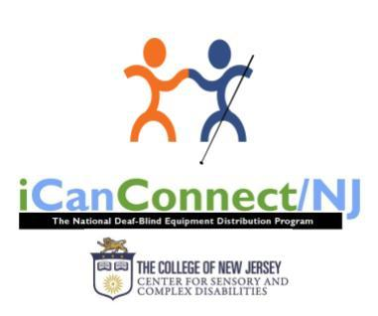
Blind or visually impaired New Jerseyans who also are losing their ability to hear may be eligible for two programs that can keep them active and involved in their communities. First, iCanConnect/NJ (iCCNJ) provides free communications equipment and training to help them stay connected with “friends, family and the world.” Second, Support Service Providers (SSPs) relay visual and environmental information, act as human guides and facilitate communication for people who are DeafBlind. These programs are funded through the NJ Commission for the Blind and Visually Impaired, are based at The College of New Jersey’s Center for Sensory and Complex Disabilities in Ewing, and work together to promote independence and full participation in the community.
It’s a common misconception that the term “DeafBlind” means a total loss of both vision and hearing. An image of Helen Keller may come to mind. However, the term “DeafBlind” also applies to those with varying levels of hearing and vision loss, not just total deafness and blindness.
We’ve learned from those who are culturally Deaf and rely on their vision to communicate through American Sign Language that it’s difficult to imagine life without vision. Similarly, people who identify as blind or vision impaired, who typically accessed information auditorily, often haven’t considered the impact of both sensory losses on everyday living.
Senior adults, who make up a large number of our consumers, have made it clear that the term “DeafBlind” is not in their vocabulary, even though they often meet the eligibility criteria for this definition. And, largely, from those who grew up hearing and sighted, but lost the functional use of their senses due to health, genetic conditions or age, we have learned the value of collaboration and importance of braiding together services.
For some, it has been through our outreach efforts that a person finally felt comfortable, and it became a moment of accepting a new identity.
So what are some examples of how our collaboration works? Learning a new technology, including software and other resources provided through iCanConnect is not easy, especially when a consumer cannot clearly hear or see what is before them. So, an SSP professional skilled in the means of communicating with that client, be it through sign language, hand-over-hand demonstration or another method, can facilitate that technology training.
Another example is when DeafBlind consumers can access notices of community events and activities through their technology, but they face challenges when interacting directly with others in their community. It can be frustrating to learn about an upcoming event and then have to wonder how they’ll be able to participate in the activity. Enter, SSPNJ program! The DeafBlind consumer utilizes their iCanConnect technology to contact the SSPNJ program to request the services of a SSP. The SSP is the “eyes and ears” for the consumer and can relay vital information to the consumer. The SSP has the responsibility to provide access to the information so the consumer can make their own informed decisions.
For more information or to learn about eligibility requirements, please contact iCanConnect at email carly.fredericks@tcnj.edu or call 609-771-2711; and for SSPNJ, email ssp.nj.tcnj@gmail.com or call 609-771-2795.

MY FIRST OFFICIAL RELEASED ALBUM
By Bryan Woolbert

Editor’s Note: Bryan is a member of the South Jersey Shore Chapter. He is a gifted musician and talented with computers.

I am thrilled to let everyone know that my first EP (Half Album) containing six original instrumental pieces was released in January. It is titled “Sounds of Nature: Songs from Dreams & Inspirations.” It has been released on iTunes and Apple Music, and is available on Amazon Music:
https://www.amazon.com/dp/B078X2RPF4/ref=cm_sw_r_cp_api_QxwwAb0TA032W
Please note that iOS users should use Safari to purchase and download the music; do not use Amazon App or it will not work:
1. Open Safari
2. Go to amazon.com
3. Search my name Bryan Woolbert
4. Navigate to the Album
5. Purchase and download. Amazon MP3: Sounds of Nature: Songs from Dreams & Inspirations
Here’s a link to the album on Spotify: https://open.spotify.com/album/58O9qdUbS2d2csL8RStFdk?si=oPmcmHeUTkSGbqTHL881og
You can also purchase the album and download it through CDBaby: https://store.cdbaby.com/cd/bryanwoolbert#.WllnA26HBxE.mailto
Thank you so much, and hope you enjoy this brand-new music!!
GET YOUR FREE WHITE CANE!

To date, the National Federation of the Blind has provided more than 62,000 free white canes through the Free White Cane Program. As the Federation’s website says: We believe the long white cane is a means to independence. The white cane has proved a useful tool to millions of blind people in navigating their environments with confidence and safety. It is a tool which allows blind people to travel where and when they want, and as such, leads to self-sufficiency.
Anyone who is blind in the United States and Puerto Rico is eligible to request a free, rigid, fiberglass cane for their personal use. Requests can be submitted as often as every six months. Sue Roberts is someone who recently discovered the Free White Cane Program:

“I recently ended up on your distribution list. I believe that occurred when I ordered a walking stick (sic) for my Dad. My Dad lost most of his vision a few years ago and is legally blind. He is having a very hard time accepting his loss of vision in his early 70s. I just want to thank you for all you do. Being on this distribution list has given me insight into a whole world of resources and information for visually impaired, associated services, legislation and other very interesting information. Going forward I hope to share this information on a regular basis with my Dad. With four teenagers my life is a little busy, but I do look forward to learning more about NFBNJ and all you do.”

NFBNJ President Joe Ruffalo reports that once he’s notified of someone in the state’s receipt of a cane, like Sue, he follows up with a personal phone call. In Sue’s case, Joe offered information on Newsline, which enables the subscriber free access to more than 400 newspapers and magazines, television listings, the weather, grocery store ads and more. As Sue says, the NFB offers a world of resources and information.
To find out more about the Free White Cane Program and to obtain an application, please visit https://nfb.org/free-cane-program. The website offers the following information on how to determine the length of your cane:
- For adult first-time cane users, we recommend measuring from your shoulders to the floor. The cane needs to reach a good two steps in front of where you are stepping. The speed of your pace and length of your stride will make a difference. More seasoned cane travelers may wish to have a longer cane, measuring at least chin height.
- For children, teens and young adults who are first-time cane users, we recommend measuring from your chin to the floor. More seasoned cane travelers may wish to have a longer cane, measuring at least nose height.

Parents of Blind Children – NJ
23 Alexander Avenue  Madison, NJ 07940 (973) 377-0976
blindchildren@verizon.net www.blindchildren.org

Parents of Blind Children-NJ began in 1991 in the home of one of our founding members. Six families decided that evening to help other families learn what they needed to know to create opportunities for their blind and visually impaired children and help them learn and grow. We began with a mailing list of 34 names. Today we number over 600!

Our goal is to help blind/visually impaired children grow up to be productive, fully functioning, independent members of society and to help blind/VI children with additional disabilities reach their full potential.

POBC-NJ offers:
- Emotional support, information, referrals, training and advocacy
- A positive attitude toward blindness/visual impairment and the abilities of blind/VI people
- Networking and contact with other families and with blind/VI adults
- The In Touch newsletter and Future Reflections magazine, full of practical info and tips
- The Blind Children’s Resource Center website – visit us at www.blindchildren.org
- Activities for parents, teacher and children
- A voice on state and national boards and ongoing interaction with legislators to work toward improving services and increasing opportunities for blind/VI children
- Affiliation with national organizations offering the resources, information and support of 50,000 blind/VI adults and parents of blind/VI children across the country
WE’RE HERE FOR YOU! Call, write or email anytime.

Please mail this form to POBC-NJ 23 Alexander Avenue Madison, NJ 07940
Parent’s Name/s _________________________________________________________
Phone (_______) ____________________Email ________________________________
Address_________________________________________________________________
Child’s Name _________________ Date of Birth ________ Eye Condition ___________
Today’s Date _________ _____ $10 Dues enclosed (Make check payable to POBC-NJ)
Please send me the following FREE literature packets:
__ Blind Students in the Elementary Classroom __Braille Literacy (Children)
__ Program Brochure Packet __ Cane Travel/O&M (Children)
__ Early Childhood __ Individualized Education Program (IEP)
__ Low Vision (Children) __ Multiply Disabled/Blind (Children)
__ Blind Teens __Social Skills (Children)
__ Parents of Blind Children
FROM THE KITCHEN OF THE SPORTS & RECREATION DIVISION

HEALTHY GREEN SMOOTHIE
Submitted by Linda Melendez

Linda is president of the Sports & Recreation Division and a member of the State Board.
Serves 1
Ingredients

8 ounces coconut water (NOT sweetened cream of coconut)
4 strawberries (I prefer frozen because they make the drink colder)
½ of a small banana
½ tsp Flax, Chia and Hemp seeds combined
A healthy handful of baby spinach
Few pieces of kale

Directions
- Blend all ingredients thoroughly into a liquid
- Chill and enjoy!
Please note that too much spinach and kale will make the smoothie too thick.

CHICKEN SURE TO PLEASE (In Approximately 30 Minutes)
Submitted by Ellen Sullivan

Ellen is new to the NJ Affiliate. She hates to cook. She was a member of the Delaware Affiliate until her recent move to NJ. She is happy to be a member of the NFB and has grown in her independence since joining!

Ingredients

2 boneless chicken breasts, split, and floured, salt and pepper
1 Delicious or Granny Smith apple, thinly sliced
1 Tablespoon lemon juice (or squeeze ½ lemon)
3 Tablespoons of maple syrup
2 Tablespoons of butter

Directions
- Sautee floured chicken breast in butter in frying pan til tender
- Add apples, lemon juice and maple syrup.
- Cook until chicken is white and apples are soft.
- Serve with wild rice.

NFBNJ CONTACT INFORMATION

National Federation of the Blind National Center
President Mark Riccobono 410-659-9314 officeofthepresident@nfb.org
NFB State Affiliate
President Joseph Ruffalo 973-743-0075 nfbnj1@verizon.net
1st Vice President Mary Jo Partyka 609-888-5459 choirnfb@gmail.com
2nd Vice President Dan Facchini 201-906-8655 danfb@verizon.net
Secretary Alice Eaddy 856-765-0601 nfbnj.secretary@aol.com
Treasurer Brian Mackey 610-750-6765 bmackey88@gmail.com
Board Members Rebecca Bryant 973-732-6559 rirvin14@optonline.net
Linda DeBerardinis 856-735-5559 ljdeber3@comcast.net
Jane Degenshein 973-736-5785 jdegen16@comcast.net Mary Fernandez 732-857-7004 trillian551@gmail.com
Veronica Gaspa 434-989-1868 Veronica.gaspa@student.shu.edu
Linda Melendez 732-421-7063 lindamelendez220@gmail.com

NFBNJ Chapters – Meeting dates, times & available at www.nfbnj.org
At Large Joe Ruffalo 973-743-0075 Nfbnj1@verizon.net
Capital Mary Jo Partyka 609-888-5459 choirnfb@gmail.com
Central Jersey Mac Biggers 801-916-9753 macbiggers@yahoo.com
Garden State Ryan Stevens 856-240-1497 RYSteve@comcast.net
Northeast Dan Facchini 201-906-8655 danfb@verizon.net
Northern Rebecca Bryant 973-732-6559 rirvin14@optonline.net
South Jersey Shore Anthony Lanzilotti 609-361-3038 Tti777@gmail.com
NFBNJ Divisions
Blind Students Vee Gaspa 434-989-1868 Veronica.gaspa@student.shu.edu
Braille Division Mary Jo Partyka 609-888-5459 choirnfb@gmail.com
Deaf-Blind Division Alice Eaddy 856-765-0601 Cheiro_alice@aol.com
Diabetes Action Network Rebecca Bryant 973-732-6559 Rirvin14@optonline.net
Guide Dog Users Dan Facchini 201-906-8655 danfb@verizon.net
Parents of Blind Children Carol Castellano 973-377-0976 blindchildren@verizon.net
Senior Blind Jane Degenshein 973-736-5785 Jdegen16@comcast.net
Sports & Recreation Linda Melendez 732-421-7063 lindamelendez220@gmail.com
Technology Jane Degenshein 973-736-5785 Jdegen16@comcast.net
Programs, Projects & Committees

Adopt Adaptive Equipment Joe Ruffalo 973-743-0075 Nfbnj1@verizon.net
BELL Academy Mary Jo Partyka 609-888-5459 choirnfb@gmail.com
Blind Children’s Resource Center Carol Castellano 973-377-0976 blindchildren@verizon.net
Blind Merchants Dan Facchini 201-906-8655 danfb@verizon.net
Braille Mentoring Mary Jo Partyka 609-888-5459 choirnfb@gmail.com
GreenDrop Linda DeBerardinis 856-735-5559 Ljdeber3@comcast.net
HAVA Liaison Rebecca Bryant 973-732-6559 Rirvin14@optonline.net
Anthony Lanzilotti 609-361-3038 Tti777@gmail.com
KNFB Reader Liaison Rick Fox 973-743-6107 Richardfox1@comcast.net
Legislative Coordinator Ryan Stevens 856-240-1497 RYSteve@comcast.net
Anthony Lanzilotti 609-361-3038 Tti777@gmail.com
Liability Insurance Phil Harrison 609-545-8575 pbharrison39@comcast.net
Marketing Consultant Amo Musharraf 732-821-1691 Amo.musharraf@outlook.com
Membership Engagement Rick Fox 973-743-6107 Richardfox1@comcast.net
NFB-NEWSLINE® Jane Degenshein 973-736-5785 Jdegen16@comcast.net
PAC Plan Coordinator Mac Biggers 801-916-9753 macbiggers@yahoo.com
Parliamentarian Ryan Stevens 856-240-1497 RYSteve@comcast.net
Public Relations/Press Corp Alice Eaddy 856-765-0601 Cheiro_alice@aol.com
Resolutions Committee Ryan Stevens 856-240-1497 RYSteve@comcast.net
Scholarship Committee Mary Fernandez 732-857-7004 trillian551@gmail.com
Social Media Coordinator Alice Eaddy 856-765-0601 Cheiro_alice@aol.com
Sounding Board Kathy Gabry 201-998-9427 Specialk38@aol.com
AnneMarie Cook 609-859-4084 aec732@gmail.com
Mary Jo Partyka 609-888-5459 choirnfb@gmail.com
Barbara Shalit 201-213-2885 barbart@tullensound.com
Spanish Committee Rosa Santiago 201-892-6946 rosa.santiago901@gmail.com
Vehicle Donation Program Andrew Rees 732-659-6002 amrees567@gmail.com
Webmaster Brian Mackey 610-750-6765 Bmackey88@gmail.com
White Cane Committee Jane Degenshein 973-736-5785 Jdegen16@comcast.net
Brian Mackey 610-750-6765 Bmackey88@gmail.com

Deadline for the Fall 2018 issue: September 15, 2018

CHECK US OUT ON THE WEB AT
www.nfbnj.org www.blindchildren.org

To receive The Sounding Board and other information via e-mail,
please contact Alice Eaddy at nfbnj.secretary@aol.com

