FALL 2017

The Sounding Board

The Publication of the National Federation of the Blind of New Jersey

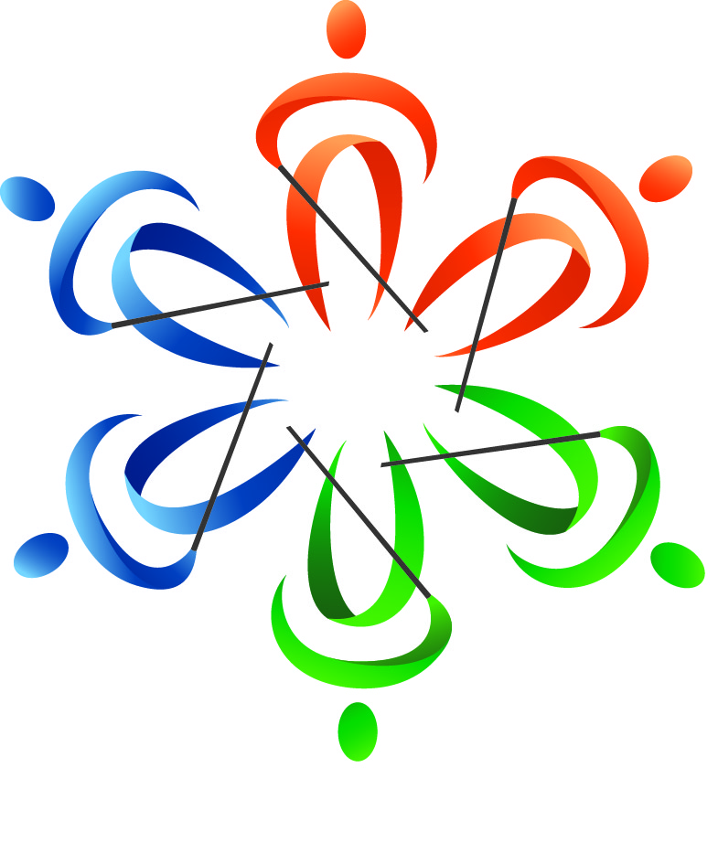
In This Issue

Katherine Gabry
Encourages you to show your cane pride
on October 15

Alyssa Shock, Amy Albin &
Connor Mullin
Share their national convention experiences

Alice Eaddy
Tells how the kindness of a stranger can make a huge difference

Ben Vercellone
Discusses why he is a Federationist

Live the Life You Want
THE SOUNDING BOARD
Fall 2017

Katherine Gabry, Editor
Ann Marie Cooke, Mary Jo Partyka & Barbara Shalit, Co-editors
Barbara Shalit, Advertising Manager

Published by e-mail and on the Web through Newsline by
The National Federation of the Blind of New Jersey
www.nfbnj.org

Joseph Ruffalo, President
State Affiliate Office 254 Spruce Street Bloomfield, NJ 07003
E-mail: nfbnj1@verizon.net

Letters to the President, address changes, subscription requests, letters to the Editor and articles should be sent to the State Affiliate Office or e-mailed to choirnfb@gmail.com. Advertisements should be sent to barbart@tullensound.com. The editorial staff reserves the right to edit all articles and advertising for space and/or clarity considerations.

Please Note: The deadline for the Spring issue is March 15, 2018.

Donations should be made payable to the
National Federation of the Blind of New Jersey
and sent to the State Affiliate office.

To subscribe via Newsline: Jane Degenshein 973-736-5785 or Jdegen16@comcast.net

JACOBUS TENBROEK LEGACY SOCIETY
Help build a future full of opportunity for the blind by becoming a member of the Jacobus tenBroek Legacy Society. Your legacy gift to the National Federation of the Blind can be made in the form of a will or a living trust, an income-generating gift, or by naming the NFB as a beneficiary of a retirement plan or life insurance policy. You can also become a member of the Jacobus tenBroek Legacy Society by making a legacy gift to your state affiliate. By committing to support an NFB affiliate, your gift will benefit both local and national programs, since all bequests made to affiliates are split evenly with the NFB national treasury. In addition to having the satisfaction of contributing to the future success of the NFB's mission, tenBroek Legacy Society members also receive a specially designed thank you gift and other benefits. For additional information, please contact Patti Chang at the NFB Jernigan Institute by e-mail at pchang@nfb.org, or by telephone at 410-659-9314, extension 2221.
Mission Statement
The National Federation of the Blind of New Jersey, Inc. is an organization of blind and interested sighted people who plan and carry out programs; work to improve the quality of life of the blind; provide a means of collective action for parents of blind children; promote the vocational, cultural and social advancement of the blind; achieve the integration of the blind into society on a basis of equality with the sighted; and take action that will improve the overall condition and standard of living of the blind.

The National Federation of the Blind knows that blindness is not the characteristic that defines you or your future. Every day we raise the expectations of blind people because low expectations create obstacles between blind people and our dreams. You can live the life you want; blindness is not what holds you back.

The National Federation of the Blind Pledge
I pledge to participate actively in the efforts of the National Federation of the Blind to achieve equality, opportunity and security for the blind; to support the programs and policies of the Federation; and to abide by its constitution.

The Sounding Board
The Sounding Board is the magazine of the National Federation of the Blind of New Jersey. It is published twice a year. Through The Sounding Board, our members can keep current with local, state and national news, and issues of concern. We also aspire to provide a source of hope, inspiration, pride and camaraderie through the personal stories in our publication.
Hundreds of readers receive our publication via e-mail and Newsline. The Sounding Board is also available for download in its entirety from our website at www.nfbnj.org. We encourage our readers to share The Sounding Board with family members, teachers, professionals, neighbors, friends and any other interested parties. We estimate our circulation to be in the thousands, as readers from across the country regularly report that The Sounding Board influences their lives. We hope you enjoy this issue.
TABLE OF CONTENTS

After the Holidays Party (inside cover)
Presidential Message, by Joe Ruffalo 1
From the Editor’s Desk: Show Your Cane Pride on October 15, by Katherine Gabry 3
National Convention Reflections, by Alyssa Shock 4
The Truth about Technology: Experiences from My First National Convention, by Amy Albin 6
Embracing the Complexities of Blindness: My Reflections on the 2017 National Convention, by Connor Mullin 8
NABS Announces New YouTube Channel 9
The Kindness of a Stranger Got Me Home: Alice Eaddy’s Story of a Fateful Day, by Katherine Gabry 10
Braille Production Comes to NJ Bell Academy 2017, by Barbara Shalit 12
Reflections from a BELL Academy Volunteer, by Alba Milla 13
Why I am a Federationist, by Ben Vercellone 14
From Vienna to Manahawkin: Indoor Audio Guide Technology Comes to State Convention, by Barbara Shalit 16
To Save a Child, by Christine Moore 17
A Unique Disability, by Ruth Silver 18
Mary Fernandez Interviewed by User1st Spotlight, Excerpted by Barbara Shalit 19
A Reprisal of “There Is Nothing Like a Cane,” by Carol Castellano 21
From Our Archives: Learning Through Leadership, by David Mostello 22
An Open Letter to the NFBNJ Family, by Jerilyn Higgins 24
Our President’s Response, by Joe Ruffalo 25
From the Kitchen of Jerilyn Higgins 26
NFBNJ Contact Info 28


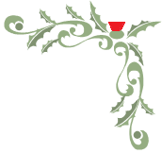
You are cordially invited
to the
National Federation of the Blind of NJ’s 9th Annual

After the Holidays Party

Saturday, January 6, 2018
1 to 5 p.m.
Knights of Columbus Hall
94 Bridge Street, Belleville, NJ
Access Link accessible Cross Street: Belleville Avenue

$25 per adult; $15 for children 6- 12 years; free for children 6 & younger

Please include a separate sheet with attendees’ names & phone numbers.
All payment must be received no later than December 31, 2017.
Make your check payable to NFBNJ and mail to:

Joe Ruffalo, President
NFBNJ 254 Spruce Street Bloomfield, NJ 07003

For additional information call Joe at 973-743-0075.

We’ll have door prizes, a sing–along & a special appearance by jolly old Santa!

Special note: If you would like an attendee to receive a gift from Santa, please bring a wrapped gift labeled with the name of the recipient.

MISTLETOE MAGIC MENU

Holiday Tossed Garden Salad with Vinaigrette Dressing
Chicken Savoy, Eggplant Rollatini, Meatballs, Pasta with Vodka Sauce
Assorted Cold Cuts and Potato Salad
Chicken Fingers
Rolls and Butter
Homemade Holiday Desserts
Coffee, Tea and Assorted Soft Drinks
Cash bar will be available.

Please join us in celebrating the holiday season!
We look forward to seeing all of our members, family and friends!

PRESIDENTIAL MESSAGE

Greetings to all!
With only three months until 2018, now seems the perfect time to reflect on the happenings of the National Federation of the Blind of New Jersey since the last issue of The Sounding Board.
At the national convention this summer, Jane Degenshein was re-elected to the National Blind Senior board, and Alice Eaddy was re-elected as president of the National DeafBlind Division. I would like to thank all who supported me in my re-election to the National Federation of the Blind’s Board of Directors. I’m honored to be serving my eighth two-year term.
On the home front, here in New Jersey, congratulations to Mac Biggers and Andrew Rees, elected as president and vice president, respectively, of the Central Jersey Chapter, and Mary Fernandez, who has been appointed chair of the State Scholarship Committee. Andrew Rees has also been appointed as chair of the Vehicle Donation Program. In addition, we continue to increase opportunities for our members to live the life they want through the development of two new NFBNJ committees. The first is the Spanish Committee, chaired by Rosa Santiago. The second, the Sports and Recreation Committee, chaired by Linda Melendez, has witnessed growth, involvement and participation in a good number of activities. With this said, the affiliate will establish the New Jersey Association of Sports and Recreation Division at the state convention this fall.
Speaking of the state convention – our 41st – it will be held at the Holiday Inn, 151 Route 72 East, in Manahawkin, from Thursday, November 9 through Sunday, November 12. Our theme this year is celebrating you: Live the Life You Want: Let’s Make It Happen! We will honor Jerilyn Higgins, a dedicated NFBNJ member for more than 30 years. Jerilyn has moved to Florida to begin a new chapter in her life, but she has made an indelible mark on the NFB affiliate in the Garden State. Jerilyn’s thoughts are provided in this issue, along with my remarks. Information pertaining to state convention registration, payment procedures through PayPal or check, hotel reservation information and the agenda are all posted on the state website and Newsline, distributed to all on our distribution lists and promoted in all upcoming chapter and division meetings. Please review your inbox as we will be forwarding a good deal of information for your consideration pertaining to the convention and other items of interest.
I encourage you to visit the state’s website at www.nfbnj.org for all the latest information on the state convention, as well as all the goings on in our active affiliate.
On a different note … did you know that the Atlantic Ocean is quite salty? I made this observation while surfing – or, shall I say, while trying to surf – during the second annual Surfing for Vision event held on August 13 at the Jersey Shore, in a small town called Long Branch. A huge thanks to At Large Chapter member and a participant in the Sports and Recreation Committee, Michael Benson, founder of Visual Experience Foundation, who sponsored this event. I admire Michael’s dedication to providing activities that demonstrate that there is life after blindness. The 29 blind/visually impaired surfers, along with volunteers, family and friends, and those on the beach witnessed us doing just that. After the actual surfing adventure, a live band provided music and all of us enjoyed the camaraderie on the beach.
As you read this issue of The Sounding Board, you will discover educational, motivational and inspirational articles that express the importance of getting into the game of life. As we play this game, we raise our own expectations and the expectations of others, and we transform our dreams into reality. Individual by individual, with love, hope and determination, we continue to build our Federation family. Every one of us can make a difference.
In closing, my challenge for myself and to all of you reading this issue is to raise your expectations. Learn the skills and techniques of blindness, share the gift of the Federation, and get and stay involved. See you all at our state convention!

With much respect,
Joe Ruffalo, President

Upcoming Important Dates
October: Meet The Blind Month, various activities sponsored by our chapters
November 1: National scholarship applications available
November 9 – 12: NFBNJ’s 41st State Convention, Raising Expectations
December: Numerous holiday events sponsored by our chapters
January 6, 2018: After the Holidays party (see the flyer in this issue)
January: Annual Washington Seminar
FROM THE EDITOR’S DESK:
SHOW YOUR CANE PRIDE ON OCTOBER 15
By Katherine Gabry

As far back as I can remember, I’ve known that a person using a white cane is blind or visually impaired. I grew up in the 1960s in Minnesota, a state known to be progressive for people with disabilities. Maybe that’s why all school children learned about the legislation signed by President Lyndon Johnson in 1964 designating October 15 as White Cane Safety Day. The National Federation of the Blind was instrumental in the passage of this legislation “… to gain recognition for the growing independence and self-sufficiency of blind people in America, and also to gain recognition of the white cane as a symbol of that independence and that self-reliance.” (www.nfb.org/white-cane-safety-day)
I got my driver’s license in Pennsylvania in the 1970s, and there, too, I remember everyone knowing that the white cane indicated a pedestrian who was blind or visually impaired. For my own edification, I recently verified that, indeed, the Pennsylvania Driver’s Manual still requires drivers to be alert to the presence of the white cane, as does the New Jersey Driver’s Manual.
Having raised a child who uses a cane and having worked as a support service provider (SSP) for DeafBlind people for nearly 20 years, I’ve seen the effectiveness of the cane in action. With proper training and use, it truly is a tool that provides invaluable information for safe travel and, as a result, confidence and independence for the user.
So why is it that most everyone I encounter has no idea that the tool is not called a “stick,” but, rather, a “white cane”? Why don’t people know that the individual using it is blind? I don’t think they understand even these basic concepts, so how can they understand the white cane as a symbol of independence or self-reliance? All that most sighted people know is the fear they feel when it’s dark and they can’t see. They don’t know the liberation and fulfillment that can be realized by the skilled use of the white cane.
It’s our responsibility – all of us in the blind and DeafBlind communities – to teach them. How can we do that? Here’s my suggestion: On Sunday, October 15, White Cane Safety Day, give the sighted public the opportunity to become aware of you using your white cane. Go out! Visit a restaurant, a grocery store, the gym, a mall. Take a walk in your neighborhood. Go to the park. Stop and get an ice cream cone or a cup of coffee. Smile and visit with people you meet along the way. I guarantee they will remember your smile, confidence and pride.
We change the world one small step at a time, and each of us can – and should – contribute to positive perceptions and education. On Sunday, October 15, I hope you will take the opportunity to make the sighted public aware of the independence and self-reliance your cane affords you.
NATIONAL CONVENTION REFLECTIONS
By Alyssa Shock

Editor’s Note: In the photo below, NFBNJ president Joe Ruffalo congratulates national scholarship winner Alyssa Shock, a student at Fairleigh Dickinson University. Here’s Alyssa’s story about her attendance at the convention.

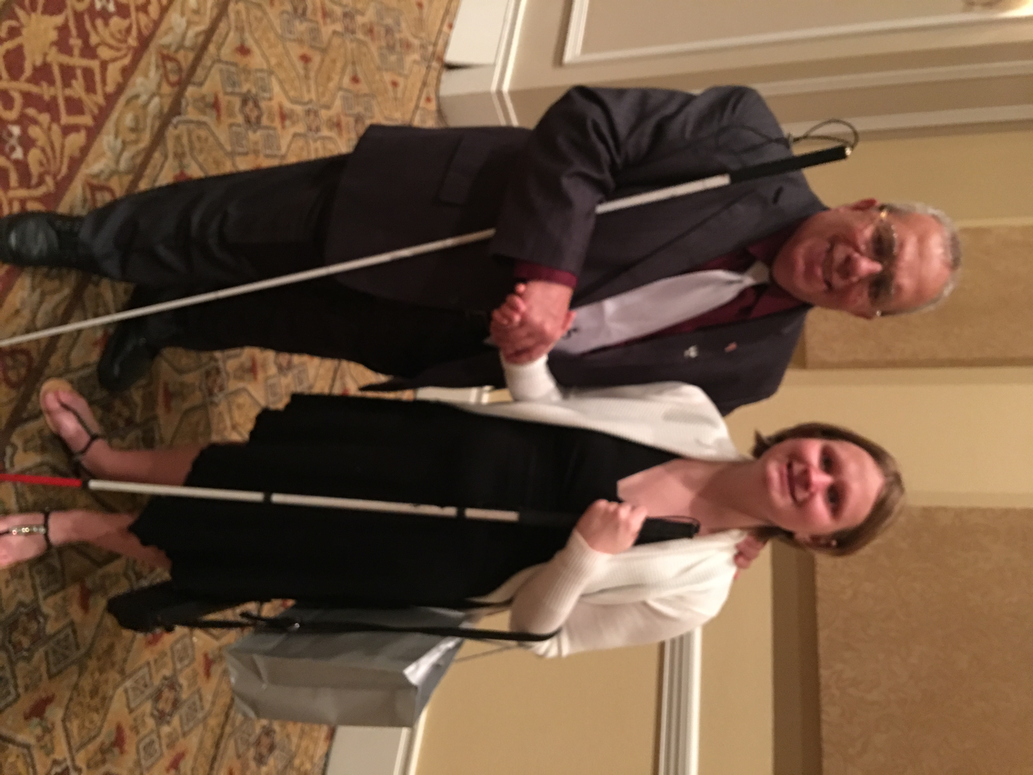
As a psychology major, I’ve been asked: Isn’t psychology just common sense? The fact is, no, psychology is not just common sense. One thing a psychology major quickly learns is that he or she will be looking at a lot of scientific research in the course of their education. Psychology majors also learn basic skills to design and answer research questions. I applied for the NFB scholarship because I had a sort of “research question” of my own: Can someone with my qualifications and experience win a scholarship and a great opportunity to attend a convention from the biggest scholarship program in the United States? I proceeded to submit my application.
I was out to dinner on a Sunday when I got a call from an unknown number. I usually don’t pick up calls from unknown numbers because of all the sales and scam calls promising things such as discounts on my electric bill. If it was important, I thought, the caller would leave a voicemail, and this caller did. Because I volunteer for a sexual violence resource center, I was worried that an emergency had come up, and someone from there was trying to contact me, so, in the middle of dinner, I proceeded to listen to my message. When I discovered the call was from a member of the NFB scholarship committee, I couldn’t help but call back immediately.
I spent the rest of that meal celebrating the fact that I had won an NFB scholarship … and wondering how in the world I would manage to make it through the convention by myself. I had been to convention once before with my mother and an aunt, but I knew this time I would be on my own. The thought of that was a bit scary.
Before I knew it, I was inside the hotel on the first day of convention. Being that I am easily overstimulated, I did find it overwhelming. One of the first things I learned was that to keep calm, I was going to have to break everything down into small steps, and focus on the action I was taking at the moment. For example, if I wanted to get to a meeting from my room, first I would have to get to the first floor, then find my way around the rotunda, and so on. I would need to focus on each step, and try to keep everything else out of my mind.
Once I figured out how to cope with the environment, I was able to gain a lot of information from the meetings. I learned about forms of discrimination and access barriers that blind people have faced, and how the NFB helps overcome these issues. For example, I learned that the NFB has fought for blind people who have faced low expectations from teachers and lacked necessary accommodations to gain the same knowledge as their sighted counterparts.
To be honest, I have personally faced little discrimination and few access barriers thus far in my life. I was shocked to hear about the terrible ways in which blind people have been slighted, and times when they had been cheated out of opportunities and experiences. I believe that continuing the fight to overcome discrimination and access barriers is extremely important. With all of this in mind, I want to take a moment to thank those who have been extremely accommodating and given me wonderful experiences throughout my life, including, especially, my family, the Dumont (NJ) School District, Fairleigh Dickinson University and the YWCA of Bergen County.
At convention, I also learned about technologies intended to help overcome access barriers, such as the awesome development of a braille display that makes images tactile. I also learned about Aira, a new technology that helps blind people have easier access to information. I would be lying if I said that I have come home from convention without the desire to invest in some new technologies for myself.
Probably the most important thing I learned is that blind people all over the world and the nation are overcoming barriers and getting the degrees, finding the jobs and having the experiences they want. In other words, they are living the lives they want. My mentors during convention were people I will never forget. They affirmed my belief that I can obtain my career goal of becoming a mental health counselor. Bigger than that, they affirmed that I can do anything I put my mind to and truly want, even if doing so does require me to overcome discrimination and access barriers. Speaking of that, I learned that the NFB will do everything they can to help blind people with these kinds of struggles.
Of course, I did not spend all of my time in convention activities. I used my spare time meeting new friends and visiting with old ones. When things became too overwhelming, my friends helped me relax and find some peace. Learning did not stop when I was outside of convention events. I learned and shared perspectives even in my spare time. All of this learning was fun and certainly did not feel like “work.”
With all of this in mind, I would definitely recommend that everyone who is blind or visually impaired try to go to an NFB convention. There is so much to experience and so many great people to meet. However, I do have one word of caution regarding convention: Sleep may be hard to come by. There is so much to do that getting the normal six to eight hours of sleep per night may not be possible.
Looking back from home, I cannot believe that one small “research question” could lead to such awesome results. A final thanks is due to the NFB scholarship committee for facilitating the awesome experience I had at convention.
The Truth about Technology:
Experiences from my First National Convention
By Amy Albin

Editor’s Note: Amy Albin graduated in June 2017 from Morristown High School and successfully completed the Employment Development Guidance Engagement (EDGE) program for teens from age 14 to 21. Amy has assisted as an instructor for the Braille Enrichment, Literacy and Learning (BELL) Academy for two years. Currently, Amy is receiving blindness skills training at CBVI's Joseph Kohn Training Center in New Brunswick.

I had the great fortune of attending the 77th NFB national convention this year, my first one ever! I’d been to three New Jersey state conventions and felt that it was time to take a leap into grander territory. With the help of my Jernigan scholarship, I stayed six days and seven nights at the largest convention of blind people—an amazing experience! I would like to thank Allen Harris and the scholarship committee for selecting me as a winner, as well as NFBNJ president Joe Ruffalo for his unwavering generosity. Without these dedicated people, I would not have come away with the insights I share below.
A significant motivation for attending this convention was to see the latest and greatest in technology. On Monday, I attended a seminar exhibiting the BrailleNote Touch by HumanWare and a different display of ElBraille by Freedom Scientific. These products are definitely worth considering as I plan to start college in January. I was particularly drawn to Aira, which enables a person to wear smart glasses and connect to a live agent for visual descriptions of the environment. This is useful for shopping; I heard an anecdote of someone who used Aira to buy medicine and read the label on the bottle. I was keenly aware that I was witnessing the cutting edge of blindness technology within the walls of this convention center.
The next day, I heard something at the National Association of Blind Students (NABS) division meeting that made me angry and confused. President Mark Riccobono gave a speech stating that we students are too willing to believe that our success as blind people emerges from technology. He said something to this effect: “It’s not technology that makes you capable; it’s you that makes you capable.” I didn’t understand. Wasn’t there a huge exhibit hall, weren’t there day-long presentations, all dedicated to demonstrating technology? Why was he saying that we rely too much on it? Did he mean that my BrailleNote and iPhone made me dependent? These thoughts were gathering momentum in my admittedly exhausted mind. I’d had a long day and wanted to go to bed. I left this meeting with a bitter taste in my mouth, and—I confess—I feared that maybe certain people were right, that the NFB was just too radical.
On Saturday July 15, I woke up with no idea what time it was. I’d stayed up past midnight at the talent show the night before. Grabbing my phone to look at the clock, I was alarmed to find that it had completely shut down. I hit the Home button, the on-off button, nothing.
This is strange, I thought, as I headed for the shower. When I turned the familiar knob, the one I’d used successfully for six days, nothing happened. I stood there for about five minutes trying to get the water started, but it just wasn’t working. I began to panic. The shower wasn’t working, and my phone wasn’t turning on, so I had no way of calling the front desk to get it fixed. If I couldn’t wash up, I didn’t want to leave my hotel room. I was trapped!
Then I remembered President Riccobono’s words: “It’s not technology that makes you capable; it’s you that makes you capable.” And finally I understood the meaning. My phone wasn’t working and neither was my shower, but I had to figure out a way to get ready and leave my hotel room. With newly found confidence, I returned from the bathroom to find the hotel phone. I remembered something I had heard days before, “For guest services, dial 0.” I picked up the phone, dialed 0, and explained that the shower wasn’t working. A hotel employee came and fixed it, and shortly thereafter my iPhone came back to life as well. I was prepared to go on with my final day.
Now I appreciated the president’s message at the NABS meeting, having experienced a lack of technology and solving my problems using my own ingenuity. One could argue that all the tools we use, even Braille, could be considered technology. The important point is that tools help us accomplish certain tasks, and when a given tool fails, we create a new one. We are the ones who learn the skills to use the technology that assists us in achieving independence.
That night at the banquet, President Riccobono made a speech about the misconception that technology has a greater impact on the progress of blind people than it does everyone else – his point being that the entire world benefits from technology. I was content as I recalled my shower panic that morning and listened to the speech with nearly 2,000 other people. By the end of the speech, I was completely swept away, chanting “Let’s go build the Federation!” along with the crowd. I was feeling the enormity of being with such a large group of people united for a common cause.
The next day, I texted my mom that I was on my way home and boarded my airplane. I was feeling grateful to live in the 21st century, where advances such as cell phones and airplanes are enhancing the lives of everyone, both sighted and blind. This new appreciation of technology and of my own capabilities made the 77th annual NFB convention well worth attending.
EMBRACING THE COMPLEXITIES OF BLINDNESS:
MY REFLECTIONS ON THE 2017 NATIONAL CONVENTION
By Connor Mullin

Editor’s Note: Connor Mullin is a recent graduate of The College of New Jersey where he majored in political science. Connor has been employed with the Family Resource Network (FRN) since August 2016 as a program coordinator for the Employment Development Guidance and Engagement (EDGE) program, which is jointly run by FRN and the New Jersey Commission for the Blind and Visually Impaired. In his spare time, Connor plays bass guitar in a band, reads and stays active at his local gym. Connor was a recipient of the Kenneth Jernigan First Timers Scholarship. Continue reading to see how the 2017 national convention in Orlando has provided a road to growth for him as a person.

After buying my plane ticket for the 2017 national convention in Orlando, I felt a mix of emotions. On the one hand, I knew that NFB national conventions are one of the biggest blindness events in the country, drawing thousands of blind people from coast to coast and abroad, and I was excited by whom I might meet, and what I might learn. Yet, I was also nervous about traveling to and from the convention; this would be my first-ever independent plane trip. In addition to disliking plane travel in general, I had no idea who I would encounter or who or what I would have to deal with. Yet, it took less than 24 hours to convince me that I had definitely made the right choice to attend.
The biggest benefits I enjoyed at convention centered around what I was able to learn. I focused most of my attention on learning about the NFB’s efforts to increase braille literacy and the approaches taken to train people at the NFB’s training centers. Admittedly ignorant of the low rates of braille education among blind and vision impaired students, I was fascinated to learn about the sheer scope of the issue, as well as the effects of a student relying only on audio and/or large print materials, such as their ability to recognize the spacial impacts of text, their spelling skills, etc. Having learned braille at a very young age, I admit that I took it for granted. Having transitioned to doing most of my reading through recordings and screen readers, I now feel galvanized to brush up on my braille skills. Concerning what I learned about the training centers, I was most moved by the idea that all students, regardless of residual vision, must learn to do all manner of tasks using only nonvisual techniques, to dispel the myth of what President Riccobono described as the “vision-centered approach.” Despite being totally blind since birth and used to doing all things without vision, I realized that I have nevertheless experienced being judged as someone who needs help by some individuals with residual vision, even those who nevertheless struggle to do daily tasks themselves due to their refusal to accept the limits of their eyesight. Consequently, I was moved by the impassioned argument for having students at these facilities work under training shades and the anecdotes from professionals of how instituting this policy at other centers has mitigated such unproductive dynamics.
As someone who works in the blindness field with high school students, I was excited to return home, ruminate on what I learned, and absorb aspects of my discoveries into my work. Already, for example, I have had thoughtful conversations with colleagues about how and under what circumstances training under sleep shades can be beneficial, and I look forward to being better prepared to counsel any of my future students who may be struggling to read their schoolwork with residual vision on why learning or staying sharp with their braille is important. Most of all, however, despite having been born blind, attending the 2017 national convention has taught me that the extent to which blind people can and have achieved is even greater than I thought, and I intend to take the increased confidence and sense of self I have gained from this realization into all the things I do in the hopes of stretching my own goals even further.

NABS ANNOUNCES NEW YouTube CHANNEL
Received from Tarik Williams, NABS

On behalf of the National Association of Blind Students (NABS), I am proud to
announce our new student division YouTube channel titled “How Blind Students See It.” This channel is a platform for blind students to show what’s going on in their lives, as well as their different successes. The channel also has educational videos presenting situations that blind people face and how blind students accomplish their goals.
Here is a link to our YouTube channel and our first video introducing the board: https://youtu.be/QnLE5sghKic We hope to have you subscribe and like our videos. We look forward to connecting with all of you in the future!
THE KINDNESS OF A STRANGER GOT ME HOME
Alice Eaddy’s Story of a Fateful Day
By Katherine Gabry

Editor’s Note: Alice Eaddy is an active member of the NFB on the local, state and national levels. In this story, she recounts an unfortunate incident on her trip home following the 2017 national convention in Orlando.

Here’s a dreaded fear: Missing your flight home after the NFB national convention. Guess what? It happened to me.
That fateful Sunday morning, I was definitely running on sensory overload. For me, sensory overload can be triggered by bright lights, crowds, movements or smells. I’d been up since 3 a.m. to catch a 6:45 a.m. flight from Orlando to Philadelphia. All my travel arrangements were in sync: First, fly to Philly, and second, meet paratransit for the ride to my home in South Jersey.
I’m a DeafBlind passenger who uses a guide dog as a mobility aide. When I booked my flight, I requested assistance upon arrival at the airports, at all connection points, and upon arrival at my destinations. Escort assistance is available from the airport curb to and from the gates, and, if you have a connecting flight, between the gates.
I had done everything that my past experiences had taught me to be a successful traveler: I checked in early (5:20 a.m.), checked my bags (5:30 a.m.), got my escort, and arrived at the gate early (6:11 a.m.). After arriving at the gate, the escort told me to sit and wait, and that someone would be back to pre-board me to be sure my guide dog would have enough floor space.
I don’t have a watch. Well, I do have a talking watch, but I can’t hear it. I don’t use a vibrating alarm on my phone either, because I can’t feel the vibrations unless it’s in my hand, and I’m cautious about taking it out of my purse for fear of dropping it and losing sight of it on the floor, or having it stolen. In the airport, I can’t hear alerts or alarms, so I trusted that escort who said that someone would be back to take me onto the plane on time.
It seemed like I had been waiting a long time, so I pulled out my phone and checked my Southwest® app. Imagine my surprise when it told me that my flight had taken off. What?!? The plane left without me? I was left at the gate, alone, isolated, with no one to tell me what was going on, and no idea what I was going to do.
In my role as president of the DeafBlind Divisions of the NFB and the NFBNJ, people often seek me out for ideas in solving their problems, and now, here I was, deeply ensnared in a really awful problem of my own. I was terrified. How could this be happening to me?
My dog, Wanda, and I set off to find help. At the first counter, a woman sent me to the dreaded “over there” by pointing. I directed Wanda to find the mystery counter, and she did. I immediately received new tickets to Philadelphia by way of St. Louis, and successfully boarded the new flight at 7:21 a.m. That was the good news. The bad news was that I would miss the paratransit I had set up from the Philadelphia airport to my home. I decided to cross that bridge when I got to Philly.
Karma was with me upon my arrival in Philadelphia at 1:34 p.m. I could have been easily overlooked and left to fend for myself, but no, my airport escort – we’ll call her TG – went above and beyond the call of duty to ensure that I would arrive home safely.
Because it’s hard for me to hear spoken communication, I used an app called Speak2see to communicate with TG. With this app, I can type or speak into my phone, as can those with whom I’m communicating, and I can read everything on my phone’s screen. In noisy places, like the airport, I’ve stopped trying to listen because it’s just too hard and makes me more anxious. Other environmental sounds become distracting and confusing, and it all makes me feel sick to my stomach. I have similar disconnects when the words become confusing, and, when I become flustered, I can occasionally stutter and stumble on what I’m trying to say. Speak2see helps me in all these situations.
TG and I found my luggage, which had arrived from my original flight and was being held for me. Then, she texted step by step directions to me to be sure that I would remember each step on my journey home. She also stayed with me until I boarded the train, and took the extra step of explaining to the conductor my status and communication methods, as well as where I needed to go to connect with buses into South Jersey.
How fortunate that this woman of impeccable character and integrity was placed in my path at just the right time! She stepped in and assisted me in dealing with my trial with a vigorous and authentic spirit, and with a deep concern for my well-being. That is the heart of life, of faith: Trusting when and where we do not see or understand.
As a result, I was able to get home safely every step of the way. When I finally arrived home at 6:56 p.m. that night, I said a prayer of thanks for TG, the conductors and the escorts who made my journey safe and possible.
After the dust settled, I filed a complaint with Southwest Air, and I now have $200 in complimentary airfare from them. In addition, I told them about the fantastic agent in Philadelphia and asked that someone make note of her supreme service that day. I also reported the incident to my contact at the Transportation Security Administration (TSA), who will be providing additional follow-up.
As frightening as the whole experience was, it was also a learning adventure. I’ve realized that without my iPhone and apps, I’d be lost (quite literally) and, probably, ignored. I also learned that sometimes I need to ask for help to get things done and to feel safer. Finally, I’ve learned to speak sparingly, so as not to confuse the issue. I hope that this never happens again, but if it does: I know I’m ready, willing and able!
BRAILLE PRODUCTION COMES TO NJ BELL ACADEMY 2017
By Barbara Shalit

During the summer of 2016, NJ BELL Academy students vied for a turn on eBrailler’s COSMO electronic braille writer/embosser, generously on loan from eBrailler’s president Dave Pillischer. COSMO writes. It erases. It embosses. It remembers where you left off writing after ejecting the paper. It chops, dices and sautés (kidding), and is generally very cool. This past summer of 2017, Dave lent COSMO again and added Duxbury Braille Translation software to its capabilities. This was a boon to lead teacher, Barbara Grames, because it enabled her to emboss print materials on the fly. (Imagine your blind student’s classroom teacher handing out a print spelling worksheet that could be turned into Braille at the same time.)

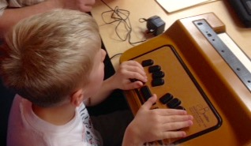
BELL 2017 student, Nate, practicing on the COSMO.

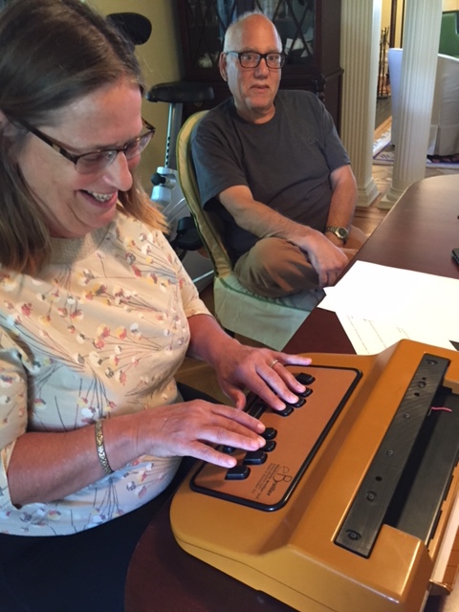
Lead teacher Barbara Grames using COSMO as a stand-alone Brailler/embosser. Dave Pillischer instructs.
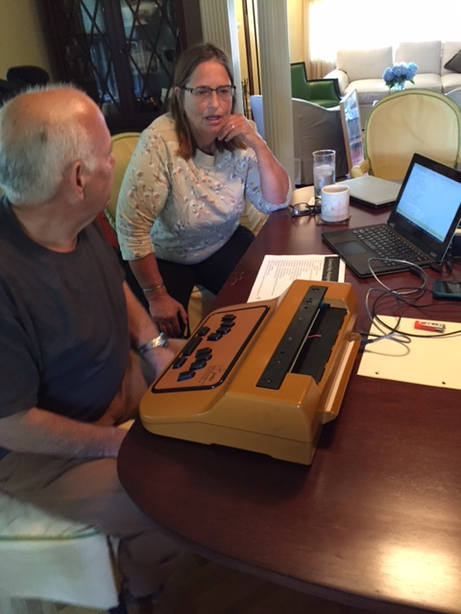
Ms. Grames and Dave with COSMO hooked up to a laptop with Duxbury translation software.

Reflections from a Bell Academy Volunteer
By Alba Milla

Editor’s Note: Alba Milla graduated from Middlesex County College with an associate’s degree in liberal arts and is now a student at Kean University majoring in early childhood special education, with a minor in bilingual education. Her daughter has been her inspiration to continue her education; she hopes that her daughter will be proud of her, and that she will value her own education and achieve her future goals, no matter how difficult they may seem.

It was a pleasure volunteering this past summer at the Braille Enrichment, Literacy and Learning (BELL) Academy. This was my first experience working with young children who are vision impaired, like me. I have a condition called Retinitis Pigmentosa, or RP. My vision was better when I was younger, but I can still see a little, and my eye condition has never stopped me from achieving my goals. I’m very independent and not afraid when I need to adapt.
When I heard about the opportunity to volunteer at BELL, I wasn’t certain I was prepared enough to work with these kids, but I was enthusiastic about trying. All I can say now is “thank you” because I’ve learned so much from these beautiful children, and I will not forget this opportunity for the rest of my life. Here are some highlights of my BELL experience:
- My first encounter with a blind child was a 4-year-old girl. She was paying attention as I was reading stories to her in braille. I also taught her some letters in braille, and she was able to copy them using the Braille writer. I felt so proud of myself and of this little girl because she was willing to learn.
- There were moments that, like any other kids, the BELL students just wanted to play and do other things as a group. Each student had a white mobility cane and was eager to go play outside on the playground. Even though all of these children had a disability, they played and had fun like any other children of the same age.
- Another great memory was working with a 10-year-old boy who was at first reluctant to be with me because I was a stranger. Little by little, I gained his trust, and was able to teach him a few more letters in Braille, which seemed to make him quite happy. We also played with puzzles. The puzzle pieces – shapes of animals – were labeled in Braille. I encouraged him to try different activities with the puzzle pieces. He not only had fun, but he also learned some important Braille reading skills.
I hope to volunteer next year at the BELL Academy because it provides a wonderful opportunity to work with – and learn from – these children. They are the future generation, and, therefore, we need to provide them the best possible education.
WHY I AM A FEDERATIONIST
By Ben Vercellone

Editor’s Note: A former resident of New Jersey and a graduate of the Leadership, Education, Advocacy and Determination (LEAD) program, Ben Vercellone is now the president of the Springfield Chapter of the NFB of Missouri. He wrote this article for the NFB of Missouri.

I have been totally blind since 1992, in my early childhood, due to a car accident. My parents raised me to the best of their ability, with the goal of me becoming a competent and independent person. They tapped into multiple resources, one of which was the National Federation of the Blind. I began to realize the NFB’s existence, purpose and dynamics in 2004, when I was 16 years old. Since then, I became increasingly involved in this organization. The more I learned about the NFB and got involved, the more I experienced as truth the message of this organization.
I attended the Louisiana Center for the Blind from late 2007 through mid-2008, and the training I received there was absolutely life changing! The Louisiana Center for the Blind (LCB) is a residential training center in Ruston, Louisiana, where the model of training is second to none. Committed students transition from LCB as confident and independent blind individuals, having done many things that society believes to be impossible for the blind. There are more than a few philosophical discussions that take place at NFB training centers. Fortunately, the rubber is applied to the road on at least an hourly basis!
All of the instructors at LCB, and at the other two equally great NFB training centers, are either blind or can perform all aspects of their job wearing sleep shades. At LCB, students with any remaining vision are required to wear sleep shades from 8 a.m. to 12 p.m. and from 1 p.m. to 5 p.m. They also must wear sleep shades during the many training activities that occur outside these hours, such as the rock climbing trip, the white water rafting and Mardi Gras. I could write volumes about my training at LCB, but I'll keep it short.
I emerged from the Louisiana Center for the Blind armed with the knowledge that blindness is not the real barrier between me and my goals. The real barrier is constructed largely from low expectations. These low expectations are not only held by those with sight. Low expectations, as I have learned and frequently observed, are quite often accepted, internalized and implemented by blind people themselves. Though most people are not out to get me, or anyone else for that matter, the good intentions of much of society regarding blindness are also part of the barrier to blind people achieving our dreams. And then there is the old-fashioned discrimination due to ignorance and apathy. Thankfully, the NFB has also succeeded in decreasing these elements quite a bit.
I am a fairly driven person. I know for a fact that if I wait around for equal access and equal opportunity in all aspects of life, I'll be waiting until the cows come home, unless other blind people have already pushed for this equal access and opportunity. The National Federation of the Blind has indeed pushed the envelope since 1940, and I am glad that I am a part of this great movement. It is only appropriate, and is quite beneficial, for me to join in the efforts of the NFB. If I don’t, the chain will be shorter, less multi-faceted and more taxed. If I get involved, our efforts to make a difference are one person stronger.
After attending LCB, I went to Montclair State University in New Jersey and got my bachelor's degree. Then I got my master's degree at Louisiana Tech University, and also received my national orientation and mobility certification. Since February 2015, I have worked as the orientation and mobility specialist with Rehabilitation Services for the Blind of Missouri, Southwest District Office. I may not have sought a career as an OM instructor and found this job without the invaluable help of the National Federation of the Blind.
I find it interesting that many people, at least in my area of the Midwest, find it quite fitting for a blind person to teach other blind people how to travel independently. Imagine that! I completely agree with this assessment! Even as recently as my childhood, a significantly higher percentage of society in the U.S. believed that sight is required to teach orientation and mobility. The NFB was pivotal in the positive change that has taken place, and is still quite revolutionary in this arena. I am thankful that Structured Discovery, problem-solving, Socratic questioning, transferable skills and an internal locus of control are all discussed at length now. This has been the case for some time. This discussion greatly helps to flesh out how blind people effectively teach OM. In fact, effective OM training does not take place without these elements, even when the instructor is sighted. The bottom line is that if it were not for the work of the National Federation of the Blind, only a small percentage of society would believe that blind people can teach independent travel, or do many other things for that matter. Believe me when I say that there is still a lot of work that needs to be done on this front. I could write a volume on this, too, but I won't right now. I want to be involved in this work.
I am somewhat of a geek, especially when it comes to theorizing how new or already-existing technologies may work or work together to help the blind. I am not a programmer or hardware designer, so I spend a lot of time sharing ideas with those who know much more, and I give feedback on existing technologies. Some people view me as the go-to person when it comes to technology. Technology is one of my big hobbies, but I’m glad it’s not my job! My motivation to get involved in the technology arena, despite my somewhat limited knowledge, has been enhanced by the “let’s make it happen” philosophy of the NFB.
In summary, if I wait around for society to believe that I am a competent individual, and that blindness does not define me or determine the length, width, height and depth of my life, I'll be waiting an awfully long time. I have seen the positive difference of the National Federation of the Blind in the lives of many blind people, both inside and outside this organization. Joining this organization and getting involved have brought this positive difference to my own life. Activity in the NFB is basically the embodiment of the American dream, but with an emphasis on overcoming the barriers related to blindness and perceptions about blindness. I have greatly benefitted from the many NFB members with whom I've worked and interacted. I trust that I have also benefitted some blind individuals. It is an honor and privilege to be serving as the president of the Springfield chapter of the National Federation of the Blind of Missouri. Let's go build the Federation!

From Vienna to Manahawkin
Indoor Audio Guide Technology Comes to State Convention
By Barbara Shalit

“LowViz Guide,” a new, indoor, free, way-finding app can guide you to all the meeting rooms, restrooms, vendor booths and other points of interest (including guide dog relief areas) at the upcoming New Jersey NFB state convention.
A way-finding technology company in Vienna (Google indoo.rs) inspired Liz Trauernicht and Dan Roberts of MD Support (Macular Degeneration Support) to have indoo.rs develop the technology to their conference specifications. Dan has offered this service to NFBNJ and will mount beacons throughout the Holiday Inn conference area. All the user has to do is go to the following site and download the app onto his or her iPhone or iPad: www.mdsupport.org. Search on “audioguide.” In addition, a four-minute, narrated video of the app in action is available at this link:
https://www.youtube.com/watch?v=RCWecoWoPVM&feature=youtu.be
LowViz Guide is the latest embodiment of Bluetooth Low Energy (BLE) beacon technology, popping up in public venues all over the world. It is similar to GPS, but useable indoors, where access to satellites, Internet and cell service may not be available. In combination with your iPhone’s or iPad’s speech capability, the guidance is audible. MD support personnel will be on hand at the state convention to provide technical assistance.
TO SAVE A CHILD
By Christine Moore

Editor’s Note: Christine Moore works at the Xavier Society for the Blind, a library and publishing center for religious and spiritual materials in New York City. This story demonstrates how one seemingly small referral can change a life, as well as a family’s hopes and dreams. The photo below shows Michelle, the social worker who worked with this family, giving a “thumbs up” and holding a handwritten note that says, “Thank You, Joe!”

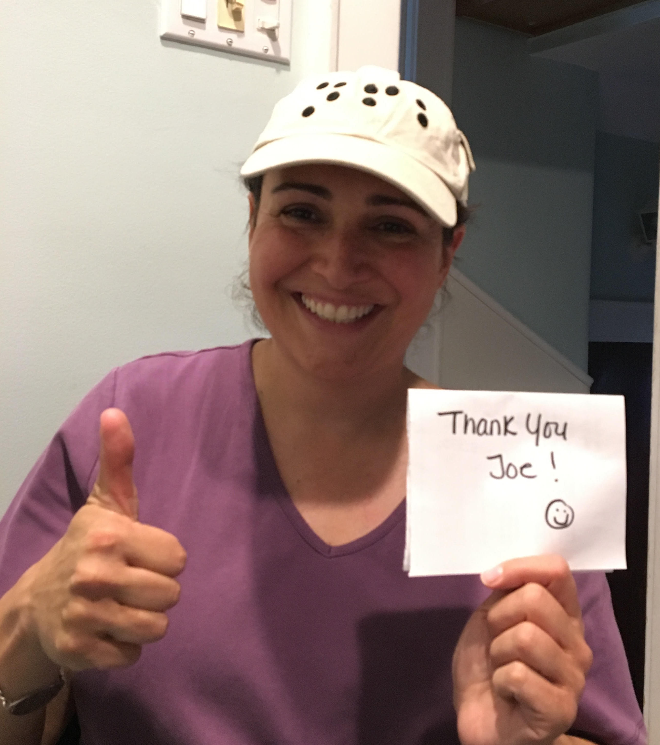
This story begins with a hard-working father who came to this country from Africa, with hopes of providing a better life for his blind daughter, whom we will call K. When she arrived from Ghana, Africa, K was enrolled in the public school system in the New Jersey town where they reside. Initially, and without a diagnosis of her vision (as no services were ever received while she was in Africa), she was placed in a general education setting with an aide. As information was obtained and clarity of the situation was made, she was moved into a special education setting.
Services for braille and mobility training were provided, but not at a level that would be adequate to ensure her future success. Luckily, she transferred schools and crossed paths with a social worker named Michelle, who, along with K’s special education teacher and her personal aide, decided that things had to change. For K to function as a blind person in a sighted world, she would need more services than the public school could provide. The daunting task of a getting K into a specialized program out of district began and was met with numerous trials and tribulations. Michelle asked my assistance because I work with the blind and because of my background as a teacher. My natural instinct? Ask the NFB for help!
As the process began, the NFB was mentioned as an advocate for K. The process continued, and K, accompanied by her father, teacher and social worker, toured St. Joseph’s School for the Blind. K was accepted there. Her father cried as he saw that there were other children like his daughter, and that they were doing well and thriving. The available accommodations were inspiring. Deadlines for decisions neared, and paperwork required approval. Michelle copied the NFB on her reports and, even without NFB intervention, just making it clear the NFB was informed, doors were opened, and approvals were granted! The final paperwork loomed for weeks, thereby prompting a follow-up email from Mr. Ruffalo. Expeditiously, the paperwork went through, the arrangements were finalized, and K began the summer session July 5.
Michelle is convinced that it was the involvement of the NFB on this case that led to its resolution. K now has opportunities she would otherwise have missed, and will have friends who share the same challenges and will normalize her fears and frustrations. Thank you to Joe Ruffalo and the NFB!
A UNIQUE DISABILITY
By Ruth Silver

Editor’s Note: Ruth Silver was a teacher, advocate, author and inspiration. Her passing on September 17, 2017 leaves an aching hole in the hearts of many in the DeafBlind community across the country. In her 80s, Ruth wrote an autobiography: Invisible: Journey Through Vision-Hearing Loss. Proceeds of her book support the Center for DeafBlind Persons, in Milwaukee. We celebrate Ruth’s life with this eloquent essay:

DeafBlindness is not simply deafness plus blindness. It is not two disabilities put together. It is one unique disability. Let me try to explain. I am totally blind having lost my vision gradually starting in childhood. In young adulthood, I started losing my hearing. With hearing aids, I can understand some speech in a quiet environment.
When I was only blind, I could socialize with many people at a gathering. Now, at best, I can converse with the individual next to me.
When I was only blind, I could interact with people in a room where the radio was playing, dishes were clattering and laughter abounded. Now, with background noise, I can understand nothing and be alone in a crowd.
When I was only blind, I could sense sadness, joy, anger and agitation by a person’s tone of voice. That is no longer possible and the loss sometimes causes misunderstandings.
When I was only blind, I could hear the softest footsteps. Today, I am repeatedly startled by the voice of a person who has entered the room with no forewarning.
When I was only blind, I could identify a person by his/her voice. Now, I cannot tell who is talking to me unless I first hear a name.
When I was only blind, I could move quickly with my white cane and, in familiar surroundings, without it. Now, I walk cautiously to avoid bumping people since I cannot hear if others are around or where they might be.
When I was only blind, I could retrieve a dropped item in seconds by hearing where it fell. No longer able to localize sound, I must now search on my hands and knees and even then may not locate the item because it rolled behind a door or into another room.
When I was only blind, I could stand unsupported in the middle of a room, bend over, turn sharply and jump out of bed quickly. This is no longer the case. Like many others with hearing loss, I have balance problems, which prohibit abrupt movements.
When I was only blind, I had no difficulty hearing the ring of the telephone or doorbell. Today, even with amplified ringers, my responses are inconsistent and I must consider using a vibrating alert system.
When I was only blind, talking on the telephone was fun. Now, even with hearing aids combined with a volume control phone, some words are missed and misunderstandings occur. Sometimes I use a Braille-type telephone, which is slower and does not convey the emotional nuances of the voice.
When I was only blind, I spent hours listening to “talking books.” Most voices now sound muffled.
When I was only blind, my husband and I enjoyed movies; he provided an occasional description. Movies are confusing and no longer pleasurable.
When I was only blind, life had minimal stress. Now, piecing together bits of information, localizing difficulties, balance problems, misunderstandings, attitudes of others and unpredictable drops in hearing increase daily stress and fatigue.
The list of challenges is equally long for individuals who are deaf and have lost or are losing vision. Deaf people rely on their vision to compensate for their hearing loss. Blind people use their hearing to compensate for their sight loss. Deaf-blind people are only able to compensate for the loss of both sight and hearing by learning deaf-blind specific adaptations that focus on developing and integrating touch, taste, smell, kinesthesia and any remaining vision or hearing.
“When I acknowledged the need and learned new ways of doing old things, my splintered pieces combined into a complete, though narrowed, whole. I rejoice once again in being able – differently able.”

Mary Fernandez Intervewed by User1st Spotlight
Excerpted by Barbara Shalit

Editor’s Note: User1st’s Spotlight interviews individuals who have advanced the rights, opportunities and boundaries of what was thought possible for individuals with disabilities. Born in Colombia, Mary Fernandez arrived in the U.S. at age seven. In the interview, she tells her story; excerpts are below. For the full interview, go to https://www.user1st.com/web-accessibility-spotlight-interview-mary-fernandez/.

Mary Fernandez (MF): In Columbia, I was considered un-teachable. I would never have graduated from high school, let alone college. Once in the U.S., learning braille and later assistive technology, I could not have been happier. In school, I was more comfortable with adults than with classmates; I knew my disability made me “not normal.” Although I knew braille, I didn’t want to read my school assignments in braille. One day, my mother made me go to my room and not come out until I had finished reading “Freckle Juice” by Judy Bloom. I later emerged and asked if we had any more braille books, beginning my lifelong love of literature.

MF: I was lonely in high school. My aide trailed up and down the school with me, though I didn’t need her only for brailling materials. I exceled academically, if not socially. I couldn’t wait to get to college at Emory, where I could make my own decisions. Everyone is different and has different education needs. There is more than one path to success; education should be suited to a student’s abilities and the challenges that will expand horizons. This is possible for all children.

MF: I majored in psychology and music; spent my freshman summer studying abroad; and I began advocating. Getting textbooks in braille was a struggle, and they arrived late. The university felt that one-on-one tutoring would suffice. Students often feel powerless in situations like these. Their success many times depends solely on an institution fulfilling its legal responsibility of equal and timely access.

MF: Looking for work after college, I applied online getting nowhere until my mother suggested exploring personal connections. I sent my résumé to everyone I knew and was soon working for a civil rights litigation law firm, Brown Goldstein & Levy. After three years there, I sharpened my blindness skills at the Louisiana Center for the Blind, returned to New Jersey, and found work helping develop the Employment Development Guidance and Engagement (EDGE) Program there, focusing on developing employment readiness skills for transitioning blind and vision impaired high schoolers. In the fall of 2016, I took a break and traveled the world with my boyfriend.

MF: Perceptions of individuals with disabilities hasn’t changed much. We still face the stereotypes of being either incredibly inspirational for doing the things everyone else does, or of being objects of pity. I think most people with disabilities will agree that it is societal misperceptions about disabilities that present the biggest barriers, not lack of skill or education.

MF: Have high expectations, allow children to take risks and to fail. Sure, I got lost a few times traveling. Yeah, I’ve gotten burns while cooking; I’ve cut my fingers a few times. But who hasn’t? Don’t listen to “you can’t.”

IN HONOR OF WHITE CANE DAy SUNDAY, OCTOBER 15, 2017:
A REPRISAL OF “THERE IS NOTHING LIKE A CANE”
By Carol Castellano

Editor’s Note: The following, sung to the tune of “There is Nothing like a Dame,” was performed by the Grassey Lassies at the 2011 NFBNJ State Convention. The original performance is available at http://www.youtube.com/watch?v=Y9rX07K_pJU

We've got walls we can run into
We've got crevices and cracks
We've got drop-offs, we've got columns
That can give our heads a smack
We've got lumps and bumps and bruises
That can leave us in great pain
What do we need?
We need a cane!
We've got folks who want to guide us
They will take us anywhere
For our own sakes they assure us
They will keep us under care
In the kindliness of strangers
We can't be content to dwell
What do we need?
You know darn well!
Independent mobility is what we're enroute for
What we need is what there ain't no substitute for...
There is nothing like a cane,
Nothing in the world,
There is nothing you can name
That is anything like a cane!
We feel restless we feel stymied
We feel that we want to flee
We feel every kind of feeling
But the one of being free
We feel patronized, infantilized,
And so misunderstood
What don't we feel?
We don't feel good.
Lots of things in life are beautiful, but brother,
There is one particular thing that is nothing whatsoever in any way, shape
or form like any other.
There is nothing like a cane,
Nothing in the world,
There is nothing you can name
That is anything like a cane!
There is absolutely nothing like the frame of a cane
We will take our canes and travel
Anywhere we want to go
What we want is independence
In the fast lane not the slow
With the method of discovery
We'll figure out a lot
We'll get there with the canes we've got.
There is nothing like a cane
Nothing in the world
There is nothing you can name
That is anything like a cane!
There are no books like a cane,
And nothing looks like a cane.
Nothing can tap like a cane,
or react like a cane,
Nothing protects like a cane,
Or detects like a cane.
There ain't a thing that’s wrong with anyone here
That can't be cured by putting him near
A classy, really long, straight white, can't go wrong CANE!

FROM OUR ARCHIVES: LEARNING THROUGH LEADERSHIP
By David Mostello

From the Editor: David Mostello is secretary of the NFBNJ’s Capital Chapter and has served as Legislative Coordinator and Board Member of the New Jersey Affiliate. He is a graduate of Seton Hall University. While a student at Seton Hall, David completed a summer internship with the Federal Communications Commission in Washington, D.C., an opportunity obtained through the Washington Center www.twc.edu. David is also a member of his local Lions Club and has chaired his community's Affordable Housing Committee. In addition to spending a lot of time on his computer, David likes to listen to XM radio and follow current events and national politics with Newsweek magazine, which he downloads from the American Printing House
website (www.aph.org). The following are David’s remarks about a leadership conference he attended in Baltimore. The article was originally published in the Spring 2003 edition of The Sounding Board. As you’ll see, it’s still relevant today.

Last May, a group of Federation leaders from New Jersey attended a Leadership Conference at the National Center for the Blind in Baltimore. Members from every chapter participated.
The van carrying Mary Jo Partyka and me, members of the Capital Chapter, stopped in Cherry Hill to pick up six members of the Garden State Chapter—Linda Deberardinis, Vito DeSantis, Ed Godfrey, Ann Jordan, Ryan Stevens and Marilyn Swartz. We were joined by Northern and Central Chapter members Julie Dawson, Andrew Godwin, Patricia Healy, Jerilyn Higgins, Ed Lewinson, Gloria Lewis, Jerry and Madelyn Moreno, Joe Ruffalo, Adrienne Snow and Stephanie Starosciak.
The National Center is a well-renovated, well-furnished, well-planned and a welcoming facility. Conference participants were awakened at 6 a.m. by invigorating music played over the center’s P.A. system from President Maurer’s special collection. Selections included “Tie Me Kangaroo Down” and “The M.T.A.” (The Man Who Never Returned). Meals were served in the Center’s dining room, where guests are served cafeteria style and are expected to deposit their dirty dishes in the appropriate bins, before leaving the room. For the most part, all the activities in which participants took part were located on the fourth floor which contains the guest rooms, the Annex, the dining room, the soda machine, the bags of nuts with the donation box (a contribution of Dr. Jernigan) and the Harbor Room.
No efforts are made to guide a blind person through the National Center. Instead, visitors learn their way around using the Discovery Approach. For example, I learned where the door to the fire escape was one evening when I became disoriented while trying to find my room, and mistakenly opened it. My action set off an alarm which required that someone from the Center (thankfully not President Maurer) come down and reset it.
After lunch on Friday afternoon, President Maurer discussed his trip to Japan last March. He told us about the three occupations for the blind in Japan—massage therapy, teacher of the blind and government worker. He then described a special type of massage therapy in Japan, where eucalyptus leaf oils are rubbed into a person’s joints to ease muscular pain.
Another topic of discussion was fundraising. Did you know that if 720 individuals made $25,000 contributions, it would finance the entire construction costs of the National Research & Training Institute for the Blind? We also learned the purposes of the NFB’s four funds: the Jernigan Fund, the SUN Fund, the tenBroek Fund and the White Cane Fund. Other methods of funding the organization include the Pre-Authorized Check (PAC) Plan, Associates and the endowment.
President Maurer solicited questions from participants regarding the NFB and its policies, and offered advice on dealing with issues on the chapter level. Many interesting issues were raised, including the differences between the ACB and the NFB, how to motivate blind individuals to join a chapter, what to do about an overprotective parent, and whether the national convention would ever be held in New Jersey (don’t hold your breath).
After these discussions, we were provided with opportunities to tour the National Center, purchase items at the Materials Center, and tour the Technology Center, where the staff demonstrated four new accessible voting machines.
At the close of Saturday’s session, President Maurer remarked that Thomas Edison, while selling his projectors to schools, claimed that 80% of what a person learns is learned through sight. President Maurer commented that the most important sense we have as blind people is touch and that schools should purchase Braille books and hire instructors to teach Braille to blind students.
In sum, the Leadership Conference was a seminar on how each member of the NFB can serve as an expert on blindness. The Conference provided a group of leaders in the New Jersey affiliate an opportunity to bond with each other while learning more about the organization we help to direct. Every Federation leader has talents. When we join our talents together, our collective action yields progressive results. Thanks to both Presidents Maurer and Ruffalo for donating their time and making the 2002 Leadership Conference a success.
AN OPEN LETTER TO THE NFBNJ FAMILY

Dear President Ruffalo and my NFB family,

Please accept my sincere appreciation and many thanks for all the opportunities and challenges you have given me through the last 30 years. It has been an honor to serve the blind community of New Jersey.
My first encounter with the NFB was the national convention in 1987. I traveled with three other members of the New Jersey affiliate to Phoenix. The experience was amazing. I never saw so many people who were blind in one place. They were from all walks of life, going on their way independently. The speeches were enlightening, encouraging, empowering and unforgettable. Seeing so many competent blind people living prosperous, independent lives changed the way I thought about my blindness. The speeches were inspiring; the exhibit hall was full of all the technology and other items of interest that you could ever imagine. That is not all; there were tours you could take to experience the local area.
When I returned to New Jersey, I immediately joined my local chapter. I couldn’t keep all the new information I learned to myself; I had to share it with other people who are blind. The positive attitudes, the fact that it is respectable to be blind, and that blindness is only a characteristic, it does not define us. From volunteering for the first Youth Slam to working in the NJ BELL Academy, it was all such a pleasure to be able to share the good news of the NFB. In the last 30 years, I have held every position on the Board except the presidency.
The best president any affiliate could have is Joseph Ruffalo. He goes above and beyond for the blind people of New Jersey. I am also taking credit for finding him. It took me a while to get him to attend an NFB meeting, but when I see good potential, I can't let it go. So when I hear him asking over and over again, “Where are my sesame cookies, or my chocolate coconut cheesecake?” I have no one but myself to blame.
I will miss co-editing The Sounding Board, chairing the Scholarship Committee, experiences at the Washington Seminar, and the Divisions I enjoyed so much.
In 1999 the Central Jersey Chapter was established. We were a small team of Federationists who reached out to Middlesex and the surrounding counties to all people who are blind to improve our lives. There is nothing like a chapter to learn about blind issues, problem solving, and for sharing information and ideas. We are a family and are there to help each other. It was my pleasure to be president since the beginning of this chapter. I will miss everyone and wish everyone the very best!
I have moved to Florida. I would love to keep in touch with everyone. My email address is: jerilynhiggins@gmail.com

Respectfully,
Jerilyn Higgins
OUR PRESIDENT’S RESPONSE

We care. We share. We grow. We make a difference! These words are part of my signature block; however, the words also highlight Jerilyn Higgins, a true friend to me and to all members to whom she introduced the gift of the Federation.
I didn’t want any part of the Federation, but Jerilyn was persistent, contacting me for six months. She cared about me. Through her experience with the Federation, she knew that I needed what the Federation offered. Thanks Jerilyn.
We shared many times via emails and phone, together at meetings, chapter functions, editing The Sounding Board, reviewing applicants for the state scholarships, attending national and state conventions, participating at Washington Seminars, presentations, conferences, workshops, the Leadership, Education, Advocacy and Determination teen program, working together with the Senior Community Independent Living Services program for seniors, and working as partners, with Jerilyn baking and providing me with cookies and cheesecakes. Jerilyn, thanks for sharing.
We have grown as members, colleagues and friends, as we were always willing to take a chance to grow as individuals and as leaders in the Federation. We grew by discussing all the possibilities and outcomes, weighing the potential outcomes and providing opportunities to our members to grow and to think outside the box. Jerilyn, thanks for encouraging me – and so many others – to grow.
We made a difference as we participated in numerous phone calls to inform many that being part of the Federation will and has made a difference in many lives. Jerilyn, thanks for making a difference!
I will express my thoughts to you from your friends and the family of Federationists with the following words: Thanks for all you have done, are doing and continue to do to change what it means to be blind!
The members of the NFBNJ will be honoring you at the 41st state convention this fall.
Jerilyn, I and all that you have touched with the gift of the Federation will miss you in New Jersey; however, you are only a phone call, email and flight away!
Enjoy your time in Florida and be prepared for visitors!
Judy and I are checking potential dates during the winter months.

With Much Love and Respect,
Your Friend,
Joe

FROM THE KITCHEN OF JERILYN HIGGINS

Editor’s Note: Jerilyn Higgins, a longtime member in the Federation and an activities of daily living instructor, offers her favorite fall recipes.

Jerilyn’s Note: Here are three recipes to make a delicious fall dinner. We made all of them in the Healthy Options class that I taught at Vision Loss Alliance. Since this is the fall edition, we like to use the produce that is in season.

SPAGHETTI SQUASH WITH WARM SPINACH WALNUT PESTO
Serves 4 – 6
Ingredients

3 large spaghetti squash
1 bag (16 ounce) bag of frozen spinach
½ cup walnut pieces
1/3 or ½ cup of chicken stock
1-1/2 cup fresh parsley
1 large shallot
2- 3 cloves garlic
¼ cup olive oil
Dash nutmeg
Parmigiana Reggiano cheese

Directions
- To soften the spaghetti squash to make it easier to cut in half: Place it in the microwave oven for 3 or 4 minutes.
- Remove the spaghetti squash and cut it in half.
- Place it back into the microwave oven and cook for about 9 minutes. Note: All microwave ovens are different; your microwave may need more time. Check after 9 minutes; if the squash is not soft and easy to pull apart, then let it cook another 2 to 3 minutes.
- Make strands with fork and season with salt and pepper.
- Defrost the spinach, squeeze the water out & use fingertips to loosen it
- Toast the walnuts: Place them on a cookie sheet, spray with a little oil and sprinkle with a little salt. Bake in the oven at350 degrees for 9 or 10 minutes. When you can smell their fragrance, take them out.
- In a food processer: Place the chicken stock, spinach, garlic, walnuts, parsley, shallots and pulse to make the pesto.
- Heat the olive oil in an electric frying pan over medium heat.
- Add the pesto and sprinkle with nutmeg, salt and pepper. Heat for 2 to 3 minutes until warm.
- Add the spaghetti squash and the cheese.

FALL HARVEST SALAD WITH BUTTERNUT SQUASH & RASPBERRY DRESSING
Incorporates the warm flavors of fresh fruits & vegetables harvested in the fall. Serves 2-3.

Salad Ingredients

2 cups kale
2 cups romaine lettuce (one bunch)
1 honey crisp apple, sliced or diced
1/2 cup walnuts, chopped
1/2 shredded carrots
1/2 cup dried cranberries
1/2 peeled and cubed butternut squash
2 tsp cinnamon
1 tablespoon olive oil

Dressing Ingredients
1/3 cup olive oil
1/2 tsp salt
1 tsp honey
1 tsp Dijon mustard

1 chopped shallot
3 tablespoons vinegar
1/2 cup fresh raspberries

Directions for Salad
- Peel and cut butternut squash into bite size pieces.
- Toss butternut squash with 1 tablespoon olive oil and 2 tsp cinnamon.
- Grill butternut squash on the George Foreman grill for 10 minutes, or cook in the microwave oven for 6 to 7 minutes.
- While cooking, Combine remaining salad ingredients in a bowl and set aside.
Directions for Dressing
- Process ingredients in the food processor until smooth. Toss with salad and top with butternut squash.

EASY HOME MADE APPLESAUCE
Ingredients

4 fresh apples, peeled, cored and chopped into chunks – any apples will do, but I like to mix Granny Smith with Fuji or Pink Lady to get the sweet and tart together
1 cup water (enough to cover bottom of pan)
1 tsp ground cinnamon
Pinch of nutmeg

Directions
- In a medium saucepan, combine apples and water. Cover and bring to a boil.
- Reduce heat to medium low and simmer for approximately 10 minutes.
- Add cinnamon and nutmeg. Cook for another 10 minutes til soft.
- Mash the mixture with a fork or a potato masher, until your desired consistency is achieved. Alternatively, you can use a blender for a smoother consistency.
NFBNJ CONTACT INFORMATION

National Federation of the Blind National Center
President Mark Riccobono 410-659-9314 officeofthepresident@nfb.org
NFB State Affiliate
President Joseph Ruffalo 973-743-0075 nfbnj1@verizon.net
1st Vice President Mary Jo Partyka 609-888-5459 choirnfb@gmail.com
Secretary Alice Eaddy 856-765-0601 nfbnj.secretary@aol.com
Treasurer Brian Mackey 609-953-6988 bmackey88@gmail.com
Board Members Rebecca Bryant 973-732-6559 rirvin14@optonline.net
Linda DeBerardinis 856-735-5559 ljdeber3@comcast.net
Jane Degenshein 973-736-5785 jdegen16@comcast.net
Dan Facchini 201-906-8655 danfb@verizon.net
Mary Fernandez 732-857-7004 trillian551@gmail.com
Linda Melendez 732-421-7063 lindamelendez220@gmail.com

NFBNJ Chapters – Meeting dates, times & available at www.nfbnj.org
At Large Joe Ruffalo 973-743-0075 Nfbnj1@verizon.net
Capital Mary Jo Partyka 609-888-5459 choirnfb@gmail.com
Central Jersey Mac Biggers 801-916-9753 macbiggers@yahoo.com
Garden State Ryan Stevens 856-240-1497 RYSteve@comcast.net
Northeast Dan Facchini 201-906-8655 danfb@verizon.net
Northern Rebecca Bryant 973-732-6559 rirvin14@optonline.net
South Jersey Shore Anthony Lanzilotti 609-361-3038 Tti777@gmail.com
NFBNJ Divisions
Blind Students Vee Gaspa 434-989-1868 Veronica.gaspa@student.shu.edu
Braille Division Mary Jo Partyka 609-888-5459 choirnfb@gmail.com
Deaf-Blind Division Alice Eaddy 856-765-0601 Cheiro_alice@aol.com
Diabetes Action Network Rebecca Bryant 973-732-6559 Rirvin14@optonline.net
Guide Dog Users Dan Facchini 201-906-8655 danfb@verizon.net
Parents of Blind Children Carol Castellano 973-377-0976 blindchildren@verizon.net
Senior Blind Jane Degenshein 973-736-5785 Jdegen16@comcast.net
Technology Jane Degenshein 973-736-5785 Jdegen16@comcast.net
Programs, Projects & Committees

Adopt Adaptive Equipment Joe Ruffalo 973-743-0075 Nfbnj1@verizon.net
BELL Academy Mary Jo Partyka 609-888-5459 choirnfb@gmail.com
Blind Children’s Resource Center Carol Castellano 973-377-0976 blindchildren@verizon.net
Blind Merchants Dan Facchini 201-906-8655 danfb@verizon.net
Braille Mentoring Mary Jo Partyka 609-888-5459 choirnfb@gmail.com
GreenDrop Linda DeBerardinis 856-735-5559 Ljdeber3@comcast.net
HAVA Liaison Rebecca Bryant 973-732-6559 Rirvin14@optonline.net
Anthony Lanzilotti 609-361-3038 Tti777@gmail.com
KNFB Reader Liaison Rick Fox 973-743-6107 Richardfox1@comcast.net
Legislative Coordinator Ryan Stevens 856-240-1497 RYSteve@comcast.net
Anthony Lanzilotti 609-361-3038 Tti777@gmail.com
Liability Insurance Phil Harrison 609-545-8575 pbharrison39@comcast.net
Marketing Consultant Amo Musharraf 732-821-1691 Amo.musharraf@outlook.com
Membership Engagement Rick Fox 973-743-6107 Richardfox1@comcast.net
NFB-NEWSLINE® Jane Degenshein 973-736-5785 Jdegen16@comcast.net
PAC Plan Coordinator Brian Mackey 609-953-6988 Bmackey88@gmail.com
Parliamentarian Ryan Stevens 856-240-1497 RYSteve@comcast.net
Public Relations/Press Corp Alice Eaddy 856-765-0601 Cheiro_alice@aol.com
Resolutions Committee Ryan Stevens 856-240-1497 RYSteve@comcast.net
Scholarship Committee Mary Fernandez 732-857-7004 trillian551@gmail.com
Social Media Coordinator Alice Eaddy 856-765-0601 Cheiro_alice@aol.com
Sounding Board Kathy Gabry 201-998-9427 Specialk38@aol.com
AnneMarie Cook 609-859-4084 aec732@gmail.com
Mary Jo Partyka 609-888-5459 choirnfb@gmail.com
Barbara Shalit 201-213-2885 barbart@tullensound.com
Spanish Committee Rosa Santiago 201-892-6946 rosa.santiago901@gmail.com
Sports & Recreation Linda Melendez 732-421-7063 lindamelendez220@gmail.com
Vehicle Donation Program Andrew Rees 732-659-6002 amrees567@gmail.com
Webmaster Brian Mackey 609-953-6988 Bmackey88@gmail.com
White Cane Committee Jane Degenshein 973-736-5785 Jdegen16@comcast.net
Brian Mackey 609-953-6988 Bmackey88@gmail.com

Deadline for the Spring 2018 issue: March 15, 2018

CHECK US OUT ON THE WEB AT
www.nfbnj.org www.blindchildren.org

To receive The Sounding Board and other information via e-mail,
please contact Alice Eaddy at nfbnj.secretary@aol.com

