THE SOUNDING BOARD

Katherine Gabry, Editor
Jerilyn Higgins, Co-editor

Published in print and cassette by

The National Federation of the Blind of New Jersey
www.nfbnj.org

Joseph Ruffalo, President

State Affiliate Office
254 Spruce Street
Bloomfield, NJ 07003
973-743-0075 nfbnj@yahoo.com

Letters to the President, address changes, subscription requests,
letters to the editor, and articles for The Sounding Board should be sent to the
State Affiliate Office or e-mailed to specialk38@aol.com

Please Note: The deadline for the Spring/Summer issue is February 15, 2008.

Sounding Board subscriptions cost the Federation about six dollars per year. Members are invited and non-members are requested to cover the subscription cost. Donations should be made payable to the
National Federation of the Blind of New Jersey
and sent to the State Affiliate Office.

The Sounding Board has been printed by Budget Print of Bloomfield
and recorded on cassette by Christopher Sabatelli.

*************************

If you or a friend would like to remember the National Federation of the Blind
of New Jersey in your will, you can do so by employing the following language:

“I give, devise and bequeath unto the National Federation of the Blind of New Jersey, 254 Spruce Street, Bloomfield, NJ 07003, a non-profit corporation,
the sum of $__ (or “__ percent of my net estate” or “The following stocks and bonds: __”) to be used for its worthy purposes on behalf of blind persons.”

TABLE OF CONTENTS

Presidential Message 3
The Sounding Board Survey 5
The March for Independence 7
A March of Celebration 8
Legislative News 9
Capital Chapter News 9
Central Jersey Chapter News 10
Garden State Chapter News 10
Northeast Chapter News 11
Northern Chapter News 11
News from NJ Association of Blind Merchants 11
POBC-NJ News 12
NJ Association of Blind Students News 13
NFB of NJ Division to Promote the Use of Braille 13
New Position for POBC-NJ President 14
Do you know about ThruOurEyes.org? 15
Access Equals Success 16
Why should I use a cane? 18
A “LEAD”ing Experience 20
News from the NJ Library 21
Good Things Are Happening at NJCBVI: 2006 Year-End Summary 22
NJIT’s EmployME! Program Receives Rave Reviews 25
New Outlook Pioneers Offer Free Brailler Repair 26
Get Connected! Access Tech Computer Training Classes 27
Adopt Adaptive Equipment 28
Letters 28
State Convention Info and Registration 29
NFB of NJ Contact Information 31

PRESIDENTIAL MESSAGE

Dear Fellow Federationists,

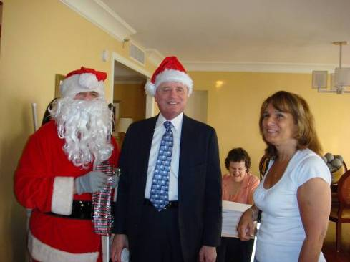
I’m writing this presidential message during the hottest time of the year, mid summer, which is also the time of year when activities really start heating up for the National Federation of the Blind of New Jersey!
I’m pleased to report that 103 New Jerseyans were filled with inspiration, education and motivation at the Federation’s National Convention in Atlanta in July. Look for features on the convention’s activities in the next issue of The Braille Monitor. A special person from the North Pole visited the members during the excitement of the convention (Santa in Atlanta, with NFB President Marc Maurer and NJ’s Jerilyn Higgins, at right).
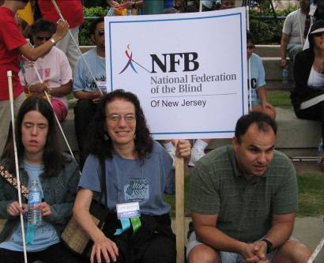
The first March for Independence was held bright and early on the morning of July 3. The excitement was heartwarming with over 1,500 members and supporters marching in the streets of Atlanta. The funds raised will assist the Jernigan Institute with program funding. In addition, half of the funds raised will revert back to the states for their programs. Members from New Jersey raised over $18,000 for this educational and inspirational event. I am proud to have been a part of it. Congratulations to all who marched and/or raised funds and to those who supported our efforts with financial donations. Please read the articles on pages 7 and 8 pertaining to the March from two future leaders of the Federation.
Serena Cucco, Carol Castellano and David DeNotaris at the March
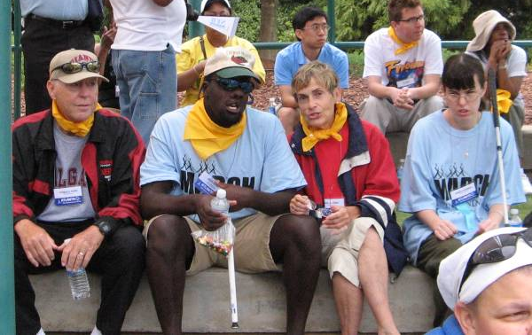
The Northeast Chapter has received two grants from the Imagination Fund, which manages the grant portion of the funds raised from the March, for ThruOurEyes.org, the chapter’s Internet radio project. This project has been extremely successful and continues to grow with listeners, programs and features. Please read the article on page 15 for more information.
The heat continues to sizzle with the introduction of a new fund-raising project for the members in the state. An EBay program has been established and information will be available at the State Convention.
The Ferrys -- Tom, John and Gail -- and Jessica Scannell
The State Convention will be held at the Holiday Inn Manahawkin, Friday, November 9 through Sunday, November 11, 2007. The Holiday Inn Manahawkin is located just one mile off the Garden State Parkway (Exit 63) and only a few minutes drive from Long Beach Island. The hotel, which opened in 2005, features 110 guestrooms, six suites, and an indoor pool with a hot tub and fitness center, as well as a full-service restaurant and Room Service. For reservations, call 609-481-6100. Please register as soon as possible; there is a registration form on page 30 of this issue. I promise you an opportunity to learn from each other as we absorb the philosophy that has made the National Federation of the Blind the largest and most influential blind organization in the nation and in our state.
Resolutions must be submitted to Mary Jo Partyka by Monday, October 22, 2007 at choirnfb@gmail.com or by phone at 609-888-5459.
We are proud to announce the establishment of two new divisions of the NFB of NJ. The New Jersey Association to Promote the Use of Braille and the New Jersey Association of Blind Seniors will become part of the state affiliate during the Convention. In addition, a new chapter will be established in Cumberland County in September. For information on this new chapter, contact Anne Jordan at 856-696-3905. The growth continues with plans to form another new chapter in the Somerset County area. Keep watching for this announcement. Meanwhile, the Northern Chapter has plans to reorganize and reintroduce the goals and purposes of this chapter with a breakfast meeting on Saturday, September 15. For more information, contact Rick Fox at 973-743-6107.
This issue is filled with exciting and diverse information. We hope you enjoy it. Please take a moment to complete the survey on pages 5 and 6 to help us improve this publication to make it what you want it to be. Feel free to share this issue of The Sounding Board with your neighbors, family members, teachers, eye care professionals, etc. This not only increases our circulation, it also gives us the opportunity to share with others how to keep on believing, dreaming and learning.

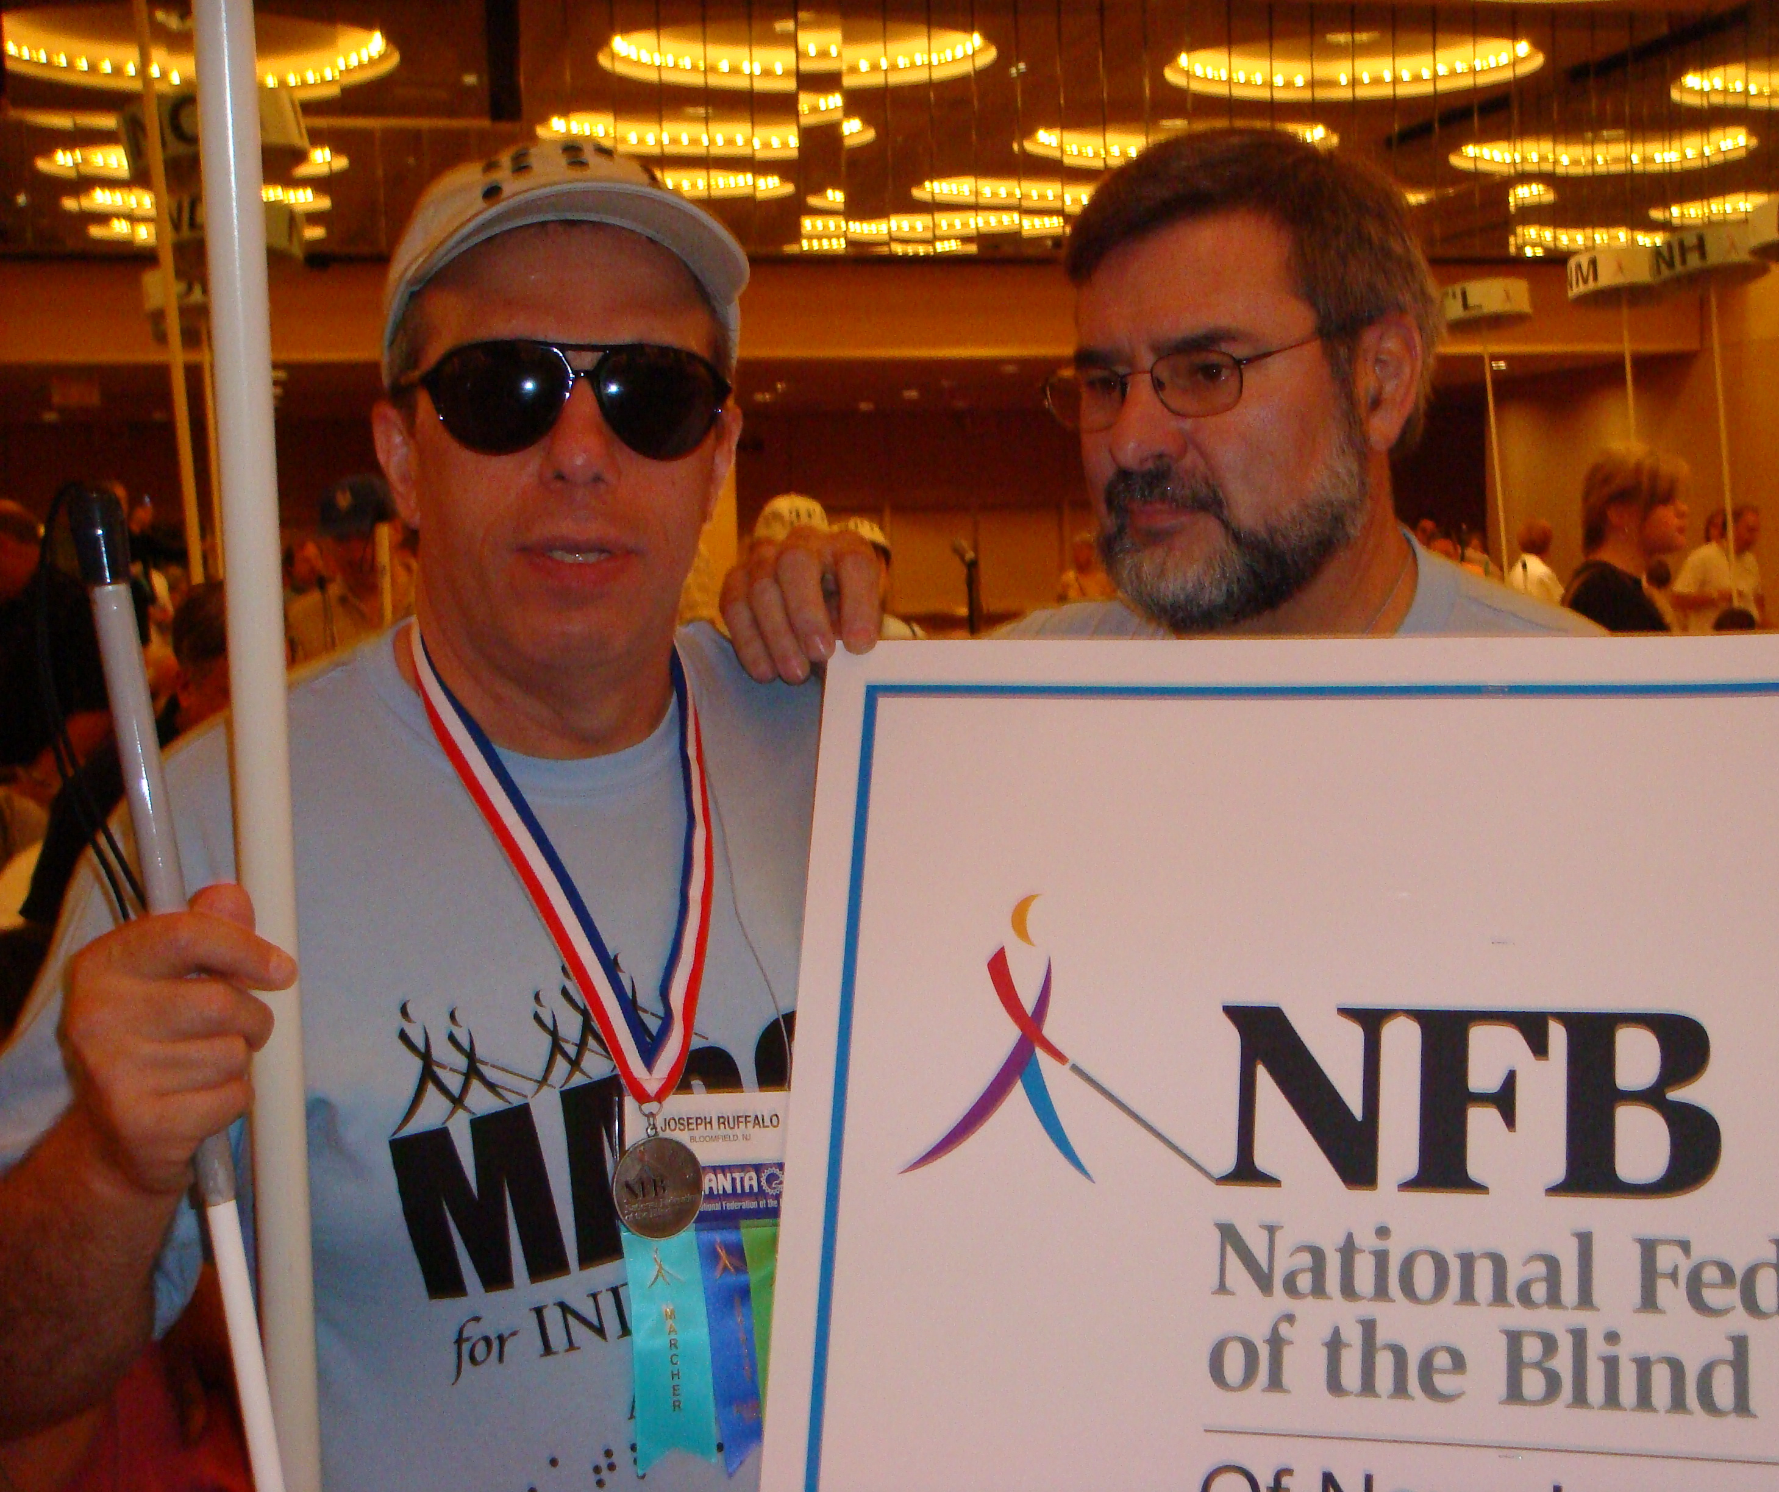
President Joe, with Bill Cucco at the March in Atlanta
Yours in Federationism,

Joseph Ruffalo
President, NFB of NJ

THE SOUNDING BOARD SURVEY

Twice a year we circulate The Sounding Board to over 1,200 subscribers. Occasionally we hear from readers who have enjoyed a particular article or perhaps the magazine as a whole, but most times, we hear nothing. We hope that we’re printing articles that are interesting to you, but to be sure, please take a few minutes to complete the following survey and mail it to Katherine Gabry, Editor, The Sounding Board, 187 Stewart Ave., Kearny, NJ 07032. Your answers to the questions can also be e-mailed to specialk38@aol.com. Thanks for your help.

1. I am a (check all that apply):
- Blind adult
- Sighted parent of a blind child
- Blind student
- Teacher
- Other: ______________________________

2. I read The Sounding Board:
- Always
- Sometimes
- Rarely
- Never

3. I access The Sounding Board in the following format (check all that apply):
- Large print
- Tape
- Electronic, via e-mail
- Via the NFB of NJ Web site

4. I would like to receive The Sounding Board:
- Once a year
- Twice a year
- Three times a year
- Four times a year

5. I think The Sounding Board is (check all that apply):
- Just the right size. It is a quick, enjoyable read.
- Too short. There should be more articles, longer and more in-depth.
- Too long. There are too many articles.
- Other comments:
6. I enjoy reading the following in The Sounding Board:
- Chapter News
- Legislative information
- News from the NJ Library
- News from the NJ Commission for the Blind
- Announcements about books, tools, equipment
- Feature stories on children and students
- Feature stories on adults
- Letters to the Editor
- Other:________________________________

7. Here’s a description of some other articles/topics I’d like to see in The Sounding Board:

8. I think The Sounding Board is (check all that apply):
- Interesting
- Informative
- Fun to read
- Timely
- Boring
- Other: _________________________________

9. When I’m finished reading my copy of The Sounding Board, I usually:
- Pass it on.
- Save it.
- Recycle it.
- Throw it away.

Thank you for completing this survey! Look for a summary of the replies and possible changes to our magazine in the next issue.

Please mail this completed survey to:
Katherine Gabry, Editor, The Sounding Board, 187 Stewart Ave., Kearny, NJ 07032
OR
e-mail your answers to: specialk38@aol.com
The March for Independence
By Serena Cucco

Editor’s Note: Serena Cucco has been a member of the NFB just about since birth. She is currently the Meet the Blind Month chairperson for the Northern Chapter of the NFB of NJ. Serena is a 2007 graduate of Manhattanville College and now works as a Life Skills Advocate at the Public Defender’s Office in Newark.
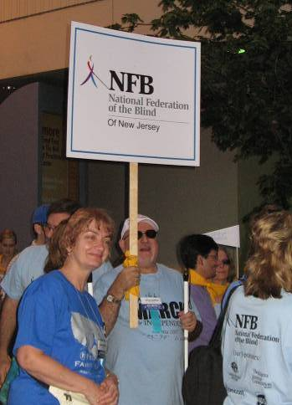
I was one of the thousands of proud marchers in the National Federation of the Blind’s first March for Independence. After donning our official March T-shirts and hats, we assembled at 6:15 a.m. (a really nasty hour) outside the Marriott Marquis hotel where we searched for the NJ banner amidst the throngs of people. When we heard Jerry Moreno calling out “New Jersey here, New Jersey,” we joined the NJ delegation.
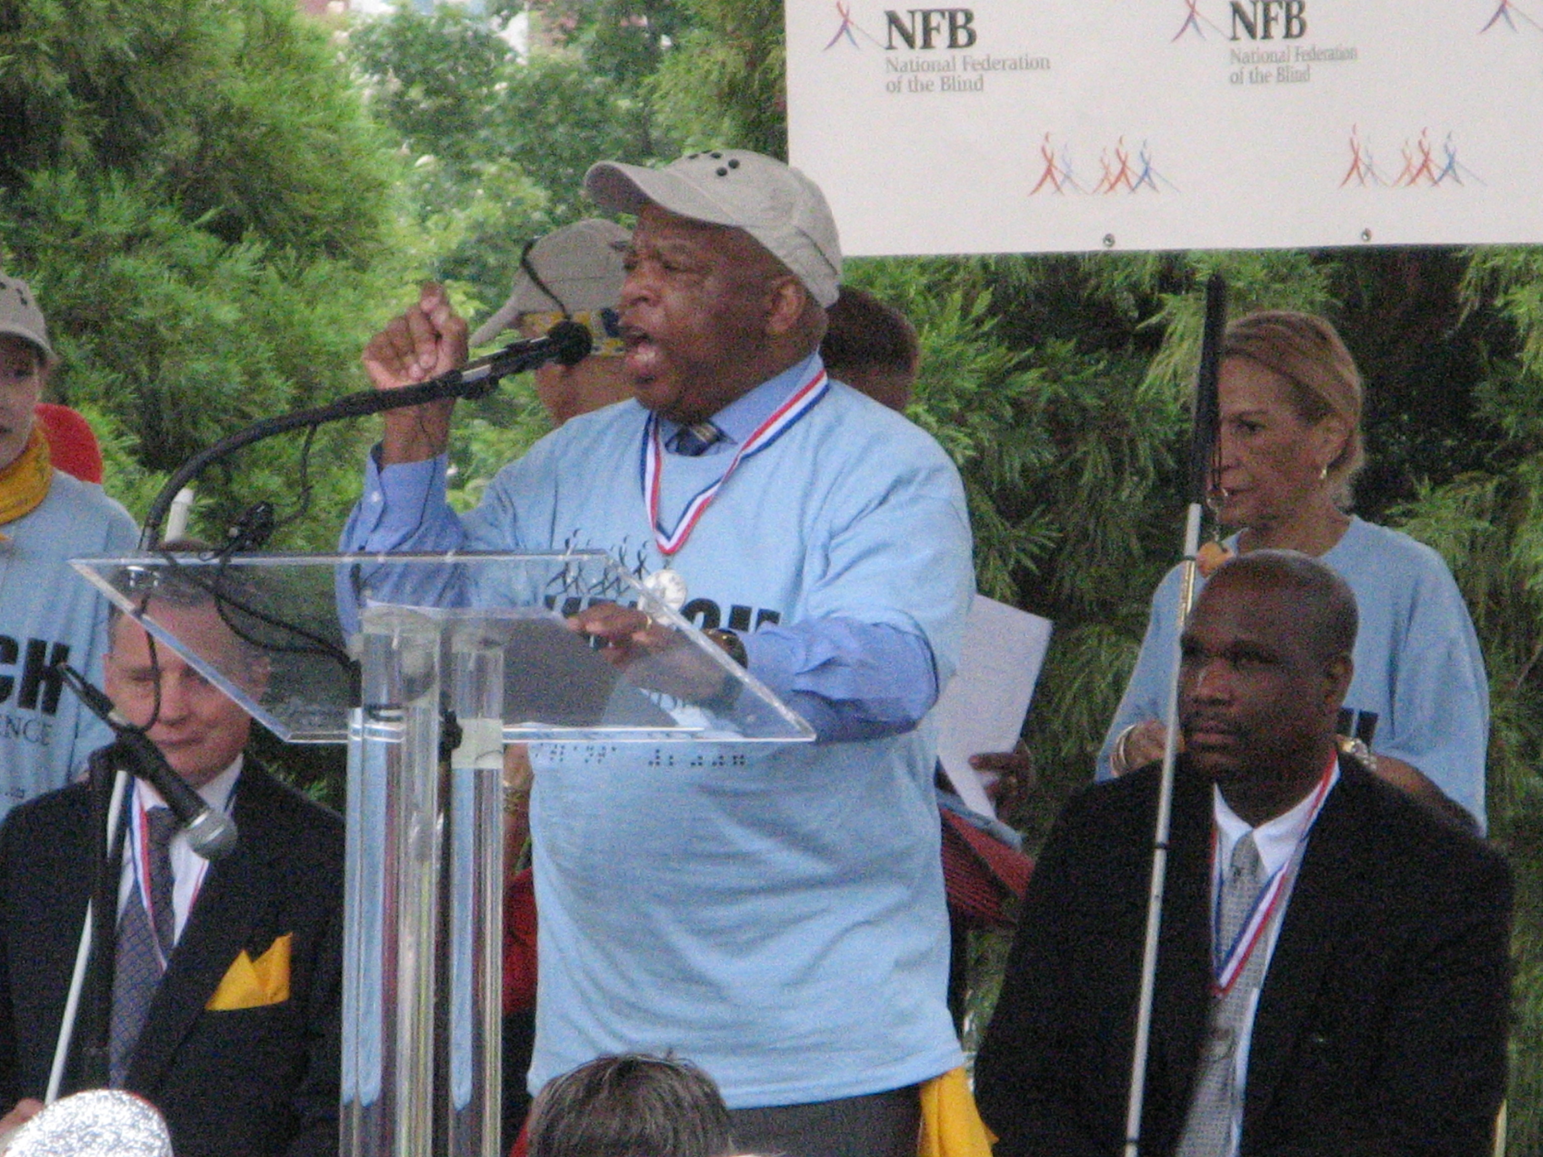
It was a beautiful day for a march, not very hot for Atlanta. As we proceeded along the March route, Jerry and other Federationists led us in chants about the NFB and independence. David DeNotaris, my mom and I were interviewed by a local radio station about what the March meant to us. To me the March stood for equality, independence and opportunity for blind people and showed the world that blind people can take their place in the world just like their sighted counterparts.
Madeline and Jerry Moreno at the March
When we arrived in Centennial Park, we heard rousing speeches from Jim Gashel, President Marc Maurer, Georgia NFB President Anil Lewis, Carol Young (wife of former Ambassador and Atlanta mayor Andrew Young), and Congressman John Lewis. Congressman Lewis’s speech particularly inspired me since he had marched for civil rights with Dr. Martin Luther King Jr.
Congressman John Lewis addresses the March
One purpose of the March was to raise money for the NFB’s programs. Those marchers who raised over $1,000 received medallions for their effort. It was an honor for me to hear the names of the NJ medallion recipients: Joe Ruffalo, Ben Vercellone, Ken Lawrence, Dan Facchini and Evelyn Valdez. The March was fantastically successful, raising more than $580,000.
After the ceremonies in the park, we marched back to the Marriott Marquis and, in one huge mass, entered the ballroom for the opening gavel. We were met by the thunderous cadences of the Atlanta Drumline. The atmosphere in the room was electric!
It was a joy for me to participate in this March and I very much look forward to marching again next year.
*************************

A MARCH OF CELEBRATION
By Mary Fernandez

Editor’s Note: Mary Fernandez is entering her senior year in high school. A member of the Leadership, Education, Advocacy and Determination Program, she has also attended the NFB's Science Camp. Mary was assisted in attending the Convention with funding from the Kenneth Jernigan Scholarship Fund, the NFB of NJ and Parents of Blind Children-NJ. Every penny was worth it.

“By marching here today, you have just gotten in trouble ... good trouble!” The voice of Congressman John Lewis reverberated throughout the park. In that moment in time I felt as one with the whole crowd. We were all in this together. All family. All marching for one cause. As I stood there, I gave thanks for the opportunity to be a part of the first-ever March for Independence that took place on July 3, 2007 in Atlanta, Georgia.
The National Federation of the Blind National Conventions have never failed to be inspiring and eventful, but this year was special. For the first time, the blind had come together and decided to show the world our independence in a very visual way. On the morning of July 3, 1,500 blind people marched three miles in Atlanta. This march was not just a demonstration of independence; it was a celebration. We were celebrating the fact that we had the freedom to march on that day.
As I walked along with the crowd, emotions and thoughts kept surfacing. It was amazing to be walking alongside people who were so motivated. There were all types of blind people. There were those who were already successful and to whom the march was a way to give back to the organization. There were those who had just become blind and to whom this march meant a new beginning, a new birth to hopes and dreams that they hadn’t dared to dream before. But no matter who you were, this march wasn’t merely a stroll down the street. This march meant freedom. This march meant both a fresh beginning and a way to cement our longstanding work toward equality and independence.
It’s impossible to describe the feelings that coursed through all of us – the joy of being together, and the strength and determination that was present in that body of people. In that span of time, I realized that I wasn’t alone. None of us was alone. In that moment, we knew that as long as we stood together, as long as we kept our goals in mind, we could do it, no matter what. We could easily march through any barriers, just as we were doing right then. All we have to do is dream together and work together to achieve our goals.

*************************

LEGISLATIVE NEWS
By Lynn Reynolds, Legislative Coordinator

As many of you know, we had a very informative Advocacy Seminar at the JKRC on March 24. Sharon Maneki helped us to see all that is involved in presenting issues to our State Representatives. The issue we wanted to deal with this year was the approval of the increase in number of positions for Orientation and Mobility instructors at the NJ Commission for the Blind and Visually Impaired. I would like to thank all who communicated with their representatives and the governor. This is an issue we still need to work on.
Nationally, our main concern in recent months has been the full funding for the transformation of all National Library Service materials to digital format. We are looking for $19.1 million each year for the next four years. I hope everyone has been receiving e-mails from me or from your chapter legislative coordinator. Again, I would like to thank all who have been communicating to the appropriate people as requested by the alerts which were sent out.
If there is anyone who would like to be added to our legislative e-mail list, please e-mail me at lhr1827@optonline.net. I look forward to working with all of you in the coming months.

*************************

CAPITAL CHAPTER NEWS
By Mary Jo Partyka, President

Since the last Sounding Board, our chapter has been working on two new projects which seem to be taking a while to reach fruition. First, we would like to get a Trenton newspaper on Newsline. We contacted one of the local newspapers, but nothing seems to be happening at this time. We would also like to take measures to make people aware of and to enforce New Jersey's White Cane Law. Right now, we are researching both of these areas. In the next few months, we will be preparing for two big fundraisers: the Septemberfest at Veterans Park and the Library Festival at the New Jersey Library for the Blind and Handicapped.
Our chapter meets on the third Saturday of each month (with the exception of July, September, November and December) at the Lawrence Library located at 2751 Brunswick Pike in Lawrenceville from 10 a.m. to noon. If you live in or are visiting the Trenton/Princeton area, we would love to have you join us.

CENTRAL JERSEY CHAPTER NEWS
By Jerilyn Higgins, President

The Central Jersey Chapter is happy to announce a new meeting place: Grace Lutheran Church, 600 New Brunswick Avenue, Perth Amboy. We meet from 10 a.m. to noon on the second Saturday of each month (when there is a holiday weekend, we change to an alternate date).
In chapter news, thanks to all who participated in our successful April Atlantic City fundraiser. On June 23, we had our end-of-the-year luncheon at Old Man Rafferty’s, and in July, 12 members from the chapter attended the National Convention in Atlanta. As usual, there was so much to see, learn and experience. Our next meeting is September 8, 2007. We will be working on our Meet the Blind Month event.
For more information about the chapter or our events, please contact Jerilyn Higgins at 973-239-8874 or by e-mail at jdhiggins@rcn.com.

*************************

GARDEN STATE CHAPTER NEWS
By Ryan Stevens, President

The Garden State Chapter meets on the third Saturday of each month (except July) in Conference Room A, Fifth Floor, John F. Kennedy Hospital in Cherry Hill. The meetings run from 10 a.m. to noon, and afterward, those who wish can join us for lunch in the hospital cafeteria.
This year, the chapter had six members attend the NFB National Convention in Atlanta, including first-timers Paul Agostinelli, Paul Grenier and Pam Hayes.
We will be holding our annual picnic at Red Bank Battlefield Park in National Park, NJ on Saturday, September 22 starting at 11 a.m. Please contact us if you wish to attend.
We currently have two Meet the Blind Month activities planned. The first is on October 6 at the YMCA in Sicklerville. The second is October 14 at the Cinnaminson Wal-Mart. We will be giving out NFB literature and Kernel books.

*************************

NORTHEAST CHAPTER NEWS

By Daniel Facchini, President

The Northeast Chapter continues to grow and stay active. We’re pleased to report that 11 of our members, including four first-timers, attended the National Convention and we raised approximately $3,000 for the March for Independence.
ThruOurEyes.org, our Web site, also continues to grow. There have been many new features and shows added to the mix, thanks to the Imagination Fund and the generous grants from the National Federation of the Blind. For specifics on the shows, be sure to read the article “Do you know about ThruOurEyes.org?” by Leonard Azzarone on page 15 in this issue.
Our annual barbecue was held July 14, and there are more exciting events planned for the next year as well. Please join us. We meet the third Saturday of the month at 39 Monona Avenue, Rutherford. Questions? Call 201-933-0355.

*************************

NORTHERN CHAPTER NEWS

The Northern Chapter is planning to reorganize and reintroduce the goals and purposes of this chapter with a breakfast meeting on Saturday, September 15, 10 a.m. to noon, at Beth Israel Hospital, 201 Lyons Avenue in Newark, in the Board Room on the first floor. For more information, contact Rick Fox at 973-743-6107.

*************************

NEWS FROM New Jersey Association of Blind Merchants
By Lynn Reynolds, Dan Facchini and Nicky Gacos

As we are in the process of strengthening our division, we are pleased to report that at our annual state meeting on May 12, we registered 14 new members, which brings our membership to 24. We hope to have a meeting in the fall.
Nationally, four of our members attended the National Convention in Atlanta. We actively participated in our fundraisers – selling Snack Packs and selling raffle tickets. We would like to thank everyone who participated in our fundraisers. Lynn Reynolds had the honor of being re-elected for another two-year term as a national board member at our annual meeting at the convention. Another New Jerseyan, Nicky Gacos, is the first vice president of the national board.
The issues concerning Randolph-Sheppard were featured as an agenda item during the general session. There will be challenges in the months ahead. We will be calling on all of you to assist in contacting our Representatives when necessary.

POBC-NJ NEWS

By Carol Castellano, President

Parents of Blind Children-NJ members have been busy with activities in many areas—training, advocacy, legislation and outreach—both in NJ and nationally. As part of the Department of Human Services (DHS) Restructuring Committee, we were invited to meet with the new Commissioner of DHS. We also remain actively involved in the Commission’s Parent Advisory Council, and several parents have been asked to be on the advisory council of The College of New Jersey’s new teacher of the blind training program. (Please see related story on page 14.)
In our ongoing effort to get more O&M instructors in NJ, we participated in the NFB of NJ’s Legislative Workshop with Sharon Maneki. Although we have not yet achieved victory, we will keep up our efforts until we do. Several of us also took part in the Federation’s annual Washington Seminar, where we visited our national legislators to discuss issues of importance to the blind, one of which is accessible textbooks for college students. As you know, we successfully fought for accessible books for blind children from Kindergarten through twelfth grade. We feel confident that we will also be able to ensure that blind college students get their books.
At the Washington Seminar, we continued our national Parent Leadership Program, of which I am project leader. We have brought parents in from all over the country to receive training, to meet Federation leaders and to see the Federation in action at both the National Convention and the Washington Seminar. These parents then go back to their home state to create or build a parents division. The program has been immensely successful.
At this year’s National Convention in Atlanta, we also participated in the National Center for Leadership in Visual Impairment (NCLVI), a new initiative established through a grant from the Office of Special Education Programs (OSEP) to develop a collaborative model for training leadership personnel in special education with an emphasis on blindness. About 20 of the doctoral students in this program were with us in Atlanta for the week. I was asked to make a presentation to them on education and research issues, and my husband Bill Cucco and I also served as mentors.
On the home front, in June we held a workshop on Independent Movement and Travel featuring Joe Cutter. As always, Joe’s interesting and original information held the attention and piqued the interest of our participants. A highlight of the day was the Cane Walk, when we took to the streets of Ocean Grove and each participant was able to try out a cane.
Our next event will be our annual parents seminar. This year our theme will be education. The seminar will be held at the Youth Temple in Ocean Grove, NJ on Saturday, September 29. Parents will receive a flyer in the mail. The flyer will also be posted on our Web site. Contact Carol Castellano at 973-377-0976 or blindchildren@verizon.net for further information. All are welcome.
NJ Association of Blind Students NEWS
By Quintina Singleton, President

The New Jersey Association of Blind Students (NJABS) has had a very productive summer and we plan to continue our work in the fall. At this year’s National Convention, NJABS marched together in the Federation’s very first March for Independence. Our student team, NJ Student Soldiers, collectively raised over $5,000 in pledges. After the march, we continued our fundraising efforts by selling Braille refrigerator magnets that promote the use of Braille. Five of our members attended the National Convention for the first time.
NJABS will be participating in POBC’s parents seminar in September, and will be co-hosting the State Convention this November. Please visit our Web site – www.njabs.org – for further details on our upcoming activities.

*************************

NFB of NJ division to promote the use of braille
By Mary Jo Partyka

Editor’s Note: At last year’s State Convention, Joe Ruffalo asked Sue Tillett and Mary Jo Partyka to spearhead this new division. To join, contact Sue Tillett at 609-924-7489 or Mary Jo Partyka in the evening at 609-888-5459.

As Federationists, we all realize how important Braille is to everyone from young children who are entering school to adults who become blind later in life. Braille is as valuable to a blind person as a pen and paper are to a sighted person. Braille enables blind people to read books, magazines and clothing tags, and write anything from class notes to letters to recipes to information needed for a job. There is a high correlation between people who read Braille and those who gain employment.
Our goal is to elicit more interest in the use of Braille even though many professionals encourage children and adults with some vision to use their remaining sight to read print instead of learning Braille. We hope that parents will consider that their children learn the fundamentals of Braille in addition to using their remaining vision.
Our division plans to stimulate the use of Braille by sponsoring activities like Braille carnivals, Braille reading contests and perhaps a book sharing opportunity where blind children could exchange Braille books. We plan to conduct workshops and other activities at our State Convention and at the Parents of Blind Children-NJ annual seminar. We hope that our workshops will show blind and visually impaired children and their siblings that Braille can be useful and fun. We want these children to realize that Braille is an alternative technique that facilitates the reading and writing skills of blind and visually impaired children. We also hope to strengthen the Braille Mentoring Program in which blind adults teach other blind individuals to read Braille.
We need your help. Chapter presidents and division heads: Please discuss this new division at your chapter meetings because we need more members. Parents: I hope you will consider bringing your children to one of our workshops to find out what we’re doing. I also hope that you and your children will think about joining one of our five local chapters in New Jersey because we know you have valuable information to share and we can all learn from one another.
Our division will meet formally only at the State Convention, but we will communicate by conference call and e-mail between conventions. I hope that you will join us.

*************************

New Position for POBC-NJ President
By Joe Ruffalo

Editor's Note: Carol Castellano has been recognized nationally as a leader in the field of blindness. In addition to conducting workshops, seminars and conferences throughout the country, Carol has authored three books: The Bridge to Braille : Reading and School Success for the Young Blind Child (with Dawn Kosman), Because Books Matter: Reading Braille Books with Young Blind Children and Making It Work: Educating the Blind/Visually Impaired Child in the Regular Classroom.
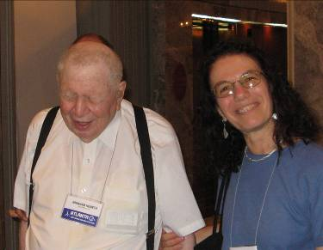
For the first time in history, New Jersey has its own training program for teachers of the blind! A collaboration between the NJ Commission for the Blind and Visually Impaired and The College of New Jersey (TCNJ), the program opened this past year at TCNJ’s campus in Ewing, NJ.
I am proud to announce that Carol Castellano, President of Parents of Blind Children-NJ, was asked to be a part of the new program. She began her new position as Outreach and Recruitment Coordinator for the Teacher of the Blind/Visually Impaired Program at TCNJ in June. Among other duties, Carol will be responsible for locating blind adults and families with blind children who would be interested in meeting on occasion with the teachers-in-training so that the students can get some good experience with blind people. If you would like to be a part of this effort, or if you are interested in becoming a teacher of the blind yourself, please contact Carol at 973-377-0976 or blindchildren@verizon.net.
Carol Castellano, with Dr. Abraham Nemeth, author of the Nemeth Code
Another great piece of news regarding Carol: At the close of the National Parents Seminar at this year's National Convention in Atlanta, NOPBC President Barbara Cheadle announced that she would not run again for president when her term is up next year. She then extolled the virtues of our own Carol Castellano and recommended that Carol be the next NOPBC President!
I can think of no one more qualified to be in these positions. Congratulations, Carol!

*************************

DO YOU KNOW ABOUT ThruOurEyes.org?
By Leonard Azzarone

ThruOurEyes.org, sponsored by the Northeast Chapter of the NFB of NJ, went live on the Web in March 2005, while WTOE (ThruOurEyes Radio Network) began in May 2005. To date we have received two Imagination Fund grants (2005 & 2006) to upgrade our site and station. We now offer seven different radio shows broadcasting every Wednesday evening starting at 8 p.m. EST. Two shows – ThruOurEyes with Joe Ruffalo and Hot Button with RyanO – cover visually impaired content.
ThruOurEyes with Joe Ruffalo is a one-hour show where the president of the NFB of NJ talks about NFB issues and philosophy and interviews people from all over the country about subjects of interest to blind and visually impaired people.
Hot Button with RyanO is a freewheeling discussion about today's hot topics concerning the blind and visually impaired. Although an advocate and member of the NFB, RyanO makes sure ALL sides of an issue are discussed! Ryan, 32, lives in Lincoln, NE, and has been an active member of the NFB for 11 years serving as state secretary, Lincoln chapter president and the Nebraska student division president. He is currently the Nebraska NFB Newsline outreach coordinator, as well as the second vice president of the Lincoln chapter.
The World of Hunter Silvastorm is another freewheeling talk show. Hunter sets aside time to interview a guest that invariably proves to be interesting, informative and fun. Hunter covers a wide range of topics such as politics, science, society, literature and the geo-political quagmire. The show encourages listeners to join the party by calling in during the live broadcast.
Uncle Ed Unscripted features Ed Sweeney, who is an independent financial planner who owns his own investment company. Uncle Ed has an admiration for creative people and entrepreneurs. The show is never scripted so you never know what will happen.
American Outlaw is moderated by Doc Dalton, though some know him as the American Outlaw due to his involvement in the fields of pro wrestling and television. Doc takes a firm stand on drugs, alcohol and the Christian way of life. The show features Christian recording artists and their music.
Live in the Arena features a clash of ideas and emotions in rapid-fire succession that impact virtually every area of thought, from the humorous to deadly serious!
Blind Tech is an original monthly technology show dedicated to technical issues about computers and software for the blind and visually impaired.
WTOE Radio has over 17,000 subscribers to its weekly podcasts with over 1,000 live listeners weekly. We are featured on over 71 Podcast Web sites, as well as iTunes.
WTOE Radio is now Beta testing WTOE Video, which means we broadcast live video along with each show. This video is simultaneously broadcast on two additional Web sites, uStream.tv and Stickam.com. This affords us a potential audience of over 1 million people.
WTOE Radio offers free advertising to any NFB affiliate that would like to advertise their next event. Simply visit www.thruoureyes.org, click on “advertise your next event” and follow the instructions. This free service can be used as often as you like. We also offer our services FREE to any affiliate or chapter throughout the country that would like to do their own radio show and/or podcast. Details are available on our Web site or through our toll free number: 1-888-572-0141.

*************************

ACCESS EQUALS SUCCESS
By Jerry Moreno

Editor’s Note: Jerry Moreno has known David DeNotaris for 13 years. David has served as a mentor, teacher, student and friend to Jerry and to those in the blindness community. David freely passed his “torch of knowledge” along to Jerry, and Jerry has continued to pass the torch to others. Keep passing the torch!

Congratulations are due to David DeNotaris, who has moved from New Jersey to Pennsylvania to assume the duties of the executive director of the Pennsylvania Bureau of Blindness and Vocational Rehabilitation. His new job began in August 2007.
One of the first things that David taught me was that “access equals success.” David has been climbing the ladder of success, accessing one level and then rising to another, always motivating others not to accept the status quo but to press on into uncharted waters.
I met David in 1994 while gathering information about assistive technology. It was all new to me and I needed some help. We met at his office and he gave me my first lesson in assistive technology. Not only did he talk to me about his computer, he introduced me to an organization that would greatly benefit me over the ensuing years. He introduced me to the National Federation of the Blind.
When I met with David that day, he asked me to go on a bus ride to the National Center in Baltimore the next month. That is where I attended my first NFB chapter meeting. I also purchased my first cane that day. I often wonder when I would have gotten around to buying one if I had not met David that April.
David was the manager of Statewide Operations for the New Jersey Commission for the Blind and Visually Impaired where he was responsible for 200 full- and part-time employees and managed over $6 million in yearly budgets. He also held other positions with the NJCBVI and worked for the First Occupational Center of New Jersey.
David earned his bachelor’s degree in speech communications from East Stroudsburg (PA) University in 1992. At first, he was denied access to that curriculum, but he pressed on to achieve his goal. He earned his master’s in administration supervision, leadership, training and development, with a concentration in education, from Montclair (NJ) State University in 2004. David was interviewed and selected to deliver the MSU graduate student address before 17,000 attendees at the Continental Airlines Arena.
David has been very active in the blindness community. Through the years, he has been on the State Rehabilitation Council, has directed the Friday portion of the NFB of NJ State Convention and has been a consultant to the NJ Department of Transportation.
He was appointed Chairperson of the NEWSLINE® Program Steering Committee by President Maurer of the National Federation of the Blind. He is also a published author and sought-after national speaker on the topic of overcoming obstacles. David has been the Job Opportunities for the Blind coordinator for New Jersey, a Lions Club member and a world champion power lifter.
According to David, one of his greatest accomplishments was on September 23, 1995, when he married Mariann Serano. They are the proud parents of three wonderful children, David, Mary Kate and Emily. David also enjoys exercising, reading biographies of individuals who have faced great challenges and getting his hands dirty in his family’s herb and vegetable garden.
One of the greatest lessons David says he has learned is from his father, Dante DeNotaris, who recommends summarizing a problem in 17 words or less and spending the rest of your time and energy focusing on the solutions.
Speaking for the Board of Directors of the affiliate, we wish David well in his endeavors in Pennsylvania. Our loss is their gain.
David’s encouragement over the past years has been a blessing to me. I have learned from his expertise and knowledge on blindness issues. And now, the State of Pennsylvania will as well.

WHY SHOULD I USE A CANE?
By Jeff Altman
Editor’s Note: Jeff Altman is a member of the National Federation of the Blind of Nebraska. In his job he teaches cane travel. This article originally appeared in The Braille Monitor. This is what he says about the importance of learning to use a cane confidently.

“Why should I use a cane?” is a rather common question among people new to blindness and, for that matter, to some folks who have been living with blindness for many years. One is tempted to respond with a matter-of-fact answer such as “Because you are blind, and the white cane is an appropriate tool for a blind person to use when traveling.” However, upon reflection, one must recognize that in reality this is not a simple question to answer since the white cane does not have the same social significance to the blind person as, say, the hammer does to a carpenter or the stethoscope does to a doctor. Occupational tools are socially acceptable, and some, such as a judge's gavel, even become symbols of high social status.
Some frequently used tools have little to do with occupations but are widely accepted because they improve the quality of our lives or are more convenient than other methods of getting things done. I will state with some certainty that most Americans prefer to cook their meals using the kitchen stove rather than building a fire in the back yard each evening. Certainly most people choose to drive or use some other form of mechanized transportation rather than walking when embarking upon a long trip.
These everyday devices seem so ordinary that we hardly think of them as alternatives to more basic methods of cooking or traveling. Yet these very devices were nearly unheard of only a few generations ago. In fact, in the beginning neither the modern stove nor the automobile was immediately accepted; people distrusted the new technology, and only when they began to understand how the stove and car worked and discovered that they were in fact safe and dependable devices did they stop chopping stove wood or retire their horses.
The long white cane is an alternative device and involves mastering some alternative techniques for efficient travel. It need not be any less effective than the more commonplace method of travel using vision. Somehow, though, our society has not come to terms with this device. Often it is perceived as inferior. More importantly, society remains somewhat uncomfortable with the people who use the white cane. Unlike many new devices which are resisted by society because the technology or operation is poorly understood or perceived as unsafe, the long cane and its use are quite simple to understand: the cane tip moves in a body-width arc, checking for obstacles and changes in terrain. The white cane has been in common use for many years and certainly does not represent a serious safety threat to the user or to others exposed to it. Isn't it odd that a device in common use for more than 50 years and absolutely straightforward in function continues to be resisted both by society in general and by the people who could benefit most from using it?
We must understand that, in spite of our society's apparent fascination with logical thinking, the majority of the decisions people make are based on emotion. Those who make important life decisions without carefully considering the facts and possible consequences are labeled impulsive and irresponsible. But in reality we often make choices based upon our emotional reactions and then assemble logical reasons and confirming opinions to justify our actions. This behavior is a significant part of what makes us human. Still it is careful gathering and examination of available information and thorough consideration of the results of our actions that serve as a gauge of our maturity and wisdom. All this said, I believe that society finds the long white cane unacceptable because blindness is surrounded by myths, misconceptions and fear. Unfortunately, as members of society, we who are blind inevitably share the negative responses to blindness that permeate society. A very fine line separates social, scientific or universal truth, on one hand, and unsubstantiated opinion on the other. It is troubling that even the people who hold themselves up as experts in the blindness field and in the use of the white cane often express by word and action the opinion that the white cane should be used only as a last-ditch method of travel. Blind travel students are often instructed to use a human guide in unfamiliar or noisy areas, to keep the long cane as short as possible in crowds to avoid tripping others, and when possible to hold the cane vertical and depend on residual vision in familiar areas. These recommendations represent and reinforce a damagingly negative view of blindness and blind people. After all, if all your experience indicates that a particular set of concepts and practices is obviously true—especially when this misinformation is presented by supposed experts—it becomes difficult to consider any other possibility, even when you hold the key to true independence in your hand.
The best person to answer the question posed at the beginning of this article is the person who asks it. It can be argued (and I would do so) that only an expert in the use of the white cane can answer the question wisely, but I also stand by my previous statement that only the blind individual can and should make the decision whether to use a cane. Therefore making a wise decision involves becoming an expert in the use of the cane. With all non-visual techniques, one cannot fully appreciate the benefits without first having learned to use them efficiently, to trust them fully and to believe in their effectiveness. For the individual with some functional vision, this goal can be achieved only by using sleep shades since people have such a strong tendency to use vision when possible rather than depending upon the feedback available through other senses.
I can respect the decision of any blind person who has made a sincere effort to learn to use the white cane and then chooses to travel without it. Those who refuse to learn the techniques for good cane travel are also entitled to make that choice, but I hope that they will also accept the responsibility for the consequences of their decisions. It may be a fine choice for them, or it may prove to be a very poor one. Unfortunately many blind people who have refused to learn to use the long white cane have clearly made the wrong choice, and sadly many of them do not recognize that it is this error that seriously limits the quality of their lives.
If you choose not to master cane travel, please be careful, and please do not then blame your blindness for what does not go well in your life. Those of us who choose to use the long white cane would prefer that society hear and learn the truth about cane travel and not self-serving excuses from people with little or no actual firsthand experience.

*************************

A “LEAD”ING EXPERIENCE
By Ben Vercellone

Editor’s Note: Ben, a graduate of the Leadership, Education, Advocacy and Determination (LEAD) Program, has attended the Washington Seminar and State Conventions, and this year attended his first National Convention in Atlanta. Ben was extremely active in raising funds for the March for Independence. Enjoy reading his thoughts about moving from dependence to independence.

I want to thank the LEAD administrators for organizing the Baltimore LEAD trip. Each year I have been in LEAD, I have eagerly awaited the trip to Baltimore. I remember my first trip in 2005. I got to operate some powerful tools and do many other things, the exact details of which I can no longer remember ... I do remember, however, having a blast. Last year when I went, it was just as cool, but I was glad my schedule was different. I got to work in the kitchen, and I gained confidence with cooking. Thank you for the variety. You know how to keep the same themes, but vary the activities enough to keep them fresh. So I definitely was ready for the trip to Baltimore this year as well.
When I was on the bus, a girl said that last year she got to operate a chain saw. I didn’t believe her! Surely she meant a band saw or circular saw or something else. But, yes, indeed she was correct! It was a chain saw, and when I operated this powerful tool, I realized that there is truly freedom, but only if I believe in myself. I wanted to operate the chain saw, but I only knew how possible and easy it was when I actually cut some wood. I thought that this was certainly easier than folding a fitted sheet. I am happy, however, that I learned some folding skills as well; they are truly important too.
I had a great time on this trip, and like always, LEAD proves to me that I can do it. Now, after four years in LEAD, I am finally feeling confident and happy wherever I go, not only when I am with this group. Without LEAD, I certainly would not be quite as fortunate. The Baltimore trip was just one of many wonderful experiences that I have had with LEAD. Thank you for your hard work and love for us and our advancement.

*************************

NEWS FROM THE NJ LIBRARY:
Fall Festival to be held Saturday, October 13, 2007
By Anne McArthur

The New Jersey Library for the Blind and Handicapped (NJLBH) is celebrating its 40th anniversary at our Fall Festival on October 13 from 9 a.m. to 3 p.m. at 2300 Stuyvesant Ave. in Trenton. Please join in the celebration of the work the library has done in serving New Jerseyans with print disabilities since it opened its doors in 1967.
NJLBH Director Faith Lundgren and her staff have been working to make the Fall Festival a success. This year’s theme is “Accessibility in the Arts” and will celebrate the contributions that individuals with visual impairments bring to the arts. The keynote speaker will be Ken Woodard, a successful commercial artist whose works have been featured at Euro Disney-Paris. Mr. Woodard will speak about how his artistry has been affected by a recent visual impairment, and the technology he uses to continue to paint.
The afternoon will feature several artists discussing their art and the ways their disability influenced it. Singer Rocco Fiorentino, who has been blind since his birth 10 years ago and is well known for educating students and teachers about blindness, will be speaking. Rocco has performed at venues including the Philadelphia Flyers, the 76ers and Sesame Place. We will also hear from Larry Bonds, a graphic artist who has impaired vision as the result of diabetic retinopathy.
There will be something for everyone. Grounds for Sculpture will provide a hands-on table with touchable sculptures. Visitors will also have the opportunity to experience demonstrations of the latest low-vision technology. Paws-on-Wheels petting zoo will be back by popular request. There will be an opportunity for guests to participate in a sing-along to showcase their musical talents.
For registration and transportation information, please call 1-800-792-8322.
GOOD THINGS ARE HAPPENING AT NJCBVI:
2006 YEAR-END SUMMARY
By Pamela Gaston

As we said good-bye to 2006, we marked the end of the 96th calendar year that the New Jersey Commission for the Blind and Visually Impaired has provided essential quality-of-life services that enable people who are blind and visually impaired to live full and productive lives.
Our success over these many years can be attributed to a variety of assets including the dedication of our staff. The ever-strengthening partnerships we have established with our consumers and community-based colleagues are also integral to the capabilities of CBVI because there is no question that a successful program for people who are blind or visually impaired must be designed with input from people who are blind or visually impaired. However, we believe that maintaining a positive approach to blindness is also one of the most valuable contributing factors to the effectiveness of CBVI services, programs and initiatives. This organization’s longstanding legacy of commitment to continuous expansion of opportunities for our consumers is based on promoting awareness and understanding that every person with a disability has a right to live with dignity.
At the same time, there is no doubt that the blind and visually impaired community has a number of issues to confront. On the national front, blindness services are being affected by declining government and non-profit funding; unmet needs in accessibility, education, employment, vocational rehabilitation, transportation and many other areas; and a growing older blind population. Through CBVI’s operational capabilities as a stand-alone organization, New Jersey remains at the forefront for services designed to meet the unique needs of individuals who are blind and visually impaired.
Each CBVI consumer who achieves their individual goals is a success story for CBVI. And each measure of progress CBVI makes towards establishing sustainable opportunities for our consumers is a victory for all.
Here are some highlights of what has been accomplished this past year:

Vocational Rehabilitation
In 2005, CBVI surpassed the Rehabilitation Services Administration’s (RSA) standards and indicators, which measures CBVI’s impact on the quality of life of its consumers. Through staff’s efforts, CBVI now stands in the upper tier of VR agencies in the country. Our spring 2006 consumer employment placement has already surpassed the number of gainful employment placements in spring 2005.

Employer’s Outreach Initiative
This new initiative involves reaching out to major employers in the state to foster relationships, partnerships and to facilitate employment opportunities.

JKRC Simulated Work Environment
Here’s where students can get hands-on experience with production, selling and developing specific skills that employers are looking for. It also serves as a model for employers to learn about the capabilities of blind and visually impaired individuals, and the various assistive technologies that are available.

The College of New Jersey Transition Program

Our partnership with The College of New Jersey created a new 3-week summer program for transition-aged students who are blind or visually impaired with other potential employment barriers. The program emphasizes preparation for employment, work skills and career exploration.

Equipped for the Future (EFF)
This is the National Institute for Literacy's (NIL) effort to improve the quality and results of the adult literacy, basic skills and life skills learning systems. EFF aims to reform previous attempts to assess and train for work readiness. The EFF standards include reading, writing and math within four key categories of skills and knowledge: those that support effective communication, working with others, problem solving and decision-making, and “learning-to-learn.”
Currently, CBVI is working to adapt the EFF so that it is accessible to our consumers. When completed, this will allow CBVI to provide the EFF training and assessment at JKRC. At the end of the EFF training, consumers will possess a certification indicating that they possess those skills required by most employers.

Business Enterprise Program
We continue to search for entrepreneurial opportunities for our consumers and operators in our Business Enterprise Program in the private sector. We recently acquired a food service contract at Fort Monmouth’s West Point Cadet Prep School and added a cafeteria service to our existing vending contract at the Jersey City Bulk Mail Center.

Education
In 2005, CBVI received $900,000 from the Governor's Literacy Initiative which has allowed CBVI to hire an additional 12 education instructors. CBVI’s goal is to increase the number of Braille lessons to four lessons per week for Level III students. An Education Focus Group met in January 2006 to examine how CBVI currently delivers education services and how its educational service programs can be enhanced. The information gathered is pending incorporation into CBVI’s five-year strategic plan, which is currently being updated.

Teacher Certification Program
CBVI has entered into a partnership agreement with The College of New Jersey in Trenton to create the first Teacher of the Blind certification program in New Jersey. This certification program will facilitate the replacement and new hires of Teachers of the Blind for CBVI.

Camp Marcella
Over 200 kids attended camp during the 2006 camping season. CBVI is working to obtain accreditation of Camp Marcella from the American Camping Association (ACA) in 2007. We joined the ACA as an Affiliated Camp for the 2006 season, and were provided training and support from the ACA to prepare the camp for the accreditation review during the 2007 season.

George F. Meyer Center
CBVI is in the process of upgrading the capabilities of the Meyer Center to meet the needs of its students and to support its instructors. CBVI has invested a significant amount of funds to upgrade the equipment at the Meyer Center. Additionally, a training area specifically to train students, staff, consumers and parents on assistive technology will be created.

Independent Living Services
In April, CBVI hosted a Task Force Meeting with the goal of developing and implementing action plans to address the specific needs of the older blind and visually impaired. CBVI seeks to provide better services to our seniors, recognizing their needs are more complex today than we’ve thought in the past. We have continued communications with advocates representing this sector of our consumer population who have impressed upon us their concerns for having greater access to opportunities to participate in their communities. The Task Force’s recommendations have put CBVI on the right track toward creating a strategic plan that will address a broader range of consumer services for this population and will ensure that New Jersey is able to provide services that will enable these residents to maintain an independent lifestyle and prevent premature institutionalization.
CBVI recently developed and secured a contractor to establish an Older Blind Program in the Toms River area, and plans to develop an additional proposal for serving older deaf-blind individuals in the Central Region using federal funding.
In November, 10 O&M instructors presented interactive programs to 30 NJ Transit team members to better assist them with communicating, assessing and determining the transportation concerns for NJ Transit travelers who are blind or visually impaired. Most of the team members were uncertain about how the world looks to people with visual impairments. As part of the presentation, to experience travel and to become sensitive to some of the issues our blind and visually impaired consumers face, the NJ Transit team, accompanied by a CBVI O&M instructor, were placed under blindfold and using four different bus stops boarded buses to 153 Halsey St, Newark and then took the subway back to NJ Transit headquarters. The program was very well received by all who attended.

Blindness & Braille Literacy Campaign
CBVI understands that the real problem of blindness is not the physical loss of eyesight but the misconceptions many sighted and blind people hold about vision loss. Blindness and Braille literacy events give the larger public, both blind and sighted individuals, an opportunity to form new and positive ideas and awareness about what blind and visually impaired people can do if they receive the proper training to deal with their blindness, and the opportunity to put that training into practice. People who are blind can live independently, participate in recreational activities and work competitively as full members of their communities.
In keeping with this philosophy, CBVI partnered with other agencies in the field of blindness to host a few exciting events this year including the Grounds for Sculpture Tour that took place in June and Covering the Bases: Blind and Visually Impaired Awareness Day at a Trenton Thunder baseball game in August.

*************************

NJIT’s EmployME! PROGRAM RECEIVES RAVE REVIEWS

When the inaugural class for the EmployME! IT training program reached its fifth week of classroom sessions, feedback was solicited from the students in these areas: classroom environment, software, hardware/computers, course content, instruction, administrative services and overall. Each category received an average score of 4.8 on a 5 point scale with 5 being the highest rating. The instructor, Bob Longo, received a rating of 4.9! All of the students indicated that they would recommend this program to others.
EmployME! is a public-private partnership that strives to prepare unemployed and underemployed men and women with disabilities for both entry level and advanced jobs in the Information Technology (IT) field that are in demand in New Jersey. The program is funded by grants from the Henry H. Kessler Foundation and the New Jersey Workforce System.
New classes form every 10 weeks. Students who meet the criteria are accepted on a first come, first served basis. Admission criteria include: high school diploma or equivalent (ninth grade reading level/eighth grade math level), interest in the Information Technology area, ability to attend an 18-week, all-day training program, successful completion of a computer technology assessment at NJIT and successful completion of an interview at NJIT. Applications for admission can be completed online at http://cpe.njit.edu/employme/ or by calling 800-624-9850, option 5.
There are two training tracks: Track One – Web Technology and Desk Top Publishing and Track Two – Open Source UNIX Administration. Tuition for the program is $4,000. Tuition is the responsibility of the student and may be partially or fully funded through tuition allocations from an agency, such as the Division of Vocational Rehabilitation Services, Commission for the Blind and Visually Impaired, One-Stop Centers (WIA), or other referring agencies. All applicants are encouraged to speak with their referring or sponsoring agency to explore the processes and procedures for referral, eligibility and approval.
For more information about the EmployME! IT training program at NJIT, please contact John Sobecki, program manager, at 973-596-5819 or sobecki@njit.edu or Cindy Montalvo-Harden at 973-596-3064 or montalvo@njit.edu.

*************************

NEW OUTLOOK PIONEERS OFFER FREE BRAILLER REPAIR

The New Outlook Pioneers provide an inexpensive repair service to Perkins Brailler owners. The Pioneer volunteers, all retirees who formerly worked in technical pursuits, repair with either new or used parts, as available, and the service is free except that they request reimbursement for their cost of any new parts that must be installed in Braillers they repair. All machines are logged by serial number to ensure the return of each machine received for repair to its proper owner.
The group provides pick up and delivery in a 20-mile radius of Denville, NJ. Owners can also ship a unit for repair, carefully packed in a box (not its carrying case), insured with the U.S. Postal Service, and with the legend “Free Matter for the Blind” in the upper right corner of the package address side. Please note that the U.S. Postal Service will charge a fee for the insurance. A card with the owner’s name, address and other contact information should be included in the package, along with a statement describing the nature of the problem.
The Pioneers also accept donations of used or damaged machines that can be used for spare parts. For further information, please contact Charles Phelan at 908-647-9226 or 908-229-0041 or via e-mail at fixnBraillers@juno.com.

*************************

Get connecteD!
AccessTech
COMPUTER TRAINING CLASSES
AVAILABLE FOR
BLIND and LOW VISION New Jersey Residents
Did you know that you can learn to use a computer even if you are blind or visually impaired? AccessTech classes are fun and free of charge. Little or no computer experience is needed!

Learn to:
- Send and receive e-mail
- Surf the Web
- Play easy-to-use games on the Internet

Learn to Use:
- The latest assistive technology hardware and/or software
- Screen readers, such as JAWS For Windows
- Screen magnifiers, such as ZoomText

SPONSORED BY:
The New Jersey Commission for the Blind and Visually Impaired.

LOCATIONS:
Statewide at public libraries and other community facilities; inquire for current sites and counties served.

Enroll: Contact 877/447-6500 ext. 227, or AccessTech@dewitt.com

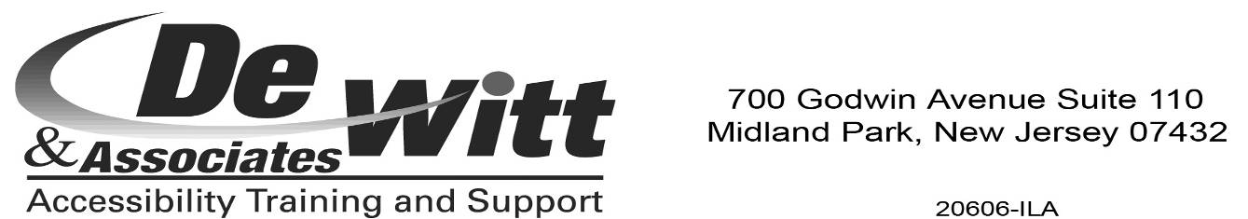
*************************

ADOPT ADAPTIVE EQUIPMENT
By Lynn Reynolds and Ed Godfrey

In the past six months, we have successfully placed Type and Speaks and a CCTV. We still have available the following items: a computer with Windows Millennium on it, a monitor and keyboard, Braille Lites and a CCTV.
Please remember that these items are donated, so they may need repairs, but the repairs may be less expensive than purchasing a new item.
If you are interested in any of these items or if you have a piece of equipment which you no longer need, please contact Lynn by phone at 908-251-5510 or by e-mail at lhr1827@optonline.net or Ed by phone at 856-906-4516 or by e-mail at egodfrey137@comcast.net.
Please remember, when we make the contact for a match, it is the responsibility of the two parties to make the arrangements for the adoption of the equipment.

*************************

LETTERS

To the NFB of NJ,

I am a member of the Northeast Chapter of the NFB of NJ, and this year I attended the National Convention in Atlanta for the first time. I received a Jernigan Institute scholarship which helped me attend the convention.
Since it was my first time, I had no idea what to expect, so I attended the Rookie Roundup, where first-timers come together and learn more about the convention and what goes on during it. I felt a bit overwhelmed because there were so many workshops ... I didn't know what to go to first! I walked in the March for Independence, which was an amazing experience that I will never forget. I felt like I was part of history. I attended all of the general sessions of the convention where professionals discussed issues like quiet cars and education.
After hearing these individuals speak at the general sessions and listening to Dr. Maurer speak, I left the convention feeling inspired. It opened my eyes to endless possibilities.
Sincerely,

Dana Hemmings

Please join us for the National Federation of the Blind of NJ’s
31st ANNUAL STATE CONVENTION

November 9, 10, 11, 2007
MANAHAWKIN HOLIDAY INN
151 Route 72 E, Manahawkin NJ 08050, 609-481-6100 Access Link accessible
C A N D O
* Commitment * Accomplishments * Networking *
* Dreams * Opportunities *
CAN DO will feature Charlie Brown, who served as President of the NFB of Virginia and NFB National Board Member for over 20 years, along with influential policy makers and experts in the fields of Braille literacy, education, mobility, employment, access technology, legislation, senior concerns and more!
Friday, Nov. 9
10 a.m. to 5 p.m. — Exhibit Hall
1 p.m. to 5 p.m. — Division and Committee meetings; workshops on Braille, technology, mobility, success for students, Dress for Success and more.
Friday Evening — Hospitality sponsored by the Vendors, Resolutions Committee meeting, American Idol NFB Style and a dance, hosted by the Student Division and the Garden State Chapter.
Saturday, Nov. 10
8 a.m. to 5 p.m. — Presentations by Charlie Brown, the Commission for the Blind, the Library for the Blind, Recording for the Blind and other experts in the blindness field, Exhibit Hall, networking opportunities, door prizes and much more.
Saturday Evening — Banquet, Scholarship Awards and Live Auction!
Sunday, Nov. 11
9 a.m. to 12 p.m. —Business Meeting, Resolutions and Elections, open to all.
Special room rate of $85 per night includes breakfast!
Call the hotel at 609-481-6100 to reserve your room right now. This special rate is guaranteed only until Nov. 1; after Nov. 1, the rate may increase. For those who register before Nov. 1: each pre-registered person will be eligible for a special drawing of a cash prize! You will also receive express registration service at the Convention.
Childcare will be available on Saturday only, by request only.
Please call Joe Ruffalo at 973-743-0075 by Oct. 22 to request childcare.
NFB of NJ STATE CONVENTION
***MAILING LIST & PRE-REGISTRATION FORM***
Please mail to NFB of NJ, 254 Spruce St., Bloomfield, NJ 07003

____ I am coming to the Convention.
____ I cannot come to the Convention, but please put my name on the mailing list for more information.
* * * PLEASE PRINT * * *
Name _____________________________________________________________

Address ___________________________________________________________

City, State, Zip _____________________________________________________

Phone _________________________ E-mail ____________________________

Please list names of all attending, including children, on separate sheet.
CONVENTION REGISTRATION HOW MANY TOTAL $
Registration–Adult–$10 _____________ __________
Registration–Child 16 & under–Free _____________ __________
Lunch Nov. 10–Adult–$10 _____________ __________
Lunch Nov. 10–Child–$8 _____________ __________
Banquet Nov. 10–Adult/Child–$25 _____________ __________
TOTAL ENCLOSED (Make check payable to NFB of NJ) $ __________

I would like my agenda in:
___Large Print ___Cassette ___Braille ___Disk
Lunch and Banquet tickets will be collected at the meals. You can pick up or purchase tickets at the Registration Table. A limited number of box lunches will be available on Friday at a cost of $11.
Last year’s Convention was terrific. This one will be even better!
Be a part of the CAN DO Convention. You’ll find what you need to succeed.
The National Federation of the Blind is changing what it means to be blind. Imagine a future full of possibilities!

All volunteers, please report to the registration table upon arrival.
NFB OF NJ CONTACT INFORMATION

NFB National Center
President Marc Maurer 410-659-9314

NFB State Affiliate
President Joseph Ruffalo 973-743-0075
First Vice President Jerilyn Higgins 973-239-8874
Second Vice President Mary Jo Partyka 609-888-5459
Secretary Gerald Moreno 973-751-8771
Treasurer Tom Ferry 973-694-5922
Board Member David Mostello 609-799-8424
Board Member Dan Facchini 201-933-0355
Board Member Lynn Reynolds 908-251-5510
Board Member Ryan Stevens 856-858-3518

NFB of NJ Chapters
Association of Blind Students www.njabs.org
Quintina Singleton, President 732-423-9428 qmsingleton@comcast.net

Capital Chapter
Mary Jo Partyka, President 609-888-5459 choirnfb@gmail.com

Central Jersey Chapter
Jerilyn Higgins, President 973-239-8874 jdhiggins@rcn.com

Garden State Chapter
Ryan Stevens, President 856-858-3518 rysteve@comcast.net

Northeast Chapter www.ThruOurEyes.org
Dan Facchini, President 201-933-0355 danfb@verizon.net

Northern Chapter
Rick Fox, President 973-743-6107 richardfox1@comcast.net

Parents of Blind Children www.blindchildrenorg.com
Carol Castellano, President 973-377-0976 blindchildren@verizon.net

Programs

Adopt Adaptive Equipment
Lynn Reynolds 908-251-5510 lhr1827@optonline.net
Ed Godfrey 856-906-4516 egodfrey137@comcast.net

Blind Children’s Resource Center www.blindchildren.org
Carol Castellano 973-377-0976 blindchildren@verizon.net

Braille Mentoring Program
Sue Tillett 609-924-7489 sue_tillett@monet.prs.k12.nj.us
Mary Jo Partyka 609-888-5459 choirnfb@gmail.com

Division to Promote the Use of Braille
Sue Tillett 609-924-7489 sue_tillett@monet.prs.k12.nj.us
Mary Jo Partyka 609-888-5459 choirnfb@gmail.com

Legislative Coordinator
Lynn Reynolds 908-251-5510 lhr1827@optonline.net

Merchants Division
Lynn Reynolds 908-251-5510 lhr1827@optonline.net
Nick Gacos 732-672-7766 nickycolorado@netscape.net

NFB Newsline http://www.nfb.org/newsline1.htm
William Dougherty 800-792-8322

Scholarship
Jerilyn Higgins 973-239-8874 jdhiggins@rcn.com

PLEASE NOTE:

Submissions deadline for the Spring/Summer 2008 issue of The Sounding Board is

February 15, 2008

Articles received after this date will be held

for the Fall/Winter 2008 issue.

CHECK US OUT ON THE WEB AT
www.nfbnj.org www.blindchildren.org www.thruoureyes.org www.njabs.org

To receive The Sounding Board and other information via e-mail,
please contact Jerry Moreno at nfbnj@comcast.net.

