NFB NATIONAL CENTER

President Marc Maurer
410-659-9314

NFB STATE AFFILIATE

President Joseph Ruffalo
973-759-3622
First Vice President Ever Lee Hairston
856-321-1296
Second Vice President Jerilyn Higgins
973-239-8874
Secretary Gerald Moreno
973-751-8771
Treasurer Gloria Lewis
908-851-2025

BOARD MEMBERS

Lynn Reynolds: 732-316-5176
Rick Fox: 973-743-6107
David Mostello: 609-799-8424
Ryan Stevens: 856-858-3518

CHAPTER PRESIDENTS

Central Jersey Chapter
Jerilyn Higgins, President
973-239-8874

Garden State Chapter
Ryan Stevens, President
856-858-3518

Northeast Chapter
Brian Keene, President
201-797-5628

Northern Chapter
Dr. Ed Lewinson, President
973-374-1223
Capital Chapter
Mary Jo Partyka, President
609-888-5459

Parents of Blind Children
Carol Castellano, President
973-377-0976

PROGRAMS

Blind Children’s Resource Center
Carol Castellano
973-377-0976

Braille Mentoring Program
Sue Tillett Mary Jo Partyka
609-924-7489 609-888-5459

Adopt Adaptive Equipment
Lynn Reynolds Brian Keene
732-316-5176 201-797-5628

Legislative Coordinator
David Mostello
609-799-8424

Job Opportunities for the Blind
David DeNotaris
973-239-8884

NFB Newsline & Jobline
David DeNotaris
973-239-8884

Scholarship Committee
Ever Lee Hairston
856-321-1296

Merchant’s Division
Lynn Reynolds Anna DeSantis
732-316-5176 732-462-4604

THE SOUNDING BOARD

John Cucco, Editor
Joseph Ruffalo, Co-editor

Published in print and cassette by

The National Federation of the Blind of New Jersey
Joseph Ruffalo, President

State Affiliate Office
69 Prospect Place
Belleville, NJ 07109

Letters to the President, address changes, subscription requests,
letters to the editor, and articles for The Sounding Board should be sent to the
State Affiliate Office or email articles to center@webspan.net.

Note: Submissions for the Fall/Winter issue should be in by July 15.

Sounding Board subscriptions cost the Federation about six dollars per year. Members are invited and non-members are requested to cover the subscription cost. Donations should be made payable to the National Federation of the Blind of New Jersey and sent to the State Affiliate Office.

The Sounding Board has been printed by Budget Print of Bloomfield
and recorded on cassette by John Cucco.

*************************

If you or a friend would like to remember the National Federation of the Blind of New Jersey in your will, you can do so by employing the following language: "I give, devise, and bequeath unto the National Federation of the Blind of New Jersey, 69 Prospect Place, Belleville, New Jersey 07109,
a non-profit corporation, the sum of $__ (or "__ percent of my net estate" or
"The following stocks and bonds: __") to be used for its worthy purposes on behalf of blind persons.

*************************

TABLE OF CONTENTS

Presidential Message . . . . . . . . . 5
Resolutions . . . . . . . . . . . 6
Chapter and Division News . . . . . . . . 8
Capital Chapter News . . . . . . . . 8
Central Jersey Chapter News . . . . . . . 8
Garden State Chapter News . . . . . . . 9
Northeast Chapter News . . . . . . . . 10
Northern Chapter News . . . . . . . . 11
Merchants Division . . . . . . . . 11 New Guide Dog Division . . . . . . . . 12
POBC-NJ News . . . . . . . . . 12
The Blind Children’s Resource Center is Now Up on the Web . . . 12

Washington Seminar Issues . . . . . . . . 13
Grand Opening of the NFB Research and Training Institute . . . 14
Vis-Ability . . . . . . . . . . . 16
Camp Marcella…56 Years Old and Counting! . . . . . 17
You Can Fold That Up Now . . . . . . . . 18
Whozit Ties . . . . . . . . . . . 19
Letters . . . . . . . . . . . 20
Pictures . . . . . . . . . . . 22
The 2003 NFB-NJ State Convention . . . . . . 23

*************************

PRESIDENTIAL MESSAGE
Joe Ruffalo

Dear Fellow Federationists,
Now that winter is far behind us, we as an organization have much to be thankful for. Despite the inclement weather, blizzard-like conditions, and below freezing temperatures, I and the members look forward to the Spring/Summer Edition of The Sounding Board. This is my 21st issue of The Sounding Board as State Affiliate President. I have had the pleasure of working with the excellent past and present editors of this publication and I am looking forward to many more issues.
In this issue, you will find articles pertaining to the resolutions we passed at the NFB-NJ State Convention in Princeton in early November. Please contact Mary Jo Partyka at (609) 888-5459 for any additional updates pertaining to the resolutions. Sixteen people attended the annual Washington Seminar, including National Federation of the Blind members, as well as students, mentors, and volunteers of the LEAD program. The NFB presented the issues important to blind people, discussed actions to be taken, and networked with members of the Federation from throughout the country. This year’s issues are summarized later in this issue, and can also be found in the Braille Monitor.
In addition, Mary Jo Partyka and Sue Tillett (609) 924-7489 are chairing the Braille Mentoring Program. This program is available to anyone who wants to learn Braille and to anyone who would like to mentor someone in Braille. Both coordinators will attempt to match requests. Ms. Pearl Mann, a Braille transcriber, has offered her expertise to assist anyone with Brailling. Her specialty is Brailling for, and working with, students. Take advantage of this wonderful volunteer by calling her at (609) 395-8984. Thanks, Pearl. Brian Keene (201) 757-5628 and Lynn Reynolds (732) 599-7420 are co-chairing the Adopt Adaptive Equipment Program. Simply stated, anyone who has unneeded equipment and anyone who is looking for equipment can call one of the coordinators, who will attempt to match and fulfill their request.
In NFB language, the spring and summer season simply means—the National Convention is near! This year’s National Convention will be in Atlanta, Georgia, at the Marriot Marquis Hotel, (404) 521-0000. Please consult future issues of the Braille Monitor and Future Reflections for the latest information concerning the Convention. Attending a National Convention will undoubtedly change your life.
Mark your calendar early for the NFB-NJ’s State Convention, in Clark NJ at the Crowne Plaza Hotel on Nov. 5-7, 2004. Additional information concerning the State Convention will appear in detail in the next edition of The Sounding Board. The raffle committee has reported that the paperwork procedure to ensure our raffle license has taken longer than expected, therefore the raffle for 2004 will be held at a later date than normal. Don’t worry, you will be informed as soon as possible so you can sell, sell, sell! In order for the Federation to continue its positive growth, we need all readers of the publication to contact chapter and division presidents so you too can GET INVOLVED.

Yours in Federationism,

Joe Ruffalo, President

*************************

RESOLUTIONS

Editor’s Note: The following resolutions were presented by Resolutions Chair Mary Jo Partyka at the 2003 NFB-NJ State Convention in Princeton. They were submitted, passed, and forwarded to the relevant parties to help insure their implementation.

Resolution 2003-01—Help America Vote Act

Whereas the Constitution of the United States guarantees all citizens the right to vote by secret ballot; and
Whereas blind people do not have access to the secret ballot due to the inaccessibility of voting equipment; and
Whereas Congress has recently passed the Help America Vote Act (HAVA) which requires accessible machines to be installed and which provides Federal funding for this purpose;
Now, therefore, be it resolved by the National Federation of the Blind of New Jersey in convention assembled this eighth day of November, 2003, in the Borough of Princeton, New Jersey, that this organization call upon state and local election officials to work with the National Federation of the Blind to fully implement the Help America Vote Act.

Resolution 2003-03—LEAD Program

Whereas the NJ Commission for the Blind and Visually Impaired and Heightened Independence and Progress (HIP) have partnered to develop the LEAD program in which blind and visually impaired high school students develop leadership, education, advocacy, and determination skills through the learning of positive attitudes, techniques and skills; and
Whereas approximately sixty high school blind and visually impaired teenagers have had the opportunity to increase their skills through attendance at numerous regional and statewide LEAD events; and
Whereas learning from mentors who are blind has given the LEAD program national recognition;
Now, therefore, be it resolved by the National Federation of the Blind of New Jersey in convention assembled this ninth day of November, 2003, in the Borough of Princeton, New Jersey, that this organization commend the New Jersey Commission for the Blind and Visually Impaired for its commitment and support of this valuable program and HIP for its effective administration of this program.

Resolution 2003-04—Technology

Whereas through the sponsorship of the NJ Commission for the Blind and Visually Impaired, companies such as DeWitt and Associates, Abilitech, and others, train, teach, and demonstrate the techniques of assistive technology; and
Whereas these companies employ competent blind and sighted teachers and role models; and
Whereas countless numbers of New Jersey blind and visually impaired citizens have learned and enhanced their computer skills and have gained sufficient competency and skills to obtain and enhance their employment;
Now, therefore, be it resolved by the National Federation of the Blind of New Jersey in convention assembled this ninth day of November, 2003, in the Borough of Princeton, New Jersey, that this organization commend the New Jersey Commission for the Blind and Visually Impaired for providing high-quality technology training through this valuable program.

*************************

CAPITAL CHAPTER NEWS
Mary Jo Partyka, President
Since the last issue of The Sounding Board was published, our chapter has been involved in fund-raising activities. We sold merchandise at the Hamilton Township Septemberfest, the NJ Library for the Blind Festival, and our State Convention. We were also the host chapter for the convention in Princeton and that took some work and organization. We had our holiday party and everyone enjoyed themselves.
We are exploring the possibility of obtaining our own website and we will look at the Capital Chapter Constitution to see if any changes need to be made. We will also sell candles for Easter and Mother's Day.
We are fortunate to have had three new members join our ranks. They are Joseph Chow, Liz Valois, and Diane Eisenberg.
The dates for our chapter meetings are as follows: April 10, May 14, June 12, August 14, and October 9.

*************************

CENTRAL JERSEY CHAPTER NEWS
Jerilyn Higgins, President

The Central Jersey Chapter of the NFB of NJ meets from September to June, at the Joseph Kohn Rehabilitation Center, located at 130 Livingston Avenue, New Brunswick.
Our meetings are scheduled for every second Saturday of the month, except for holiday weekends, when there is an alternative date.
We gather at 9:30 AM to network and share information while enjoying coffee and donuts. The meeting is then called to order at 10:30 and adjourned by noon.
Presently we are fundraising to assist chapter members who need help in attending to this summer’s NFB National Convention in Atlanta, Georgia. We are planning to raise money for this by selling candy and candles.

Upcoming Events:
Our legislative coordinator Anna DeSantis and Vice President CJC chapter Lynn Reynolds are composing a letter for members to send to their Congress members concerning the issues that were covered at the Washington Seminar in February.
April 3, 2004 is the Central Jersey Chapter’s fifth anniversary breakfast. We will also be holding elections that day. There will be two board seats open for election. We will have breakfast, prepared by Ben’s Café at 9:30 AM, followed by our meeting.
Every year we have had an end of the year barbecue, to which all the NFB chapter members are invited. This year will be something different. We are planning a lunch cruise on the Spirit of New Jersey on Saturday, June 12, 2004, instead of the barbecue. Everyone is welcome to join us and we hope you will be able to attend. The boat leaves from Weehawken. For those living in Middlesex County, Area-Wide will provide transport. The lunch cruise is $35.00 per person. This cost includes the cruise and a full lunch with a choice of five different salads as well as a choice of five entrees, including filet of sole stuffed with crabmeat, Salisbury steak topped with a mushroom cream sauce, and roasted vegetable lasagna. Desserts are a choice of either cheesecake or chocolate mousse cake. We must be at the dock to board at 9:30 AM and we disembark at 2:00 PM. For more information, call Jim Dougherty at (732) 549-5826.
Please come and join the chapter in working for security, equality, and opportunity for individuals who happen to be blind, living happy and prosperous lives. For more information about the Central Chapter, email President Jerilyn Higgins at Jerilyn57@yahoo.com or call her at (732) 906-2311.

*************************

GARDEN STATE CHAPTER NEWS
Ryan Stevens, President

After six successful terms as President of the Garden State Chapter, Ever Lee Hairston chose not to seek a seventh so that she could pursue other responsibilities and ventures. In October, a new board was elected. It is currently constituted as Ryan Stevens, President; Ed Godfrey, Vice President; Paula DiPierro, Secretary; Linda DeBerardinis, Treasurer; and Ann Jordan and Dean MacGlaughlin, Board Members.
Also in October, the chapter participated in two "Meet the Blind Month" activities. The first was on October 4, when we worked an information table at a health fair/walk-a-thon in McLaughlin Park in Audobon. The next was on October 25, when we held an information day at the Cherry Hill Library. The library was also a recipient of Kernel books at that event.
December 13 was the chapter Holiday Party, held at the Coastline in Cherry Hill. We had thirty in attendance, including nine participants from the LEAD program. Games and prizes were part of the festivities.
Two of our members, Vice President Ed Godfrey and Joey Alvarado made their debut appearances at the 2004 Washington Seminar. In fact, Ed is the chapter's Legislative Committee Chair.
Finally, member Willis Edmonds is now taking yoga lessons. We keep joking that he'll need to demonstrate the Lotus position by the time National Convention rolls around.

*************************

NORTHEAST CHAPTER NEWS
Brian Keene, President

The Northeast Chapter is fast approaching its one year anniversary in April. We have built our membership to 22 members strong, with other potential members regularly attending meetings.
In October, “Meet the Blind Month,” we sponsored a table at the Fair Lawn Street Fair. There we met and recruited two new members, handed out many flyers, and met and spoke with way too many people to count.
The Northeast Chapter members joined the Northern Chapter's holiday party and had a grand time. We wish to thank the Northern Chapter for inviting us to their great party.
In January, Joe Ruffalo requested that a member from each chapter become a legislative representative. Cindy Simon, our alternate board member, volunteered for the position. Our Vice President, Dan Facchini, is in the process of creating a statewide Guide Dog User's Division with help from our chapter. Last, but not least, the NFB-NJ has bestowed on our chapter the honor of co-hosting the State Convention this year. We can't wait!

*************************

NORTHERN CHAPTER NEWS
Jerry Moreno

We held our annual Holiday party last December at the Chandelier Restaurant in Belleville, and everyone had a great time. Thanks to Adrienne Snow and John Luland for the music and to all who donated door prizes. Perhaps you’ll consider joining us this coming year?
Quintina Singleton was named our legislative coordinator. Our chapter meetings are held every third Saturday of the month (except for July and August) at 10:30 in the chapel in the Gateway Hotel in Newark, NJ. The hotel is located at Raymond Plaza and Raymond Boulevard.

Our meeting dates for the rest of the year are as follows:

April 17 General Meeting
May 15 Membership Drive Meeting
June 19 Pre-Convention Meeting
September 18 Meeting with Lunch to Follow
October 16 Meet the Blind Month Activity
November 20 General Meeting
December 18 Annual Holiday Party

Why don’t you plan on attending the next meeting? For more information, call Jerry Moreno at (973) 751-8771.

*************************

MERCHANTS DIVISION

The NFB-NJ Merchants Division is looking to increase our membership, especially among Business Enterprise Program participants. We will be having a meeting on June 19 at the JKRC in New Brunswick. Jim McCarthy, from the NFB National Headquarters, will be our guest speaker at this important meeting. Please call Lynn Reynolds at (732) 316-5176 or Anna DeSantis at (732) 462-4604 for more information.

*************************
NEW GUIDE DOG DIVISION

Dan Facchini is in the process of starting a guide dog user division in New Jersey. If you are interested in joining or in helping to start this division, please contact Dan by email at bfi@comcast.net or phone at (201) 933-0355.

*************************

POBC-NJ NEWS
Carol Castellano, President

The Board of POBC-NJ has just met for its annual meeting. We have had a very busy year creating our website and assisting families, teachers, college students, professors, technology specialists, museum staff, advocates, and many others. In fact, the number of phone calls we received this year was nearly double the number from last year. Now that we are on the web, we expect even more action!
Two committees have been especially active lately. Our committee for children with additional disabilities is working toward getting information about Dr. Lilli Neilsen’s Active Learning approach out to families and teachers. We will also be taking part in the Statewide Parents Advocacy Network (SPAN) medical student project. Our college committee is working with Commission staff to get more information out to parents of college-bound students.
Our next event will be our annual Seminar which will take place on May 15, at the Breakers Hotel in Spring Lake. Our theme will be “Your Children’s Education: Charting a Successful Course.” If you are not on the POBC-NJ mailing list and would like information about this seminar, please call President Carol Castellano at (973) 377-0976.

*************************

THE BLIND CHILDREN’S RESOURCE CENTER
IS NOW UP ON THE WEB!
By Carol Castellano

We are proud to announce the completion of the official website of Parents of Blind Children-NJ. It’s called the Blind Children’s Resource Center and the address is www.blindchildren.org. The site contains much of the information that we send out to new parents and lots of other interesting and informative articles for downloading. It is absolutely PACKED with information and we hope it will help many, many families in New Jersey, the nation, and around the world!
Sections include Information about Blindness, Education and Development, Independent Movement and Travel, and Sports, Games, and Leisure Time. Within these sections are subsections such as What Can Parents Do, Play, School, Children with Additional Disabilities, Deaf-Blindness, Summer Programs, and Resources galore. In the future, we plan to post our newsletter, In Touch, on the site. The site also features stories that will inspire you and pictures of some of the most beautiful blind/VI children in the world! (Yes, they’re ours.)
We hope that families, teachers, and advocates will find the information on the site inspirational and useful as they work toward creating the best environment for their blind child’s development and education. A very special thank you goes out to Sarah DeSanti who volunteered many, many hours of her time to create this beautiful site for us.

*************************

WASHINGTON SEMINAR ISSUES

Editor’s Note: Each year in February, representatives of the NFB of every state march on Washington in an effort to educate legislators about issues important to the blind. The following are the issues the NFB brought to this year’s Washington Seminar.

1. Congress should enact legislation amending the Fair Labor Standards Act so blindness cannot be a factor to permit paying less than the minimum wage. This proposal recognizes that blindness does not reduce a person’s productive capacity and it makes the law consistent with actual practice.

2. Congress should amend the Higher Education Act to improve opportunities for blind students by promoting self-reliance, giving them responsibility to control blindness related services, and assuring equal opportunity to participate in programs and courses. This proposal would result in blind students taking charge of blindness-related services as part of their academic experience in order to prepare for success in school and in life.

3. Congress should eliminate the Social Security earnings penalty placed on blind people who work. This proposal includes mandated adjustments in the blind person’s earnings limit to reach $30,000 over the next 5 years, thereby reducing the disincentive to work.

*************************

GRAND OPENING OF THE NATIONAL FEDERATION OF THE BLIND
RESEARCH AND TRAINING INSTITUTE

Editor’s Note: The Grand Opening Gala of the NFB Jernigan Institute was extremely well-attended with approximately 1400 present. The following is taken from the official press release publicizing the event. An upcoming issue of the Braille Monitor will be devoted to the opening of the Institute.

Baltimore, MD (January 29, 2004)—National Federation of the Blind (NFB) president Marc Maurer proudly announced the Grand Opening at 5:30 p.m. on January 30 of the NFB Research and Training Institute—the first research and training facility developed and operated by an organization of blind people. The Institute is located in south Federal Hill at 1800 Johnson Street. (The Institute entrance is on Wells Street.) It will achieve breakthroughs in education, rehabilitation, employment opportunities, and research meaningful to the blind through an understanding of the real problems of blindness.
“The research and programs—designed with high standards and expectations of achievement—will change the lives of ordinary blind people, young and old, in ways that most of us have never thought possible,” said President Marc Maurer. “Blind people have experience and knowledge of what is possible, so we can best imagine what training and education will work. The Institute’s inaugural projects demonstrate this principle,” Maurer said.
These projects include a unique science experience for blind youth, planned in collaboration with NASA; an NFB Online Education Program (developed with The Learning House, Inc.); a joint venture with Kurzweil Technologies, Inc., to develop a pocket-size reader; the third annual Low Vision Resource Fair for Seniors, providing the strategies blind seniors need to remain active and independent; establishment of the Jacobus tenBroek Research Library and Resource Center; and a series of activities designed to teach blind youth standard print formatting styles using nonvisual access technology.
Grand Opening exhibits highlighted the Celebration theme—Imagine a Future Full of Opportunity—with displays meant to challenge the notion of what is possible for the blind. In its promotion of greater opportunities in science for blind people, NASA provided a twelve-foot rocket similar to the one to be launched in an Institute science camp for blind youth. Imagine a group of talented blind youth building a rocket payload, launching the rocket, and then studying the data using nonvisual techniques and technology.
A “smart” car simulation gave a glimpse into the future, a vehicle with the high-tech gadgetry that could make driving by the blind a reality. Reading machines for the blind, from the first model built in the 70s (about the size of a large office copier) to the present-day portable handheld prototype, were on display. There was also a demonstration of the Institute’s innovative online program for education about blindness developed by the blind themselves, as well as information on the third annual Low Vision Resource Fair for Seniors.
Special guests included Honorary Chairman Governor Robert L. Ehrlich Jr.; Mayor Martin O’Malley; Senator Paul S. Sarbanes; Congressman Benjamin L. Cardin; NASA Administrator Sean O’Keefe and Deputy Administrator Frederick D. Gregory; NASA Goddard Space Flight Center Director Al Diaz; and Raymond Kurzweil, president, Kurzweil Technologies, Inc. WBAL TV’s Donna Hamilton served as Master of Ceremonies.
The evening’s schedule included a silent auction, food and beverages from many of Baltimore’s best restaurants, an eclectic mix of music from bagpiper and NFB member Craig Hedgecock to the Baltimore School for the Arts student performers, Peabody Institute artists, Gilman School and Bryn Mawr choirs, a Dixieland band, and an Everest Art Exhibit.
A live show featuring a Rhythm & Blues All-Star Review hosted by Ali Ollie Woodson, lead singer from the Temptations; the Winstons Orchestra; the Drifters; the Platters; and Major Harris, formerly of the Delfonics, with Pat Palmer and Johnney Smalls concluded the evening.
The Institute’s primary initiatives are research, development, and support of the commercialization of technologies for meeting the needs of the blind; development of innovative training methods and education for the entire blind population with special emphasis on underserved populations, e.g., blind seniors and blind children; improvement of nonvisual access to and use of information through innovative technologies and Braille education; and evaluation, development, and implementation of programs to increase employment opportunities for the blind.
With more than 50,000 members and 700 local and state affiliates and chapters, the National Federation of the Blind, headquartered in Baltimore, Maryland, is the largest and most influential membership organization of blind people in the United States. NFB members believe that with effective training and equal opportunity blind people can reduce the impact of this disability from tragedy to physical nuisance. The NFB improves blind people’s lives through advocacy, education, research, technology, and programs encouraging independence and self-confidence. It is the leading force in the blindness field today and the voice of the nation’s blind.

*************************

VIS-ABILITY

Editor’s Note: Mike Parker, President of Vis-Ability Inc. has been a friend to members of the NFB. He has always supported the NFB-NJ with his expertise, knowledge, and generosity.

Michael Parker is founder and President of Vis-Ability Inc., an organization established in 1996 and devoted to the sale and distribution of products for blind and visually impaired individuals. Vis-Ability Inc. is based in New City, NY, just over the NJ/NY border in Rockland County and serves customers in both New Jersey and New York.
Vis-Ability Inc.'s customers have different needs. Whether a person is blind, low vision, dyslexic, reading-disabled, or has difficulty accessing print for another reason, Vis-Ability Inc. can help. The company's goal is to improve the quality of life for those with visual needs. Vis-Ability Inc. has grown to become a leading distributor of products from over twenty manufacturers of low vision, blindness, learning disability tools, software, and other adaptive equipment.
Michael Parker has taken great pleasure in regularly donating blindness and low vision products to the New Jersey NFB. Through the use of donated equipment such as stand-alone reading machines and CCTV magnifiers, many people who would not normally be able to read print are now able to do so independently. We thank and salute Mike Parker and Vis-Ability. If you would like more information about Vis-Ability Inc. and their products, please call toll free at 1-800-598-0635.

*************************

CAMP MARCELLA... 56 YEARS OLD AND COUNTING!
By Phil Cocilovo, Camp Director

Editor’s Note: Camp Marcella, established fifty-six years ago, continues to grow in the number of enthusiastic campers and continues to encourage skills and create lifelong memories.

The summer of 2004 will mark the 56th year of Camp Marcella, the New Jersey Camp for Blind Children, in Rockaway, New Jersey. The camp is a cooperative partnership among the NJ Commission for the Blind and Visually Impaired, the NJ Camp for Blind Children, Inc., and the Lions Clubs of New Jersey. For every one of those years, Camp Marcella has opened its gates for over 200 children with blindness and visual impairments, from High Point to Cape May, who attend one of three two-week sessions. Senior Camp is for 13-16 year olds, Junior Camp is for 9-12 year olds, and our youngest campers, the Pioneers, are aged 5-8. Following breakfast in our dining hall, campers, along with the counselors who share their cabins, return to their cabins for cabin cleanup. There, counselors supervise and assist campers in their activities for daily living, which include learning how to clean their cabins, make their bunks, fold their clothes, and organize their lockers, all while preparing for the busy day ahead.
Each cabin follows a full schedule of age-appropriate activities every day, including swimming, boating, music, nature, crafts, phys ed, library, and life skills. In each area, campers participate fully in our adaptive programs and learn a great deal about what they can accomplish while having fun. We also include surprise activities, theme days, special presentations, and camp-wide evening activities ranging from ball games, scavenger hunts, and carnival nights to dances, free swims, and talent shows! A favorite addition to each session is the delicious picnic supper provided by our many friends in the Lions Clubs of New Jersey.
Camp Marcella also offers two one-week programs for our children who have additional disabilities. During these sessions, our schedule and activities are geared toward many special needs, and camper numbers are limited so as to provide a better than one-to-one camper to staff ratio.
In addition to our counselors, program leaders, and assistants, camp staff includes a full time kitchen staff for whom special dietary needs are never a problem, and a nursing staff that is second to none in skill, sensitivity, and TLC! We also have a full time maintenance man and launderer to round out our 40+ staff. Each newly hired staff member goes through an application and personal interview process, as well as a fingerprint and background check.
Most of the campers are driven to camp by their families and depart after our closing campfire, to which families are welcomed and encouraged to attend! For those families encountering transportation difficulties, free bus pick-up and drop-off is available to and from CBVI locations in Newark and Camden. Parents are welcome to call and speak with our staff concerning their children at any time, and we are of course in close contact with the family if the need arises. In the event that medical attention is warranted, St. Clare's Hospital is about a fifteen-minute ride from camp, and families are notified immediately. Our number one family goal is to help you feel comfortable and confident in your decision to send your child to Camp Marcella!
Over the years, our campers have come to think of Camp Marcella as their home away from home, and look forward to joining us each summer to renew old friendships and form new relationships as well, in a safe, caring, and nurturing environment. Many of our campers return in later years to join our staff, giving back to other children the same incredible experience they themselves enjoyed as campers. That is, after all, exactly what Camp Marcella is all about!
At this time, I am in the process of hiring for the summer of 2004, and will soon be sending out camper applications as well. If you are interested in sending your child to Camp Marcella and would like more information, or if you know someone of college age interested in a truly rewarding summer job experience, please call me at (973) 209-0579. We'll look forward to welcoming you this summer at Camp Marcella!

*************************

YOU CAN FOLD THAT UP NOW
By Gloria Lewis

Editor’s Note: Gloria Lewis, Treasurer of the State Affiliate and of the Northern Chapter, has written many articles for The Sounding Board over the years. The following story illustrates the importance of cane skills and changing attitudes towards blindness.

Many well-intentioned sighted people are inclined to act in a protective and custodial manner toward a blind person carrying a cane on a busy street. Here is an experience I had a few months ago, while I was on my way to a chapter meeting. I was near Penn Station, Newark, going toward the Gateway Hilton Hotel. A gentleman approached me on the street to offer his assistance, which I accepted.
He inquired about my destination and I provided him that information. “Do you have a reservation at that hotel?" he asked. “No, sir," I replied, "I am going to the hotel to attend a meeting."
As soon as we started our journey, he looked at my cane and said to me, "You can fold that up now." I pretended not to hear this and continued our conversation. Along the pavement leading to the hotel, there are changes in elevation. I made them smoothly and successfully with my cane, to the genuine amazement of my guide.
He must have thought I was hearing impaired as well, because again, he looked at my cane and said to me, "You can fold that up now." My reaction was exactly the same as it was the first time. "Clearly,” I thought to myself, “he is trying to dilute the value of my cane.” He presumed that I no longer needed to have my cane extended because he was assisting me.
As incredible as it may seem, he said a third time, “You can fold that up now." You can guess my reaction.
Finally, we arrived at the hotel. As we walked into the main lobby, I explained to him that I would be going up the escalator to the second floor. He seemed genuinely concerned and apprehensive about my using the escalator. I assured the kind gentleman that I could negotiate the escalator on my own. I then expressed thanks and appreciation for his help, and bid him goodbye as I, without incident, gracefully ascended the escalator.
I needed to demonstrate to the gentleman, that a white cane is an extremely effective tool of people who are blind, in their daily movements. Members of the public have limiting beliefs about our abilities; therefore, the onus is on blind persons ourselves to make them fully aware of the meaning of a white cane. The cane is a simple tool used to get around safely and efficiently. Success stories about blind people will become less exceptional as our public education campaign moves into high gear.

*************************

WHOZIT TIES

Look sharp, be sharp: purchase your silk Whozit tie for the National Convention, NFB meetings, and other dress occasions. These ties are embroidered with the Whozit logo in full color. Tie colors are black, burgundy, gray, blue, and beige. Prices are $30 per tie or two ties for $50. Add $3 for shipping. All proceeds will go toward the NFB-NJ Scholarship Fund. To order, contact Joe Ruffalo, (973) 759-3622, or email nfbnj@yahoo.com. Note: Many additional items can be embroidered with the Whozit logo. You name it and we can have it done. Just ask.

*************************

LETTERS

Editor’s Note: NJ Education Commissioner William Librera wrote this letter in response to ideas for Braille literacy sent to him by POBC-NJ President Carol Castellano.

March 8, 2004
Dear Ms. Castellano:
Governor James E. McGreevey has asked me to respond to your suggestions regarding the promotion of Braille literacy. We appreciate and thank you for the valuable work that you provide for New Jersey's blind and visually impaired children and their families.
As you know, the Governor's Early Literacy Initiative is a primary mission of the Department of Education. This initiative includes the goal that all children will read well by the end of grade three. Teachers and parents play an important role in achieving this goal and in the development of children's early literacy. We commend your involvement in your daughter's literacy development and the present position that you hold to assist other parents and their children in literacy.
Your offer to work collaboratively on literacy issues is greatly appreciated, and I am sure you offer a perspective that could inform many of the persons involved with making this initiative a reality. I will forward your contact information to the Office of Early Literacy for future reference and planning.
Again, we thank you for the efforts that you and your organization put forth to promote literacy for all of the students in New Jersey, and we wish you much success in your endeavors.
Sincerely,
William Librera, Ed.D.
Commissioner

*************************

Editor’s Note: The following three letters were written by the 2003 NFB-NJ Scholarship Winners, Kristen Diaz, Serena Cucco, and Eugene Mackowiak.

March 14, 2004

Dear Scholarship Committee:

This note of gratitude is well overdue, for which I have no excuse, but I am no less grateful than when you presented me with a scholarship at this year’s NFB-NJ Convention Banquet. Now in my second semester of college, I have all the more for which to thank you. Every class this year has called me to rise to its rigors and challenged me to a deeper level of thinking. The NFB-NJ scholarship has played a significant role in equipping and preparing me for my future as a writer. Thank you for your investment and generosity.

Sincerely,
Kristen Diaz

*************************

December 29, 2003

Dear Ever Lee, Joe, the Scholarship Committee, and My Friends in the NFB- NJ,

I felt extremely honored when I received the scholarship from the NFB of NJ at the State Convention. This scholarship will really help me with my college expenses.
Thank you so much for all the support that the NFB has given me. Thank you for the LEAD program. It has taught me so many blindness skills and given me so much confidence and inspiration as I've embarked on my new life journey—college. I've made so many friends through LEAD and learned so much from the mentors. I always use the Federation philosophy when things seem challenging, such as dealing with times when none of my readers are available
Thank you for the family of the NFB. You have helped to make me the person I am today.

With love,
Serena Cucco

*************************
To the Scholarship Committee:

I wanted to write this letter in appreciation and thanks for all you and the NFB have done for me. As a scholarship winner, I feel that I have a responsibility to the younger generation, to set an example for them to strive for. I will live up to these expectations and rise above and beyond the call of duty. I will try to maintain a good GPA—a good positive attitude, in addition to ASKing—always seeking knowledge to expand my horizons. Now I am a confident, hard-working, determined, enthusiastic, and energetic individual. Because I was recognized for my accomplishments, I will try to be a role model. I am grateful for this opportunity and I will do my best to shine to the best of my ability. Thank you once again.

Sincerely yours,
Eugene W. Mackowiak, Jr.

*************************

PICTURES

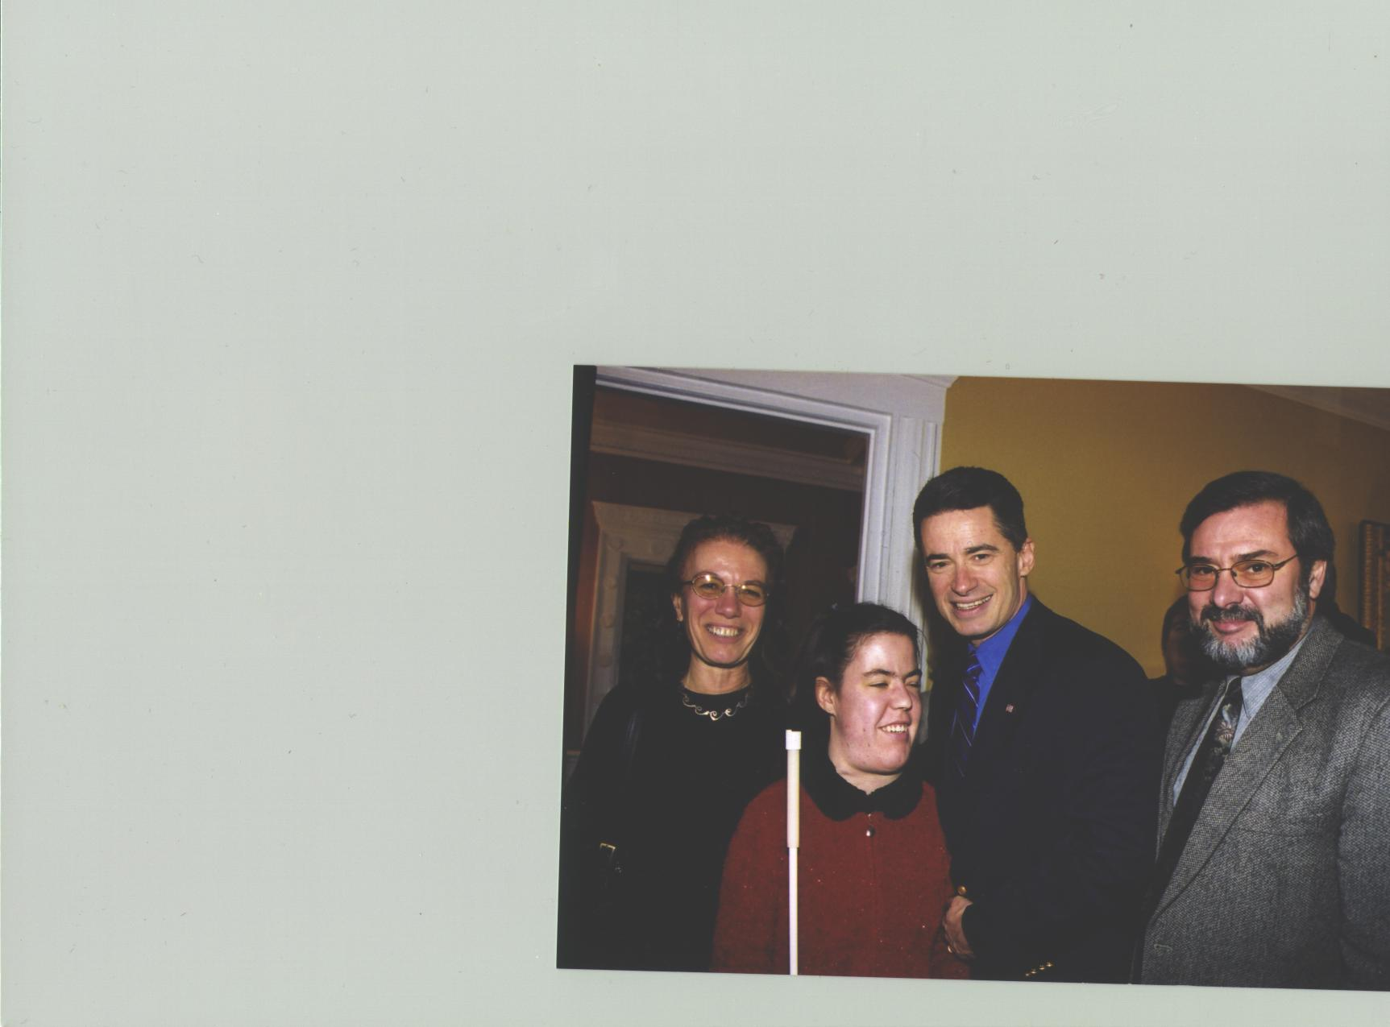
Carol Castellano, Serena Cucco, and Bill Cucco represent NFB of NJ and POBC-NJ as they say hello to Gov. James E. McGreevey at a reception to introduce the new Commissioner of Human Services, Jim Davey, at Drumthwacket, the Governor’s residence, in January.

THE 2003 NFB-NJ STATE CONVENTION

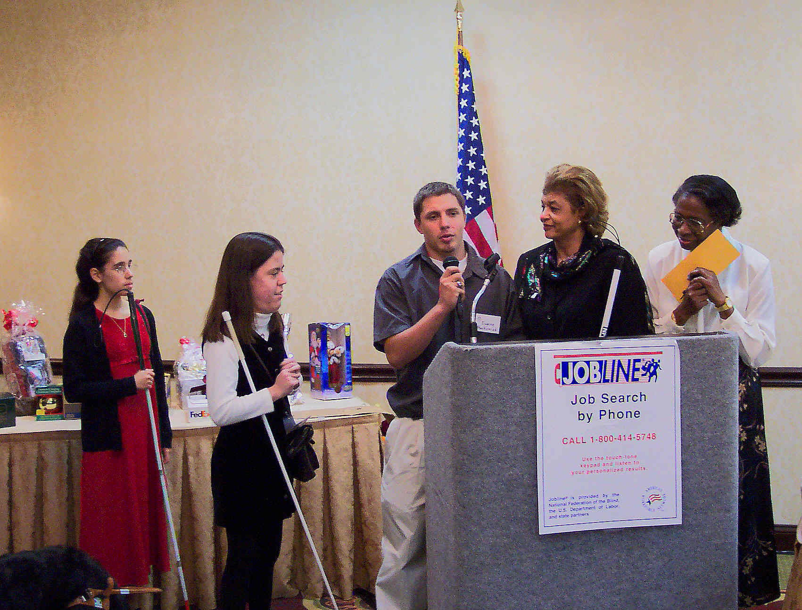
NFB-NJ Scholarship Winner Eugene Mackowiak thanks the organization while (from left) scholarship winners Kristen Diaz and Serena Cucco and committee members Ever Lee Hairston and Gloria Lewis look on.

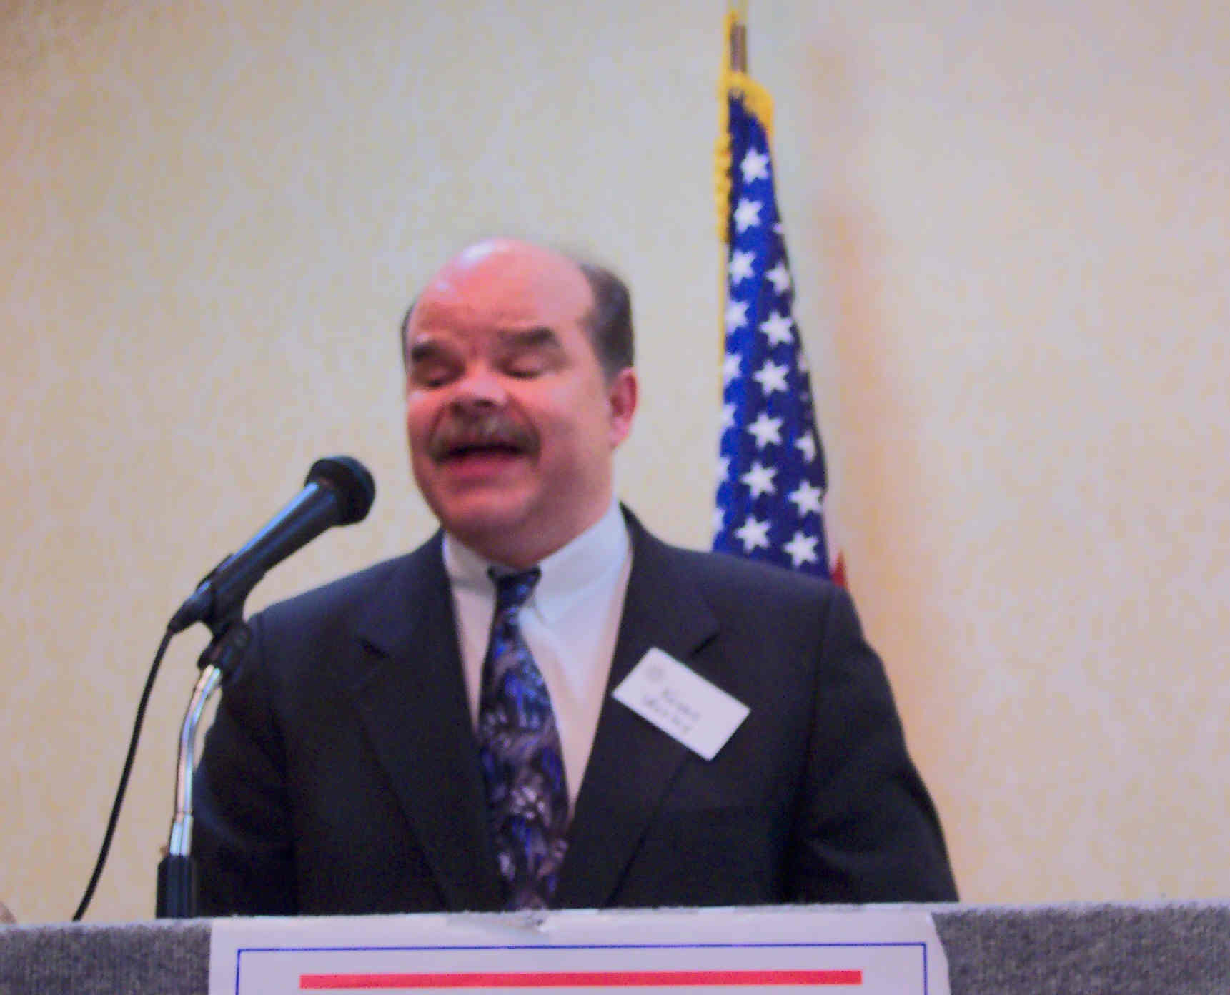

NFB National Representative Kevan Worley, President of the National Association of Blind Merchants, addresses the Convention.

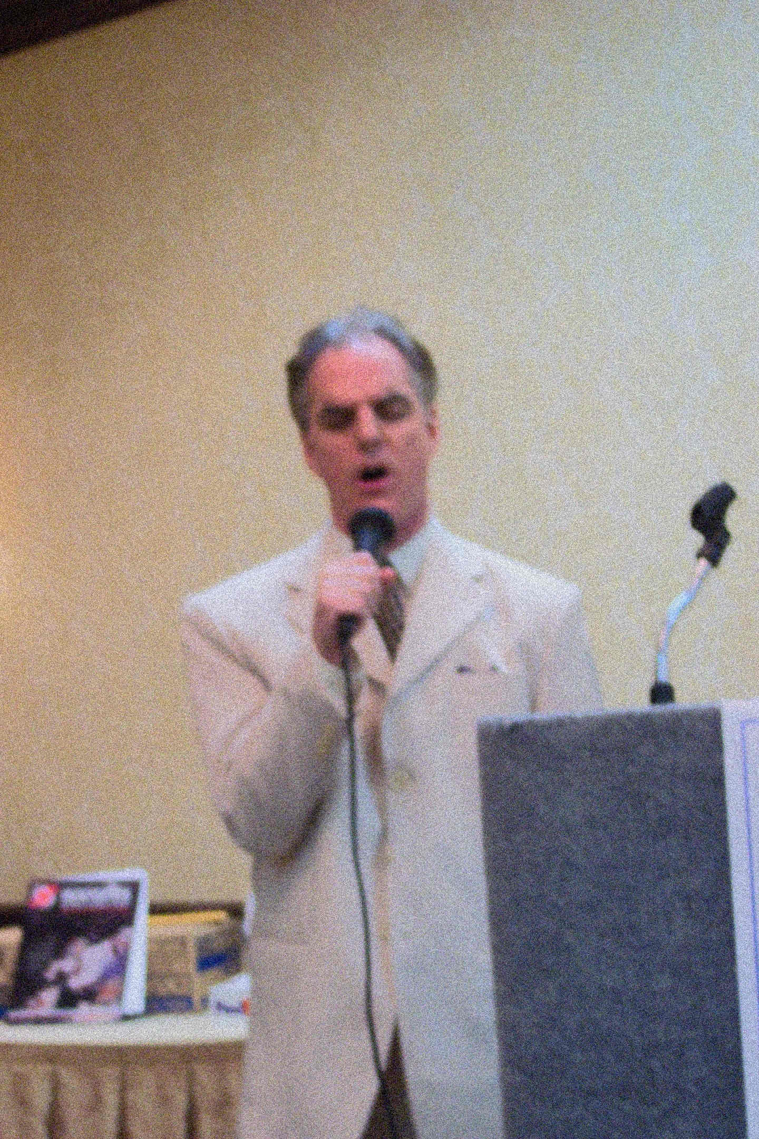

NFB-NJ member John Luland shares his talent
with the conventions as he sings the Impossible
Dream at the Saturday evening banquet.

