rnrnrnrnrnrnrnrnrnrnrnrnrnrnrnrnmrnrnrn
©
Fall/Winter 1998 ©
©
i ©
' ©©
©
©
B O,o '
'°DRTU"'

1 1l-()JE:
&OVNDltSG
BOARD
ThePUBLICATION of the
NATIONAL FEDERATION of the BLIND
of NEW JERSEY
PRESIDENT
JOSEPH RUFFALO F:l'l
1..1 69 PROSPECT PLACE
BELLEVILLE, NJ 07109
CALL OR FAX: (973) 450-3030

"The National Federation of the Blind is an organization
of the blind speakinmg fmor mthemmselves." m m

TABLE OF CONTENTS

Officers page 1
Information about The Sounding Board page 2
What Is the National Federation of the Blind? page 3
Presidential Message.............................................................page 3
By Joe Ruffalo
Meet Diane McGeorge............................................................page 5
Hotel Accomodations for the State Convention page 6
Specialized Rehabilitation Services Position Statement. page 7
Implementation of Informed Choice page 9
Mission Statement of the NJCBVI page 10
A Partnership for Progress page 11
Dallas Was on Fire!................................................................page 12
By Pamela Gaston
NFB of NJ Programs and Initiatives page 15
Braille Mentoring page 17
By Lois Wencil
Computer Tutoring.................................................................page 19
By Anthony Di Girolamo
Adopt Adaptive Equipment. page 19
By David Mostella
A Visit to the National Federation of the Blind's Center page 21
By Ever Lee Hairston and Vito Desantis
The Scholarship Program page 23
By Gloria Lewis
Doug Burroughs Scholarship page 23
History of the National Federation of the Blind page 24
By Agnes Allen
Employment New Jersey: A Garden of Opportunity page 27
Letters.....................................................................................page 29
By Ronald C. Parent Helen Duhn
Margaret M. Belowsky
Through My Eyes..................................................................page 32
By Rachael Degenshein
Registration Form page 36

fall/winter 1998 THE SOUNDING BOARD page 1

OFFICERS
PRESIDENT - Joseph Ruffalo VICE PRESIDENT - Ever Lee Hairston
SECOND VICE PRESIDENT - Tracey Hall
SECRETARY - Jerilyn Higgins TREASURER - Gloria Lewis

BOARD MEMBERS
Gerald Moreno, Kathleen Benjamin, David Mostella, and Michelle Foster

CHAPTER PRESIDENTS
Garden State Chapter - Ever Lee Hairston (609) 321-1296 Northern (Essex) Chapter - Edwin Lewinson (973) 675-3377 Metro-Suburban Chapter - Gerald Moreno (973) 751-8771 Atlantic-Cape May Chapter - Michelle Foster (609) 653-0869

JOB OPPORTUNITIES FOR THE BLIND
David DeNotaris - (973) 239-8884

PARENTS OF BLIND CHILDREN
Carol Castellano - (201) 377-0976

LEGISLATIVE COORDINATOR
David Mostella - (609) 799-8424

BRAILLE MENTORING PROGRAM
Barbara Esposito - (609) 858-2283

ASSOCIATE COORDINATOR
Gerald Moreno - (973) 751-8771

NEWSLINE COORDINATOR
Richard Fox- (973) 743-6107

JOBLINE CO-COORDINATORS
Jamie Hilton - (973) 648-2324
David DeNotaris - (973) 239-8884

fall/winter 1998 THE SOUNDING BOARD

THE SOUNDING BOARD

Joseph Ruffalo, Editor Rachael Degenshein, Co-editor

Published in print and cassette by
page2

THE NATIONAL FEDERATION OF THE BLIND OF NEW JERSEY JOSEPH RUFFALO, PRESIDENT

State Affiliate Office 69 Prospect Place
Belleville, NJ 07109

Letters to the President, address changes, subscription requests, letters to the editor, and articles for the Sounding Board should be sent to the State Affiliate Office.

Sounding Board subscriptions cost the Federation about six dollars per year. Members are invited and non-members are requested to cover the subscription cost. Donations should be made payable to the National Federation of the Blind of New Jersey and sent to the
State Affiliate Office

Sounding Board has been printed by Budget Print of Bloomfield, New Jersey and recorded on cassette by Joel Blake.

*************************
If you or a friend would like to remember the National Federation of the Blind of New Jersey in your will you can do so by employing the following language: "I give, devise, and bequeath unto the National Federation of the Blind of New Jersey, 69 Prospect Place, Belleville, New Jersey 07109, a non-profit corporation the sum of$_ (or"_ percent of my net estate" or "The following stocks and bonds:_'? to be used for its worthy purposes on behalf of blind persons.
**************************

fall/winter 1998 THE SOUNDING BOARD page 3

WHAT IS THE NATIONAL FEDERATION OF THE BLIND?

The National Federation of the Blind is an organization of blind people who purpose is to promote equal opportunity for the blind.
Founded in 1940, the Federation has affiliates in every state and includes more than 50,000 of the nation's blind.
Dedicated to the complete integration of the blind into society, the Federation works toward the removal of legal, economic, ad societal barriers to full participation by blind people in employment, education, recreation, and all other aspects of community life.
The Federation is working to end discrimination by educating the public to new concepts about blindness and the abilities of blind people, offering training and advocacy to blind people and to parents of blind children, and providing job referrals and placements.
The Federation helps the newly blinded to learn the techniques that will enable them to maintain productive lives and informs them of services available from governmental and private agencies and of the laws and regulations concerning the blind.
The National Federation of the Blind is an organization of the blind speaking for themselves.

PRESIDENTIAL MESSAGE

Dear Federationists,

We have always known as Blind and Visually Impaired individuals that if we want to achieve success, we have to first prove our capability to the public at large. We have to earn their respect and cooperation and prove to them that we are people who just happen to be blind. Recently, we in the Federation received an official partner in this goal, the New Jersey Commission for the Blind. Jointly we have funded, implemented, and brainstormed many new and exciting projects for the Blind and Visually Impaired citizens of New Jersey, and in some cases the entire United States.
On the national level, the NFBNJ and the New Jersey CBVI co sponsored the Information Fair on June 8, 1998 at the National Convention at the Dallas/Ft. Worth Hyatt. In attendance were over one hundred and fifty blind individuals, leaders, directors, educators, and counselors from diverse geographic regions all united in purpose,

fall/winter 1998 THE SOUNDING BOARD page4

to learn more about New Jersey, and its partnership in progress, and to sample some of the food we provided.
Here in New Jersey, some of our most important projects are LEAD, the Blind Children's Resource Center, Newsline, and Jobline, all of which are discussed later in this issue (consult the table of contents on the first page of the newsletter for faster location).
One of the greatest ambitions of the National Federation of the Blind is for members to achieve employment opportunities and positions on par with our sighted colleagues. This has always been difficult due to prejudice, lack of confidence, transportation issues, and what have you. Although the efforts have been greatly enhanced with Job Opportunities for the Blind, we felt that something more direct needed to be done. For this reason at the convention on Friday, November 13th, we have invited numerous prominent business leaders, and decision-makers to attend, and to speak. We hope this information session will bring motivation and opportunity.
The most prospectively important aspect of this process will be that these leaders will be willing to accept any resumes that members submit to them for consideration.
In order to ensure that these resumes accurately reflect you, and demonstrate all of your abilities while downpJaying your weaknesses (as resumes tend to do), we are offering two workshops on resume writing to be held on Monday, September 14 and Wednesday, October 14. There will be four locations for these workshops. William HadJey will coordinate the Camden workshops. For more information on these workshops, or to reserve a position, contact William at (609) 757-2509. The Toms River workshops will be coordinated by Judy Ebenfeld who can be reached at (732) 255- 0904. For a reservation or information on the Newark workshops, call WiHiam Steiber at (973) 648-3739. And if you would like to attend the workshops at the Joseph Kohn Rehabilitation Center, in New Brunswick, contact Ronald Parent at (732) 937-6363. IT IS IMPERATIVE THAT IF YOU WISH TO ATTEND A WORKSHOP YOU CALL TO RESERVE A PLACE!
Another way to earn money, if you are Jucky, is in our annuaJ 50/50 raffle. The prize of $1617 went to the winner, with an equal amount going to the scholarship fund. We would like to thank everyone who sold tickets as well as everyone who bought them for making this fundraiser so successful.

fall/winter 1998 THE SOUNDING BOARD page 5

It is always nice to know you have people on your side to help you, support you, and encourage you in worthwhile endeavors. That is one of the main allures of any organization. Here in the National Federation of the Blind, we are fortunate to have extended our working family to have more advocates, pioneers, and friends then ever before. We welcome the New Jersey Commission for the Blind and Visually Impaired into our newly forged partnership, and company and look forward to great accomplishments following this fruitful union.
Yours in federationism,

Joseph Ruffalo, President

MEET DIANE MCGEORGE, NATIONAL REPRESENTATIVE FOR THE NFBNJ STATE CONVENTION

Diane McGeorge has served on the national board of directors for the National Federation of the Blind since 1977, having served in the capacity as an officer and a board member. As a national board member, she has had the opportunity to travel to state conventions and serve as a national representative, bringing much needed infomiation regarding national activities of the NFB. She also participates in state seminars dealing with employment, education of blind children and adults, legislative issues, and advocacy for the Blind.
She has served on a number of national committees such as
the guide dog committee, human services division, and the Preauthorized Check plan committee. Presently, she serves as the director of the Colorado Center for the Blind, a private nonprofit organization that provides rehabilitation services to blind adults. Prior to her work establishing the center ten years ago, Diane advocated blind traveling throughout the United States. She currently also serves as chairman of the legislative committee for the Colorado Rehabilitation Advisory Council.
fall/winter 1998 THE SOUNDING BOARD page6

HOTEL ACCOMODATIONS FOR THE STATE CONVENTION

The Holiday Inn at Tinton Falls is the location of the November, 1998 Convention. Based on the requirements, here is the information regarding the event.
Dates of Function
Friday, November 13, 1998 through Sunday, November 15, 1998
Sleeping Room Requirements
$72.00 Sleeping Room Rate plus 6% tax
Meeting Room Requirements
Friday, November 13, 1998
12:00 Noon - Registration for Seminar Vendor Display Hospitality Room Saturday, November 14, 1998
On own for Breakfast Main Meeting Room Lunch Arrangements Dinner Arrangements
Sunday, November 15, 1998
Board Meeting On own for Meals

The primary concern is guest satisfaction and with that in mind each guest at the Holiday Inn at Tinton Falls receives:
- Coffee makers in each guest room
- Shuttle to and from Newark Airport at $20.00 per person
- Workout room with sauna
- Morgan's full service restaurant and lounge
- Happy Hour Monday - Friday 4:00 PM - 7:00 PM
- Room service 7:00 AM - 11:00 PM
- Cable TV with Showtime and pay-per-view movies
- Complimentary Newspaper
- Banquet and meeting facilities for 10-350 people
- Same day dry cleaning
- Gift Shop
The Holiday Inn at Tinton Falls is the Number 1 Hotel in the state of NJ for Customer Service. If you need any further information, contact Joe Ruffalo.

fall/winter 1998 THE SOUNDING BOARD page7

Editor's Note: The following statement was prepared in the fall of 1993 by the Committee on Joint Organizational Effort [JOE] of the national organizations and agencies listed at the end of this statement. It was printed in the Arizona newsletter.
SPECIALIZED REHABILITATION SERVICES FOR BLIND AND VISUALLY IMPAIRED PERSONS POSITION STATEMENT

The Americans with Disabilities Act and other laws enacted in recent years in the United States and Canada represent enlightened disability policy. However, the noticeable trend to define "disability" as an overarching generic condition for purposes of program design, administration, and funding is pernicious in its effect upon rehabilitation services for children and adults who are blind or visually impaired.
It is the common experience of the agencies and organizations that have joined in this statement that specialized, comprehensive rehabilitation services and essential changes in social attitudes about blindness do not occur when rehabilitation services for the bl.ind are provided through a single program which serves both blind and disabled persons. This is so large in part because the characteristics and distinctive needs of the blind become lost amid much larger issues and populations and because specialized services are overshadowed by diverse, unrelated goals.
The accomplishment of individualized rehabilitation goals can be achieved in an efficient, consumer-responsive manner when blind people have access to an agency dedicated to providing blindness specific services. Such an agency must be administratively identifiable and have qualified personnel specially trained to serve the blind. Accountability for program results is strengthened by this organizational structure and staffing since accomplishment of specific objectives for a defined target population of n-1c:1nageabie $iLe Ccin readily be measured. When program results fail to merit support, blind consumers and their advocates or the professionals who serve them can make focused efforts to insist upon improvements.
Promoting more enlightened social attitudes about blindness is an indispensable goal of specialized services for the blind. To achieve this unique goal, competent personnel, including blind persons serving as role models in both staff and volunteer capacities, must be assigned to teach blindness-related alternative techniques.
Blind individuals require comprehensive and often complex

fall/winter 1998 THE SOUNDING BOARD page8

rehabilitation services in areas such as adjustment training, independent mobility, Braille, and the use of assistive technology to meet their particular information needs resulting from vision loss.
Most importantly, they must develop confidence, which is a prerequisite to effective use of these skills in daily life.
Law pertaining to "people with disabilities" as a class may appropriately be general if the purpose is to prohibit discrimination or to identify individual rights. However, rehabilitation programs and the laws which authorize them have a far more precise mission. When services for the blind are submerged into broad disability programs, precision is sacrificed for generality, and comprehensive, consumer responsive services for blind individuals are lost.
This position statement has been unanimously adopted by national agencies and organizations in the United States and Canada which represent those who provide services for persons who are blind or visually impaired and those who are the elected representatives of the blind. We are firmly committed to the provision of specialized rehabilitation services for blind persons by identifiable agencies specially established to serve them. We urge program administrators, lawmakers, and other public officials to follow the principles expressed in this statement.

AMERICAN COUNCIL OF THE BLIND (ACB), Paul Edwards, First
Vice-President

AMERICAN ASSOCIATION OF EDUCATORS AND REHABILITATORS OF THE BLIND AND VISUALLY IMPAIRED
(AER), Dr. Barbara McCarthy , President Elect

CANADIAN COUNCIL OF THE BLIND (CCB), Geraldine Braak,
President

NATIONAL FEDERATION OF THE BLIND (NFB), Dr. Kenneth
Jernigan, President Emeritus

AMERICAN FOUNDATION FOR THE BLIND (AFB), Dr. Susan
Spungin, Associate Executive Director

BLINDED VETERANS ASSOCIATION (BVA), Carl Foley

fall/winter 1998 THE SOUNDING BOARD page 9

CANADIAN NATIONAL INSTITUTE FOR THE BLIND (CNIB), Dr.
Euclid Herie, Executive Director

NATIONAL LIBRARY SERVICE FOR THE BLIND AND
PHYSICALLY HANDICAPPED (NLS), Frank Kurt Cylke, Director

10:95 - 4.3 IMPLEMENTATION OF INFORMED CHOICE

- The Commission applies the principles of informed choice at eligibility, at plan development/ plan amendment.

- The consumer is expected to be an active participant to the extent feasible in evaluating potential programs and services. This will ensure that informed choice occurs.

- Counselors will provide, to the extent that the information is available, the costs of programs, qualifications of the service provider, satisfaction, and the degree that the program is provided in an integrated setting.

- A reasonable number of programs/services will be evaluated.

- Prior to the establishment of a vocational goal, preference will be given to in-state programs in order to establish and maintain close communication among the client, counselor, and service provider. If a client elects to attend a comparable program out of state, the client will be responsible for the additional costs related to attending the program. After a vocational goal has been established, preference will be given to in-state programs to maintain fiscal responsibility and maintain the close working relationship between client and counselor. Clients will be responsible for any additional costs related to attending out of state programs. The Commission's financial needs test and comparable benefits shall be applied to training services in accordance with 10:91 - Subchapter 3.

- Counselors and consumers will together evaluate current labor market trends to determine the likelihood of an employment outcome following training.
fall/winter 1998 THE SOUNDING BOARD page 10

MISSION STATEMENT OF THE NJCBVI

The mission of the New Jersey Commission for the Blind and Visually Impaired is to promote and provide services in the areas of education, employment, independence, and eye health through informed choice and partnership with persons who are blind or visually impaired, their families, and the community.

STATEMENT OF PHILOSOPHY: We at the New Jersey Commission for the Blind and Visually Impaired believe that people who are blind and visually impaired can succeed in education, in careers, in the home, and in the community. The information we dispense and the services we provide are based on our positive beliefs about blindness.

We further believe that:
- The consumer is the most important part of the process.
- The skills of blindness are essential to independence, education, and employment.
- The pursuit of independence, education, and employment by people who are blind and visually impaired is of primary importance and is to be valued, aided, and encouraged.
- Promoting positive attitudes toward blindness by the general public, by employers, by Commission staff, and by consumers is a key factor leading to independence, education, and employment for people for are blind and visually impaired.
- Since each person is an individual with different strengths, interests, and aptitudes, planning for and provision of services must be specific to the individual's needs and desires, with respect for cultural differences.
- Education and rehabilitation is a cooperative venture between the Commission and the consumer and should be accomplished in an atmosphere of mutual respect, mutual responsibility, and informed choice.
- Communication among consumers, Commission staff, organizations of the blind, and the community is essential to developing effective agency programs, policies, and procedures.

fall/winter 1998 THE SOUNDING BOARD page 11

- A highly qualified staff which operates with professionalism, integrity, open-mindedness, sensitivity, and responsibility will contribute to the consumer's success.
- Involvement and support by the consumer's family and the community increases success.
- Research and development of assistive technology should be encouraged and supported to ensure that people who are blind and visually impaired can be competitive in independence, education, and employment.

THE NATIONAL FEDERATION OF THE BLIND AND THE STATE COMMISSION FOR THE BLIND AND VISUALLY IMPAIRED
"A PARTNERSHIP FOR PROGRESS"
Submitted by Pamela Gaston

In New Jersey, the NFB and the Commission for the Blind and Visually Impaired (CBVI) work together in a "Partnership for Progress". The relationship is based upon open communication, responsiveness and a mutual commitment to promoting the abilities of individuals of all ages who are blind and the quality of their lives. NFB members have been invited to take an active role in the development of programs and policy and also participate in analyzing the effectiveness of this state agency's services.
Joe Ruffalo, President of the National Federation of the Blind of New Jersey is the current Chairman of the Commission for the Blind and Visually Impaired Board of Trustees. Carol Castellano, President of Parents of Blind Children (POBC) - NJ and Vice President of the national POBC and three other NFB of NJ members currently serve as governor appointees to the Commission's Rehabilitation Advisory Council.
This partnership extends also to NJCBVI working with and supporting many of NFB of NJ's programs and initiatives, most outstandingly: Newsline; The Leadership, Education, Advocacy, and Determination Program; The Blind Children's Resource Center; and Jobline.
NFB of NJ, in turn, has played a key role in developing the NJCBVI:
- Statement of Mission, Philosophy, Goals, and Objectives
- Consumer Satisfaction Survey
fall/winter 1998 THE SOUNDING BOARD page 12

- Handbooks for parents of children who are blind or visually impaired
- Presentation of consumer forums; and
- Curriculum for in-service training workshops for parents, teachers, and other professionals

As a further example of the "Partnership for Progress", all Commission staff was encouraged to visit NFS Headquarters in Baltimore, MD, as a professional development activity. Three NFS of NJ sponsored bus tours departed from CBVI facilities: 12/9/97 (Administrative & Northern Regional Staff); 2/24/98 (Joseph Kohn Rehabilitation Center Staff); and June 9, 1998 (Central & Southern Regional Staff).
Jamie Hilton, NJCBVI Executive Director and Joe Ruffalo, President of NFS of NJ believe that in New Jersey the slogan is, "NFS and CBVI - Perfect Together."

DALLAS WAS ON FIRE!
By Pamela L. Gaston
CBVI Community Involvement Specialist

Having spent twenty-four years working with people who are blind, I guess that I really didn't expect the experience of participating in the 1998 NFS National Convention in Dallas, Texas to be so awe inspiring.
From the moment we arrived at the Hyatt I was struck by the number of conventioneers rushing through the lobby or just sort of hanging out talking, but the enormity of it all didn't set in until the next morning when we were on the convention floor!
We got there kind of early and most of the seats were empty. I stood describing the set-up to Jamie and I was thinking, "They aren't possibly going to fill this room!" Since our arrival I had seen maybe about 200 or so conventioneers at the most. To say I was shocked when the room, which I judged to have been as large as a football field, filled up within about ten minutes, is an understatement. It was then that I began to think, "You are really going to love this!"
My excitement grew during the roll call of the states. I felt so proud and honored to be there sharing the experience with all the other members of our state's delegation that by the time Joe Ruffalo


fall/winter 1998 THE SOUNDING BOARD page 13

got the mike, I was already clapping and cheering, "New Jersey is in the house!"
I have been a reader of the Braille Monitor for many, many years. For me it was a kick to see and hear people like Dr. Jernigan, Marc Maurer, and James Gashel in person. Even though I have long admired the NFB because I believe in standing up for yourself and your beliefs even under the most adverse circumstances, being there gave so much more clarity to what the NFB is about.
I met a lot of great people and got to see another side of a couple of people that I thought I knew pretty well. Spending one evening sitting around the dinner table singing old Motown hits increased my admiration and kinship with several people I have sat around numerous meeting tables with over the years. Also listening to someone you have worked with everyday for nine years tell you and over two thousand other people how she feels about the responsibility of being a woman and a leader who happens to be blind, gives you more than an idea of what that person has in her heart.
The convention filled my heart with a glow. I was inspired and somewhat enlightened by many of the speakers, but there was one young lady that will pop into my mind first whenever I reflect upon my experience. She was about sixteen years old. I first encountered her in the hallway telling someone about the "Babysitters' Workshop".
The next time was one evening at the Descriptive Video Services demonstration, where she was handling two toddlers. One baby was enjoying the video, but the other was extremely fussy. At first I wished that they would leave, but then I watched how determined she was to handle her babysitting assignment and I began to hope that no one interfered and let her do her thing. She never lost her composure. She quietly soothed the cranky baby until he settled down and then we were all able to watch and hear the video. I didn't see her again until our last day in Dallas. She came down to breakfast alone, adeptly using her cane to travel through the crowded and busy diner. Once seated she ordered, using a Braille menu, and while waiting for her food, typed on a "Braille and Speak". When she had finished her breakfast and had paid her bill, she left the diner the same way she had arrived, independently. Within a couple of moments she came back to the table and the waitress ran to her and said, "Can I help you? Did you leave something?" And the young

fall/winter 1998 THE SOUNDING BOARD page 14

lady smiled and said, "No. I went to get change. I wanted to give you a tip." As I watched her leave, I thought to myself, "You go girl!"
When we first arrived, someone told us that "Win Dixie" had called the Hyatt and said that the hotel should not send any more blind people to their store. I thought, "How could they be so ignorant?" But, I soon knew that it wasn't going to go unchallenged and I also knew that "Win Dixie", like me, would never forget the 1998 NFB National Convention.
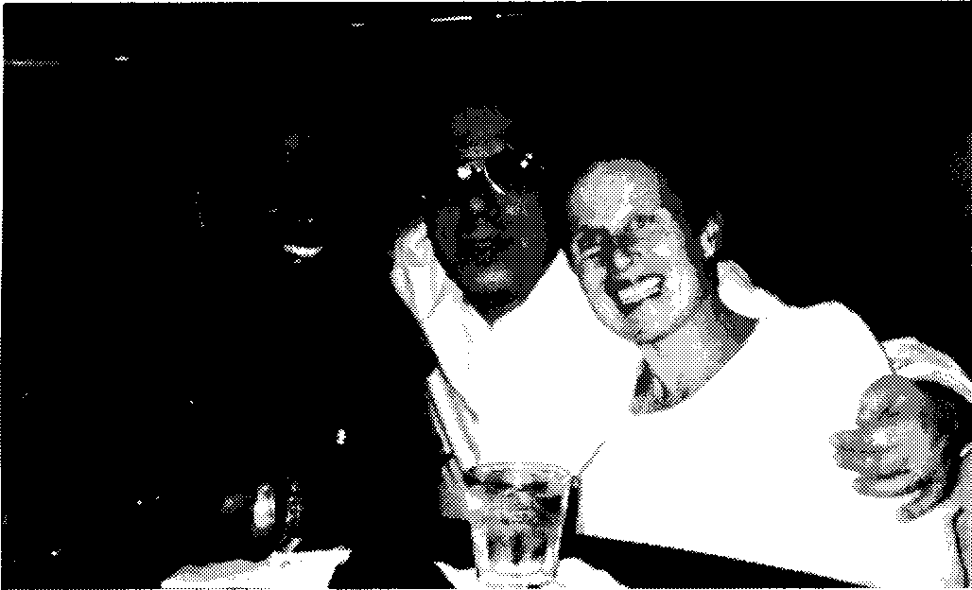

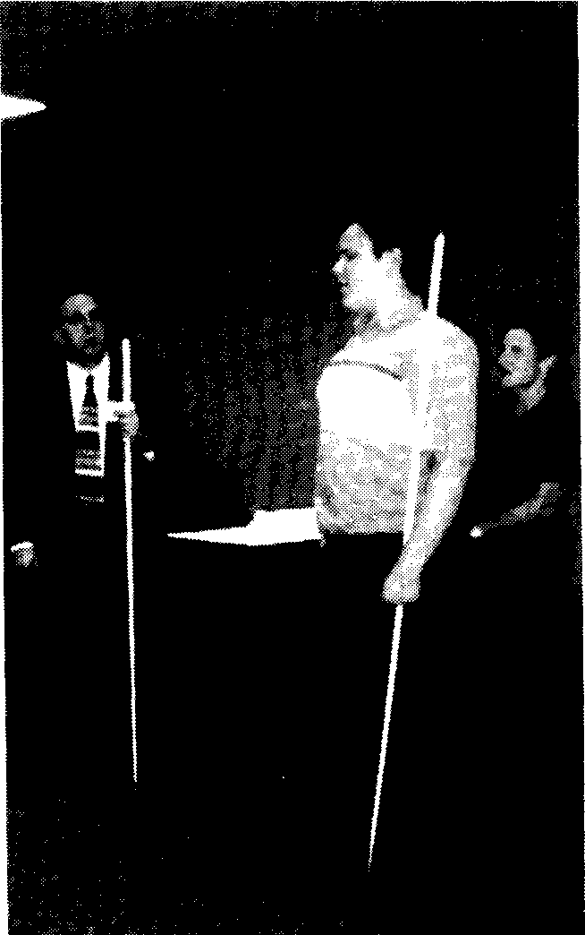

Pam Gaston (left), Assistant to Jamie Hilton, Joe Ruffalo, President NFBNJ, and Jamie Hilton, Executive Director of CBVI, pausing from discussion to smile for the camera.

Pictured (above) left to right are Joe Ruffalo, Brett Boyer, and Jamie Hilton, three featured speakers at the Information Fair held July 8, at the Dallas/Ft. Worth Hyatt.
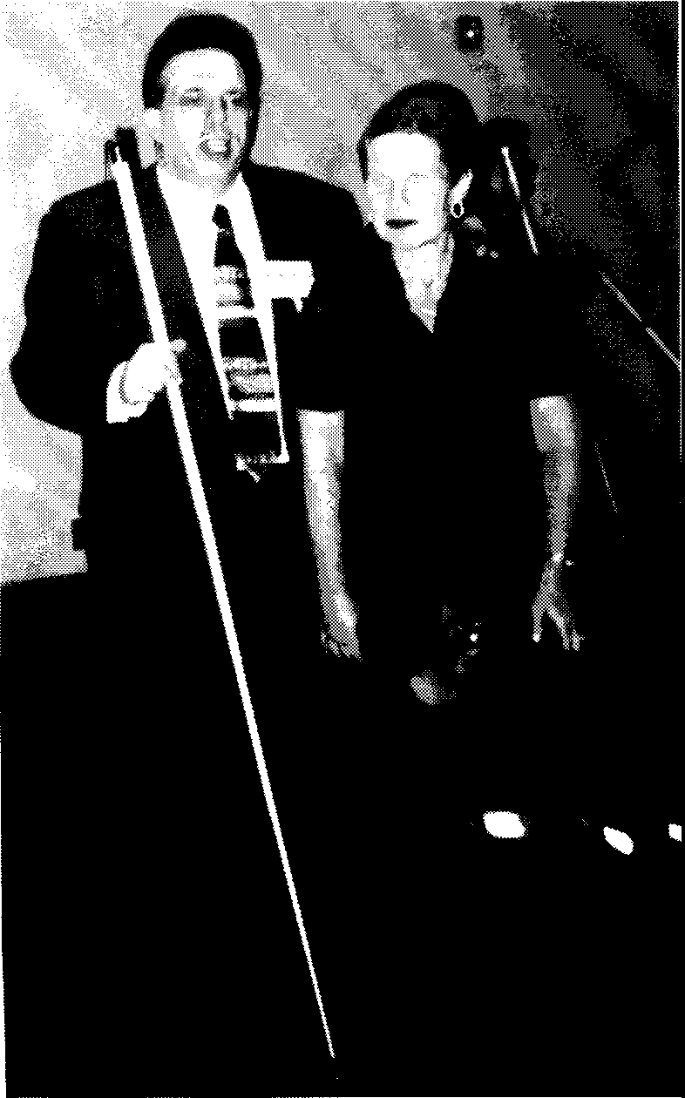

Pictured (left) are Joe Ruffalo and Jamie Hilton using their mobility skills. Joe is using the long white cane, and Jamie is accompanied by her guide dog, Stanley.

fall/winter 1998 THE SOUNDING BOARD page 15

NFB OF NJ PROGRAMS AND INITIATIVES

LEAD: The Leadership Education Advocacy and Determination is a pilot program sponsored by the New Jersey Commission for the Blind and Visually Impaired in conjunction with the National Federation of the Blind (NFB) - Garden State Chapter.
Leadership Education Advocacy and Determination is a program for youth between the ages of 14 and 19.
Prerequisite for participation in this program will be motivation on the part of the 14 to 19 year-olds, completion of an application describing personal and education goals, an interview including student and parent/guardian and a commitment to participate once accepted to the program.
The pilot program will run for approximately one year, being divided into several weekend sessions (approximately 10-12). The program will focus on group activities and utilize group process technique to promote independence and leadership skills.
Members of the NFB will provide instruction, mentoring and the administration of the program. The Commission would provide the resources of funding, materials, and the use of Camp Marcella's facilities.
The purpose of the LEAD program is to engage adolescents in a group process whereby they have the opportunity to become acquainted with areas necessary to achieve success in the "sighted" world.
The process by which this will be presented will incorporate the areas of the social skills, disability law, the building of self-esteem through physical activity and challenge courses, Adjustment to Daily Living (AOL) and self-care skill development and discussions on choosing a career and/or making college selections, though it is not limited to these areas. This program is to create a comfortable relaxed environment where a group of people can begin to share some of their concerns about "growing up". Ideally, the leaders will provide a positive image to the student.
For more information, please contact Barbara Esposito at HAIL (609) 854-7781.

NEWSLINE: Newsline is a 24-hour special service administered by the national office of the NFB located in Baltimore, MD. The service
fall/winter 1998 THE SOUNDING BOARD page 16

uses a speech program to scan and then speak aloud the text of three national newspapers.
Registrants may use their touch-tone phone to access any given portion of one of the several newspapers that are available.
The New Jersey Commission has funded Newsline in New Jersey for the Blind and Visually Impaired for the past two years (since October, 1996). In addition to The New York Times, The Chicago Tribune, and USA Today. New Jerseyans can also select The Courier Post, and soon The Star Ledger .
Users do not have to pay a fee to access the service. They may, however, be charged for the phone call they make to Camden at (609) 757-2560 or New Brunswick at (732) 745-8210 to use the service.
For more information, please contact Harrison Burton at (609) 784-7247 or you may contact Joseph Ruffalo at (973) 450-3030.

THE BLIND CHILDREN'S RESOURCE CENTER: The Blind
Children's Resource Center is dedicated to helping the parents and teachers of the more than 2200 blind and visually impaired children in New Jersey to obtain valuable information so that they and their children can get off to a good start. The Center is a vehicle for the quick and widespread dissemination of information.
Parents and teachers can call or drop in at the Center for information, assistance, and ideas. They can view our "What's Available?" Display an extensive collection of developmental, educational, technological, and recreational items that blind children can use. They learn simple techniques for including the blind child more fully in family life and learn how to adapt classroom materials.
A unique feature of the Center is a model classroom, which displays in a life-like setting the equipment, materials, and technology a blind child can use in school. Parents and teachers are able to try out this equipment and better understand how the blind child will participate successfully in the classroom. On view, also, are simple, logical systems for adapting schoolwork, organizing materials, and maximizing the child's independence.
An added dimension of The Blind Child's Resource Center is the Sensory Safari, an exhibit of mounted wild animals, provided by Safari Club International.
The funding for our Center came in the form of a generous grant from the Board of Trustees of the NJ Commission for the Blind.

fall/winter 1998 THE SOUNDING BOARD page 17

For more information, please contact Carol Castellano, Director, at (973) 377-0976.

JOBLINE: Individuals who cannot read standard video displays and computer terminals will find the JOBLINE service offered jointly by the Department of Labor and the National Federation of the Blind a refreshingly easy and effective means to get information about potential employment. This service is also jointly funded by the New Jersey Commission for the Blind and Visually Impaired.
JOBLINE will be a universal access alternative to using a computer and the Internet. All information and prompts will be presented on the telephone in full-word speech. Job search criteria, including geographic and job-preference/qualifications choices will be entered from the touch-tone keypad. This service will be ideal for serving persons with disabilities and persons without disabilities on completely equal terms.
JOBLINE WILL:
- Deliver information about available employment opportunities free of charge to anyone who calls the system from a touch-tone telephone.
- Be instantly available 24 hours a day to provide all job announcements in a high quality, synthetic speech format instead of printed text.

BRAILLE MENTORING
By Lois Wencil

I have now been a Braille mentor for several years. Many more of us are needed. Perhaps you have thought of assisting in this worthwhile project but have questions about the actual way in which it works.
What does a Braille mentor do? A mentor assists interested persons in learning contracted and uncontracted Braille. These persons usually come to your home. They are either visually impaired people hoping to read again and manage their business affairs more independently or parents of blind children hoping to play a part in assisting their children in reading more, and with greater ease.
Who can be a Braille mentor? Anyone who knows how to read and write Braille. You do not need to be the fastest reader or be an
fall/winter 1998 THE SOUNDING BOARD page 18

expert in every rule that is contained in the Braille code. You mainly need to want to share all that Braille has enabled you to do with others.
Where does a mentor get materials with which to teach? You can either write them yourself, get a book from NFB headquarters, or phone me for a copy of what I use at (973) 467-3923.
How do students and mentors meet? You can call Barbara Esposito at (609) 858-2283. Or you can mention your willingness to mentor at your local chapter or state meetings.
How much time will it take? Usually each lesson will take from 1 to one-and-a-half hours. It will depend on your schedules whether the lessons are weekly or biweekly. I have found that weekly instruction is best.
Why would a person want to do this type of volunteer work? I could give many answers but none as compelling as the words of those who have been mentored:
"She is now five and can read. I have brailled her favorite books for her to read to herself and to me."
"You know I wrote him every week at camp. He read my letters to the other kids. They had to get their counselor to read their letter to them. And do you know, he wrote to me in Braille. You bet I cried."
"I can label and find my own things now. Tapes took too long to find phone numbers. Braille is best."
"I wrote these poems just for you. I never wrote poetry before."
"I want to mentor too. I want to give someone else as much as I have received."
I have received Braille letters, cards, and updates in Braille. I cried and saved them all. Braille and mobility are my keys to the world. It is a great thrill to participate in and have a role in watching others unlock the doors to their future. I consider mentoring a privilege and a way of saying thank you to all those who showed me the pathway to independence and true freedom.

Editor's Note: The Braille Mentoring Program has profound effects in all arenas of a person's life. A fine example is of the author of the following article, Anthony Di Girolamo. Inspired by the giving nature of his Braille mentor, Lois Wencil, Anthony decided to offer his expertise on the subject of computers to better the lives of his prospective students.

fall/winter 1998 THE SOUNDING BOARD

COMPUTER TUTORING
Anthony Di Girolamo
page 19

Please be advised that I am willing to help anyone in the following areas:
Keyboarding
Introduction to computers and Windows 95 JAWS for Windows version 3 and 3.2
The Internet including eudora E-mail and Internet Explorer The Omni/Kurzweil scanning program
The Xerox Reading Expert Reading Machine
As I am blind myself, transportation is somewhat a problem; therefore I would prefer that a student come to my home in Hopatcong.
However, I am willing to listen to another arrangement. I also would prefer that their computer system and the adaptive equipment be installed and working correctly, however I can install these products as long as there aren't any conflicts with other programs on their system.
I can be reached at the address below. I look forward to helping.

Very truly yours, Anthony V. Di Girolamo 509 River Styx Road
Hopatcong, New Jersey 07843-1836
Tel. (973) 770-0606 Fax. (973) 770-0606

ADOPT ADAPTIVE EQUIPMENT
By David Mostello

The Adopt Adaptive Equipment Bank was conceived by our President, Joseph Ruffalo, three years ago, in June of 1995. The purpose of the Adopt Adaptive Equipment Bank (hereafter The Equipment Bank), was to 1) have a base from which to coordinate the donation of used adaptive equipment among the membership of the NFB of NJ and among other blind individuals throughout the state, 2) to make use of limited State and private resources, and 3) to accept equipment from blind people on behalf of other blind people who have expressed a need for such equipment.
Although the NFB of NJ has received several computers, fax machines, printers, and cassette duplication equipment, the need for

fall/winter 1998 THE SOUNDING BOARD page 20

such equipment continues to be unmatched. The greatest need among blind New Jerseyans is that of computer equipment. In 1996, the NFB of NJ turned to Lou and Arianna Calesso of Morristown to assist in meeting the needs of the NFB of NJ in computer equipment. The Calessos have unfortunately moved to South Dakota, so another resource must be found.
Lou Calesso was a retiree from Bell Labs, who with the assistance of other retirees of Lucent Technologies, was able to adapt used computer equipment for use by blind people. Calesso promised interested individuals a computer provided that the individual agreed to purchase a synthesizer, DoubleTalk, for approximately $285.00 for Calesso to integrate into the computer system. Calesso would have the individual come to his Morristown apartment to integrate the synthesizer into the computer system, and to instruct the individual user in basic computer commands to enable the user to work with the equipment. In addition to the hardware, software, and oral instruction, Calesso provided the individual with a set of taped tutorials to study.
What the NFB of NJ needs is an individual to fill the role of Lou Calesso and make up computer systems for blind people for a nominal or no fee.
The individual should be familiar with computer hardware and software, have a finished basement or a large reasonably clean, heated area in which to disassemble and reconfigure computer hard drives, and peripherals, a potential source for the computer hardware (a large company which is upgrading systems), and a source of transportation for the equipment from the large company to the individual user.
The expense of computer equipment for the blind lies in the adaptive equipment itself and adaptive software. How many individuals need a Braille embosser, a speech synthesizer, or one of numerous screen reading packages or Optical Character Recognition Software (OCR) with a scanner? Relatively few when considering the whole computer market.
When upgrading or purchasing any new computer equipment, any person wants to save as much money as possible, using old components or parts from the previous computer system, in order to complete the new system he has purchased. What parts/components he does not incorporate into the new system either are given to others who can use the parts, or are simply discarded.

fall/winter 1998 THE SOUNDING BOARD page 21

Organizations such as Arkenstone of Sunnyvale, CA, have begun solving the dilemmas of finance and upgrade of computer systems through the company's Arkenlease program, whereby an individual can borrow up to $6,000.00 for a period of 3 years with monthly payments of $60.00. When the 3 years have elapsed, the individual buys the leased equipment for $1.00. Arkenstone has also devised a program whereby components from units which have been sent to be upgraded, are used in other introductory products. By the time the components to these other machines wear out, the machines are so old, that no one is interested in accepting the equipment for the original intended purpose.
A popular old computer item, which people want to donate, is the Apple lie Personal Computer. The Apple lie (Apple) does not enable a user to access the Internet, equip his system with a Braille embosser, or outfit his computer with a scanner and OCR software. The only place for an Apple system is a spare bedroom or basement, where a person can show his friends and children how old computers functioned.
An additional source of purchasing used computers is Ed Ryan, member of Parents of Blind Children of New Jersey. For more information, call Ed at (609) 291-0670.
If interested in assuming responsibility for the Adopt Adaptive Equipment Bank, please call me at (609) 799-8424.

A VISIT TO THE NATIONAL FEDERATION OF THE BLIND'S CENTER
By Ever Lee Hairston, President, Garden State Chapter and Vito Desantis, Office Manager, Camden

The Toms River and Camden Offices embarked on an adventure on June 9, 1998 to visit the National Center for the Blind in Baltimore. The bus trip was a pleasurable experience with our host Ever Lee and CBVI staff volunteers providing us with breakfast treats and a very cordial and happy atmosphere.
Upon arrival, we were greeted by Ors. Kenneth Jernigan and Marc Maurer. The theme of the welcoming remarks was partnership among the agencies for the blind. The need for cooperation and trust among the various groups is important in order to join forces for the common purpose to keep Blind Agencies as a separate entity.

fall/winter 1998 THE SOUNDING BOARD page 22

We had a delicious lunch and shared conversations with Ors. Jernigan and Maurer and Jersey President Joe Ruffalo. Following lunch Mrs. Maurer took us on a tour of the Center. We visited the elaborate kitchen facility, Braille library, file room, tape duplication program. recording studio. new spacious outdoor deck overlooking the Baltimore skyline and Camden Yards, and the beautiful harbor room.
The most impressive and educational part of the tour was the International Braille and Technology Center. The last leg of the tour brought us to the materials center and store where staff made purchases and examined the merchandise.
The Commission staff now has greater appreciation for NFB's mission of assisting individuals who are blind to become independent. This will promote a greater partnership between the New Jersey Commission for the Blind and the NFBNJ.
The members of the Toms River and Camden Offices would like to thank Joe Ruffalo. Ors. Jernigan and Maurer, Mrs. Maurer and the rest of the NFB staff for a very informative and enjoyable day.

The picture at left was taken at the Information Fair on July 8th. At this event, Ever Lee Hairston discussed the LEAD project and the bus trip to the National Center which occurred on June 9th and which was the topic of the previous article. Ever Lee is Chapter President of the Garden State Chapter, First Vice President of the NFB, Scholarship Chairperson, and an active participant in the LEAD project.
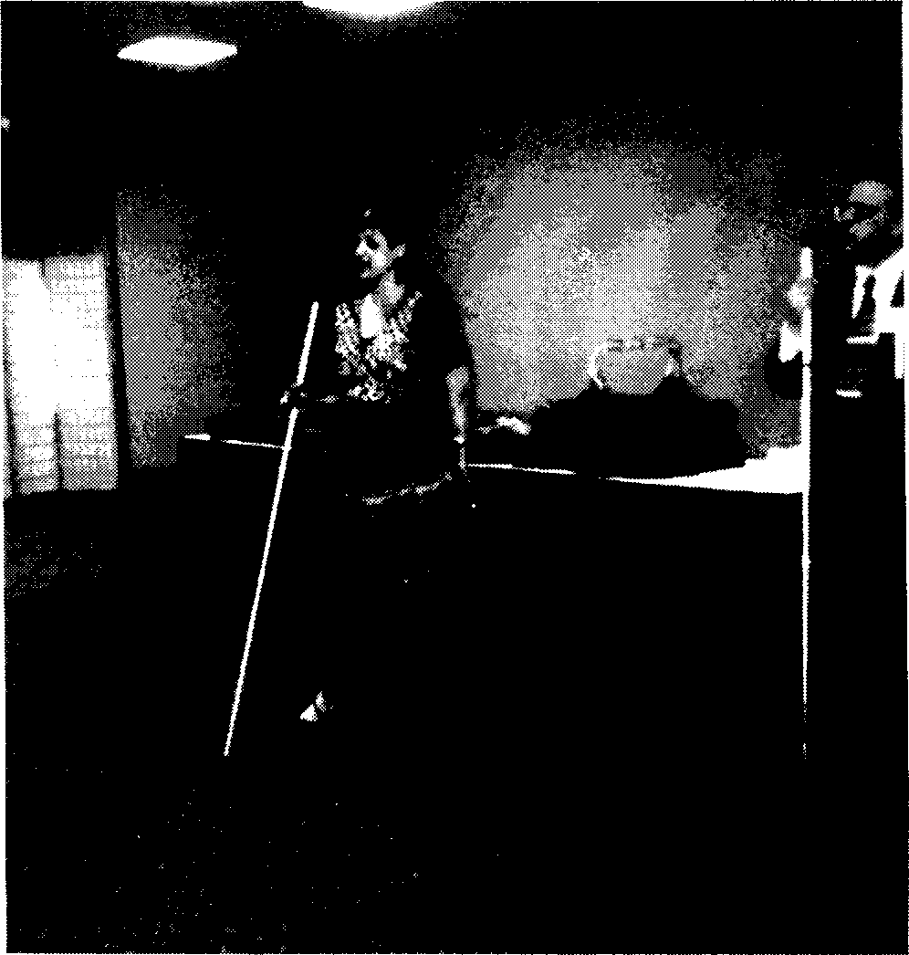

fall/winter 1998 THE SOUNDING BOARD page 23

THE SCHOLARSHIP PROGRAM
By Gloria Lewis, Scholarship Committee Member

The National Federation of the Blind recognizes its responsibility to ensure that all blind persons receive a first class education. Assisting talented post-secondary students to fulfill their academic and professional dreams is one of the most effective ways for us to demonstrate our conviction that blind people deserve the right to enter the field of study for which they feel equipped.
Blind students can take advantage of the same scholarship programs that are available to sighted students, and should be encouraged to do so; however, there are scholarship programs reserved for the Blind.
Past results demonstrate that the Federation's Scholarship Program has been a success. This program is widely publicized, being mentioned in magazines, newsletters from Congressional offices, and student-aid publications. We award scholarships to recognize achievement by blind scholars. At our most recent State Convention, we presented three awards, with a total value of two thousand seven hundred dollars.
We are determined to expand the number, variety, and value of the awards we present each year at our State Convention.
By using alternative techniques, such as Braille, sound recordings, raised line drawings, enlarged print and digital text in computer readable formats, we the Blind acquire the necessary skills that allow us to perform on equal terms with the sighted.

Editor's Note: The following article appeared in the spring/summer edition of last year's Sounding Board. Through the generosity of members of the NFB, Doug's family and friends, $1500 was raised in his honor. Hopefully, the funds collected this year in Doug's name will surpass this high mark. Thank you for your contributions.

DOUG BURROUGHS SCHOLARSHIP

The NFB of New Jersey sadly announces the passing of one of its newest, but most inspirational members. Douglas Burroughs died in his parents' home in Mechanicsville, Maryland on Sunday
-September 1, 1996 from a severe attack of cancer at age 27. Doug, a graduate student at Trenton State College of New Jersey, attended

fall/winter 1998 THE SOUNDING BOARD page 24

state and national conventions, spoke to children in hospitals, did a weekly blues radio shows, played the guitar, and countless other activities despite battling cancer for most of his adolescent and adult life.
Doug's scholastic achievements earned him the NFB of New Jersey's top academic scholarship in 1995. His deeply personal and moving remarks about pushing forward in the face of adversity and being one's own best advocate truly exemplified the ideals of the Federation and served as a model by which we can all measure our own efforts.
Starting in 1997 the New Jersey affiliate will award a scholarship in Doug's honor to a worthy academic recipient. Though Doug is no longer with us in body, his tremendous fortitude and serene, good-natured sense of humor in even the toughest and most painful of times will always give the rest of us strength to persevere no matter what obstacles life may throw in our way. He will be missed. Additional donations to the Doug Burroughs scholarship fund can be sent to NFBNJ 69 Prospect Pl. Belleville, NJ 07109.
Make checks payable to NFBNJ, In memo portion please note DOUG FUND.
Editor's Note: The following is an address delivered by Agnes Allen prior to the beginning of the fifth annual talent show, produced by the Garden State chapter on March 28, 1998.

HISTORY OF THE NATIONAL FEDERATION OF THE BLIND
By Agnes Allen

The National Federation of the Blind is today one of the most powerful forces in affairs that concern the blind of the United States, and its influence is felt worldwide.
But what is the National Federation of the Blind, and how and why did it come into existence?
The Federation was first organized back in the 1940's. At that time the educational, economic, social, and cultural conditions in the lives of most blind men and women were indeed dismal, depressing, and most discouraging. The welfare system was not conducive to creating individual initiative, for a blind person to go to work and become self-supporting. And just by way of a personal note: I was growing up in that era and was one of the more fortunate ones to attend college, to be graduated and to look forward to a brighter

fall/winter 1998 THE SOUNDING BOARD page 25

future. But soon after graduation a would-be counselor visited my mother and me, presumably to begin planning for that future. But when my mother questioned him as to what I would be able to do now that I had a college education, he advised, quite condescendingly, that I should stay at home AND COLLECT THE BLIND PENSION. Well, obviously, I did not do this, as my friends and family can attest.
But to get on with the subject at hand, many of the colleges and institutions of higher learning closed their doors to aspiring blind students who wished to better themselves in order to live more productive and fulfilling lives. The attitude of the general public was one of custodialism and paternalism. It was as if the blind were being told to stay at home, listen to their radios and talking book records, read their Braille books and be content with their hundred dollar monthly pension which Big Brother government was generous and kind enough to send them. The general message was for the blind to remain quiet and subservient and in no way to mingle with the mainstream of life.
So in 1940 a small nucleus of blind people representing seven states and fed up with this "I'll take care of you" attitude assembled in Wilkes-Barre, Pennsylvania to discuss the blatant interference by the government in the lives of the blind and to lay the foundation for the organization we know today as the National Federation of the Blind (NFB). Their purpose in meeting was to change the bleak and stultifying past into a future filled with bright hope and promising tomorrows for blind men and women everywhere. They wanted every person who was willing to work hard in spite of the enormous obstacles facing them to enjoy the opportunity to make what was once seemingly impossible possible at last, to make dreams come true.
These early pioneers, led by their illustrious and brilliant president, Dr. Jacobus tenBroek, formed the beginning of a civil rights movement for the blind of our nation. They introduced a whole new way of thinking about who the blind are as human beings, and about how they could contribute to society in the same way their sighted peers were doing - with dignity, respect, and good will. Dr. tenBroek and his disciples were telling their fellow blind that they too had a right to achieve opportunity, security and equality; that they too, just like their sighted friends, deserved to be educated and decently employed. They had the right to own their own homes or to rent their

fall/winter 1998 THE SOUNDING BOARD page 26

own apartments - in short, they should be able to enjoy the same chance for independence and self-respect that everyone else did. They indeed were changing what it meant to be blind.
The first president and leader of the NFB, Dr. tenBroek, showed his fellow Federationists that all of this was possible through his example. His blindness did not stop him from earning degrees; his blindness did not prevent him from becoming a much admired and well-respected college professor. His blindness did not preclude him from becoming an outstanding constitutional scholar. Dr. tenBroek and his followers were indeed showing the sighted world and the blind community to follow in their footsteps. They demonstrated to future generations of blind citizens that they could become whatever they wanted to become and they would be able to do whatever they wanted to do with their lives in terms of becoming first-class citizens
- just like the sighted. No longer were we to be victimized by our blindness and forced to live in an environment of ignorance, despair, prejudice, and human disdain. No longer need our aspirations be thwarted by well-meaning but misguided agencies and institutions.
Since those fledgling years, the NFB has advanced and flourished under the able leadership and wise guidance of Dr. tenBroek's two successors, Dr. Kenneth Jernigan and Dr. Marc Maurer. It has grown by leaps and bounds to today's count of 50,000 members. We represent every walk of life and are employed in practically every profession and industry, working along side of, and competing with, our sighted colleagues. We are taking responsibility for our own lives, providing for our own welfare, and support, and solving our own problems.
And now, having said all that, am I leaving you with the impression that we do not need help from our sighted families, relatives and friends? I hope not, for nothing could be further from the truth. While it is true that we must do for ourselves, it is also true that we need the assistance, support, and understanding of the sighted if we are to achieve our goals of security, equality, and opportunity. Without the help of the sighted community we cannot succeed in gaining full inclusion into society. We can all learn from one another. Together we can work to improve the quality of life for blind persons not only in this country but also throughout the world. All of us together can change what it really means to be blind, and so doing, erase that age-old stereotyped image of a helpless, useless, hopeless blind person.

fall/winter 1998 THE SOUNDING BOARD page 27

We have come a long way since that first convention in Wilkes Barre, Pennsylvania. Much progress has been made in our efforts to achieve first-class citizenship through education, suitable employment and social acceptance. Many of us have had opportunities for living successful lives far beyond the wildest imagination of those early pioneers.
But there still persists in the minds of many that blindness somehow makes us different. We in the Federation firmly believe that we are just like everybody else, having the same human needs, being possessed by the same drives, ambitions, and dreams.
Blindness, with proper training and attitude, can become a mere nuisance. The real obstacles impeding our forward movement in overcoming blindness, have nothing to do with blindness itself; they are the lingering prejudice, loathsome discrimination, and gross misunderstanding and misconceptions on the part of the public.
Join us in helping to eliminate these stumbling blocks and preventing bias from rearing its ugly head.
Let's all together, blind and sighted, march out of the twentieth century and into the twenty-first with hope in our hearts and joy in our spirit, striving to bring independence and freedom where in the past there lurked an atmosphere of subservience, slavishness, and hopelessness. The National Federation of the Blind is dedicated to this goal, and you can work with us to achieve it through your personal involvement and concern.

EMPLOYMENT NEW JERSEY: A GARDEN OF OPPORTUNITY
A Weekly Half Hour Series June 15- December 13, 1998 NJN Public Television

What is it? - "Employment New Jersey" (ENJ) is a half hour television series dedicated to helping the residents of New Jersey find jobs, enable those that are employed to improve their performance in their current work environment, and assist New Jersey companies to communicate the skills and training necessary to fill their ranks over the next few years.
The positive upbeat show highlights the growth industries that
will provide the largest number of jobs in New Jersey through the next several years. Primary attention will be paid to those companies that represent the most immediate opportunities. "Employment New
fall/winter 1998 THE SOUNDING BOARD page 28

Jersey" will focus on how to use the state's numerous agencies and educational institutions to improve skills and pursue a meaningful career.
"Employment New Jersey" will make extensive use of NJN's and the State of New Jersey's web sites to collect and aggregate employment information. A special series within the program will explain the benefits of using the Internet. It will teach viewers how to use it and where to go to gain access to it.
When and Where Will It Run? - "Employment New Jersey" is scheduled to run for 26 weeks, from June 15 to December 13, 1998, on the NJN New Jersey Public Broadcasting Network. It will have two runs each week: Monday 7:00-7:30 PM and Sunday 9:30-10:00 AM.
Who Is Involved? - The Employment Channel, a production company specializing in career management and recruitment, is co producing the show with NJN. The New Jersey Department of Labor and the New Jersey Department of Education are major underwriters. "The Center for Employment Policy and Workforce Development" at Rutgers, led by Carl Van Horn, will serve as technical and content advisor, as well as occasional segment hosts.
The Production - The show will be produced at NJN's Newark and Trenton facilities. It will have two studio hosts, two full time reporters, and a video crew that will travel statewide, shooting interviews and developing reports. "Employment New Jersey" will be modular with each show containing up to eight segments covering topics from community colleges and workforce, to employment categories such as the pharmaceutical and healthcare industries. In addition, recruitment ads and job listings will be placed a minimum of four times between segments (Job Links and Corporate Profiles segments).
The Online Presence - "ENJ" will have a major Online presence linking the extensive web site of the Department of Labor with that of The Employment Channel's, employ.com, and the Department of Education. Utilizing Hot Jobs, lnc.'s industry know-how and unparalleled technology for recruiting, employ.com will become a site that offers New Jersey residents access to thousands of employment opportunities. New Jersey companies, who participate in the underwriting, will have direct links to their own websites, and web sitelets specifically designed for the program.

fall/winter 1998 THE SOUNDING BOARD page 29

The Northern Chapter of the National Federation of the Blind of New Jersey will be hosting a picnic on Saturday, September 12, 1998 at Summit Field North Picnic Site at the South Mountain Reservation, South Orange Avenue in South Orange, NJ (NJ Transit 31). The picnic will take place between 11:00 AM and 5:00 PM. The price of admission is five dollars plus your favorite desert. For more information contact Gloria Lewis at (908) 851-2025.

LETTERS
Dear Mr. Maurer:

On behalf of the students and staff of the Joseph Kohn Rehabilitation Center, I would like to take this opportunity to thank you and your staff for the tour we were given this week at the National Center for the Blind in Baltimore.

Our students expressed many positive comments regarding the facility in general, and were particularly impressed with the technology center and the opportunity to see the various pieces of adaptive equipment and devices firsthand. In all it was a very educational, informative, and rewarding experience. Everyone, I feel, brought back some additional knowledge about the Center and the work of the National Federation of the Blind.

Since we are contemplating the addition of a technology center here for New Jersey residents, I would like to be able to return to your facility in the near future to discuss some ideas on what items might be appropriate based on your staff's experience. Please let me know if there is a time that would be convenient for me to come.

Again, thank you for your hospitality and I hope that we might be able to come again in the future with a new group of students. In the interim, if I can ever be of any assistance to you or your organization, please do not hesitate to call me at (732) 937-6363

Sincerely,

Ronald C. Parent Manager CBVI

fall/winter 1998 THE SOUNDING BOARD page 30

Editor's Note: The following letter from Helen Duhn epitomizes two important concepts of the NFB and important precepts for the Blind community in general. The first is that networking is important to achieve success, in any endeavor, and for personal and social satisfaction. The second concept is that there are many different images of the same situation. For some, the concept of aging seems insurmountable, and stagnation inevitable. But for Helen Duhn, and others like her, becoming older in no means stopped her, or even slowed her down in her ambitions. The same should be said for blindness issues. Though others may view blindness as a barrier, we can view it the same way Helen did, as something that will not stand in our way. We are pleased to introduce our friend from Oregon, Helen Duhn.

Dear Joe Ruffalo,

Greetings from Oregon and the National Federation of the Blind! Carla McQuillan has written to me about your success as an
L.M.T. Congratulations! I have just graduated as a Blind Masseuse
-from normal classes (a pilot program) at Central Oregon Community College. I used every tool I could get my hands on as the 520 hours included anatomy and pathology research. It worked out well.
We are just beginning an NFB Chapter in Bend, OR. I think I have something to give back to the Blind services. They have given so much to me. I am 73, glaucoma caused my blindness. My husband is third year Alzheimer's, we have six children, eighteen grandchildren, and twelve great-grandchildren.
We could write a book. I have a nursing background and began volunteer work in Hospice Home Health and Parish Nursing. The need for my work is great.
I have a Guide Dog, Skye. I attended Portland School for the Blind, Newport Visual Arts for the Blind, Hadley's to third level Braille and Keyboard, and earned my dog at Leader Dogs in Rochester, Michigan, etc., etc. I have tried teaching Braille and swimnastics for the Blind, but I have always come back to nursing.
At this point, I need the humble pre-med confidence to become proficient in record-keeping. How do you work legal documenting Dunbary - Voiceover - recording??

fall/winter 1998 THE SOUNDING BOARD page 31

I know it's klutzy to send pictures. Your readers can tell you about OREGON.
Please send me a sample of your SOAPS - Transcribed Orders - and how you sign your records for staff evaluation. Every shred of information helps me to avoid errors.
Always rejoicing, Helen Duhn

P.S. Here's a little something I thought you'd enjoy. Oh what a happy soul am I!
Although I cannot see,
I am resolved that in this world Contented I will be.
How many blessings I enjoy That other people don't!
To weep and sigh because I'm blind, I cannot, and I won't.

Johnny Crosby 7/13/98

********************************

Dear Services Provider:

The New Jersey Donated Dental Services program provides free dental care to medically compromised elderly, and/or permanently disabled individuals throughout the state. Through volunteer dentists, qualifying patients are able to obtain much needed dental care that, due to limited income, they are unable to afford.
You can receive a brochure by writing to Donated Dental Services (DDS) at P.O. Box 6020 North Brunswick, NJ 08902-6020 or by calling (732) 821-2977. If you have any questions or concerns, please do not hesitate to call.
We cannot provide treatment to those who have Medicaid or Private Dental Insurance.

Sincerely,
Margaret M. Belowsky DDS Program Coordinator

fall/winter 1998 THE SOUNDING BOARD page 32

Editor's Note: Rachael's "adventure" to Ireland was the result of winning a contest sponsored by The Star Ledger, Parade. and React magazines. It was the impetus for a chain of events that ultimately culminated in the donation of a $1000 scholarship by both Rachael and the Sears KidHero program to be awarded to a deserving recipient at the November convention. This is further evidence that one event can influence not just one person, but many, that one event can make a difference after all..

THROUGH MY EYES
By Rachael Degenshein
Recently, I attended Drew University for summer classes. One of the courses in which I enrolled was called Social Justice. The purpose of this class was to analyze the different views of social responsibility, conscience, government, democracy, and the individual in society. Towards the end of the three weeks, we discussed various current event issues relevant to the general theme of the class, one of which was prejudice. Our professor, Howard Ernst, who also teaches at the University of Virginia and Mary Baldwin in Staunton, Virginia, told us that one of the most efficient ways to eradicate prejudice is for one to travel, to expand his horizons. He said that once a person is able to see people of all ethnic backgrounds, of all financial situations, governments, cultures, philosophies, religions, and physical capabilities, he begins to truly appreciate his place in a grand scheme of interdependence, based on overwhelming similarities.
For these reasons, the piece I chose for this issue deals with my trip to Ireland a year and a half ago. I figure not many people get the opportunity to travel to other countries, and since I was fortunate enough to view another culture firsthand, perhaps my experience can
be shared.
The Horizon of Reality

The soft, pink petals that paved the road stirred as we floated over them. The methodic motion of the bus lulled me to a level of consciousness I had never known. I felt I was moving through a dream. In my fatigued view, every movement was through a sea of warm, thick air that enveloped me in its loving arms. It was not often that I moved though, I was too fixated on the images that flashed before me through my window. The scene was so grandiose and

fall/winter 1998 THE SOUNDING BOARD page 33

spectacular I could hardly believe it was real. The rolling, never ending emerald hills carpeted the landscape with the striking mark of virgin nature. Here and there a daisy, lone and delicate, dotted the earth. Patches of clover announced we had reached our destination and welcomed us to our two-week home.
As I drank in the pure air, unadulterated by the byproducts of industry, I took comfort in knowing a place so clear and ruggedly organized still existed. The bus seemed out of place, but as we passed each thatched-roof hut with four-foot-tall doors painted with the pigment of wildflowers, I felt I was engaged in it all, a part of it all. Here, a house, new in that it was so old and simple, quaint, captured my gaze. A jolly woman of near fifty clothed in bonnet, apron, and calf-length skirt hummed to herself as she collected homegrown cabbage, presumably for soup. A young child looked on smiling, her face soiled from too much youthful enjoyment of the earth.
I reached to touch my own face. Had I ever smiled like that?
Had I once felt the comfort of self-sustenance and the joys of country life? Ooh! The contact between my fingers and my face was a piercing sting. I noticed my cheeks were sunburned. Instinctively, I glanced upward, towards the sky. There was the constant sun, bright, announcing its presence, its warmth and its love. The gentle rays showered the land and bathed it in a golden hue. The pain of my sunburn melted away until I felt grateful and even blessed that this almighty sun would choose me on whom to leave its mark. The red of my cheeks was a badge of honor to me now. Ireland had touched me beyond emotionally, but outwardly so everyone could see. I felt I had been chosen, we all had, myself, my traveling companions. The hospitable sun had anointed us; we were knighted with her gentle sword and would leave changed, better for it.
Next we passed a house, was it? Or was it a farm? The score
of sheep bleated a song of contentment. They ambled about, occasionally stumbling into each other playfully. A boy of fifteen casually leaned against a tree eating a raw carrot, like it was routine.
On the other hand, everything was so new and real, alive to me! The thought that all which separated me from such paradise was the thin piece of transparent glass was astounding! I used to always think of the "burden of stress" as a metaphor, and a hyperbole. But now that I was there, I saw that it was a truism. My movements were much easier, freer, and I was able to carry myself as if I were in a low gravity atmosphere, bouncing, frolicking, feeling so light. Every

fall/winter 1998 THE SOUNDING BOARD page 34

breath was complete and clean and filled me with the intoxication of my adoration for the land and restored my complete serenity.
We entered then a new region of our expedition of geography and self-knowledge. The pristine grass of this countryside was covered with stolid stone walls. They stood there, proud and majestic, but evidence of human intervention in nature as well. After all, separation was a human invention, not one of the animal kingdom.
Abruptly, the silence of solitude and contemplation was shattered by the shrill sound of a voice. It was our tour guide Deirdre who had chosen the moment of my epiphany to interject. "Attention!" she shrieked with the voice of blissful inebriation. "Just a minor note about these walls! Now, while they were used functionally to separate property, mostly it was just a way to rid the country of excess stones in a useful manner. Quite a smart idea, don't you think?"
I was amazed! "One more thing!" she yelled in the piercing voice, "Every child in this part of the country learns how to stack the stones so no cement or mortar is necessary. That is all!"
So I had been completely mistaken! These walls which in my urban ignorance I had presumed to be partitions were really a cause for fraternity and a richness of cultural heritage descendant through generations. As if to reaffirm this more correct conclusion, the view out of my window was of two middle-aged Irishmen shaking hands over the wall that lay between their property. The phrase "Top o' the mornin' to you!" came to mind because at that point it seemed I was at the apex of existence! I had a new understanding of the balance of every living creature, from the smallest seemingly insignificant lichen to the glory of egotistical man. And the morning, my was it beautiful! The sky was a sea in which I was drowning. My feelings, my being my soul were now a part of that sky! Everything was in perfect balance. And isn't it significant that the phrase of greeting ends with "to you" as you put your neighbors' need above your own and invite them to share your enthusiasm and your friendship?
"Attention!" Aah! That irritating noise came again, "It's sing-a long time everyone!" It always astounded me how this woman, so obviously under the influence was still so able to access the obscure information only a tour guide would need to know. As I gradually lifted myself out of the sedated, pensive state, her voice became sweeter, sweet like blackberry brandy. She distributed a sheet of

fall/winter 1998 THE SOUNDING BOARD page 35

paper to each of us. The size of the ditto belied its contents, for although there were a mere eight photocopied lines scrawled there, they contained infinite meaning for me. Before the swell of music filled our vehicle, I had time for one last thought. By scrutinizing every angle, creature, feature, facet of this new and strange land, I had stumbled on balance, and fraternity as the strongest assets. This had instilled in me such feelings as I had never known. But I wondered, did the others on the bus feel the same? Did they relish the crystal brooks tumbling over the native marble? Did they fully appreciate the cloudless sky blessing our journey? And could they, as I, understand the power of a lone cottage atop a perfectly sculpted hill of lush clover? If not, was I contrary to the values Ireland had shown me, to the secrets I had discovered and the ancient morals I had exhumed? But as I looked at the far-off expressions of angelic half-recognition which graced the faces of my new friends, I realized this magical place had taken us all captive to Neverland. I remembered the paper in my hand, and began to read it in entirety.

Sure a little bit of heaven fell from out the sky one day And it nestled in the ocean in a spot so far away.
And when the angels saw it, sure it looked so sweet and fair, They said, "suppose we leave it, for it looks so peaceful there."
Then they sprinkled it with stardust just to make the shamrocks grow It's the only place you'll find them, no matter where you go
Then they dotted it with silver just to make the lakes so grand, And when they had it finished, sure they called it Ireland!

It has been a year since I've first heard that song, or last seen the lyrics, but I remember them and all that I saw on my maiden transatlantic journey. I learned countless things there, and gained a new appreciation of many aspects of nature. Mostly though, the calm of emotional, psychological, and philosophical growth which can only come from finally finding something one thinks doesn't exist is Ireland's legacy to me. A place so perfect can be real, it is real. It's the Land of Oz, a few thousand miles away, and I can find it, indelibly etched in my memory, whenever I choose to return.
We in the federation are akin to the travelers on the bus in the tale. We are united in purpose and spirit attempting to find something new, fraternity and balance, where before there existed just an emptiness, but a want for more.
fall/winter 1998 THE SOUNDING BOARD

PRE-REGISTRATION FORM DUE OCTOBER 13, 1998

THE NATIONAL FEDERATION OF THE BLIND OF NEW JERSEY IS PROUD TO ANNOUNCE OUR 22ND ANNUAL STATE
CONVENTION TO BE HELD ON NOVEMBER 13TH, 14TH, AND 15TH
AT THE TINTON FALLS HOLIDAY INN, 700 HOPE ROAD, TINTON FALLS, NJ, 07724 (EXIT 105 GARDEN STATE PARKWAY)
NAME: _
ADDRESS: _ CITY STATE ZIP: _
PHONENUMBE ------
PLEASE LIST ADDITIONAL NAMES ON BACK->>

EA |  | TOTAL
REGISTRATION $10 PER PERSON
$5 FOR CHILDREN (INCLUDING CHILD CARE)
LUNCH NOVEMBER 14TH $10 PER PERSON
LUNCH NOVEMBER 14TH $8 PER CHILD
BANQUET NOVEMBER 14TH $20 PER PERSON
TOTAL ENCLOSED

MAKE YOUR CHECK PAYABLE TO NFBNJ AND MAIL TO: JOSEPH RUFFALO
NATIONAL FEDERATION OF THE BLIND OF NEW JERSEY
69 PROSPECT PLACE
BELLEVILLE, NJ 07109

FOR ADDITIONAL INFORMATION CONTACT JOSEPH RUFFALO AT (973) 736-5785.

DON'T MISS OUR INNOVATIVE GUEST SPEAKERS, STATE OF THE ART TECHNOLOGY, DISPLAYS AND DEMONSTRATIONS.
DON'T FORGET! CALL 1-732-544-9300 FOR SPECIAL $72 NFB RATE.
All VOLUNTEERS REPORT TO REGISTRATION TABLE UPON
l
ARRIVAL!

PLEASE CHECK PREFERENCE FOR MEDIA OF AGENDA:

LARGE PRINT
CASSETTE
BRAILLE

